

***Title - ‘A Modern Business Inventory and Management System for Small Businesses to manage and avoid potential disasters’.***

**Software Development Project**

***Project Interim Report***

**Hamza Bari M00668318**

**Supervisor – Ralph Moseley**

**Module No - CST3990**

**School of Science & Technology**

***Contents***

***Abstract*** 3

**Background & Literature Review** 4

**Project Title** 4

**Introduction** 4

**Introducing the Problem** 4

**Solution to the problem** 4

**Introducing the papers** 5

**Disaster Recovery Plan** 5

**What is Disaster Recovery Plan?** 5

**What should a DRP include?** 5

**Issues with business having or not having a disaster recovery plan.** 7

**Good Business Plans** 9

**New-Horizon Company Example** 9

**What is ERP?** 10

**Pen & Paper** 10

**Microsoft Excel** 10

**Inflow Cloud** 11

**QuickBooks** 15

**Info Cloud vs QuickBooks** 20

**Other Existing Software** 21

**Java** 21

**Java Utility Package** 22

**Java Lang Package** 22

**Java JDBC & SQL Package** 23

**What is API?** 23

**Java IO Package** 25

**JavaFX** 27

**MySQL** 40

**FTP-Server** 46

**Java vs Python** 50

**MySQL vs SQLite** 50

**Hard disk vs Server Storage** 51

***Requirements Analysis & Design*** 53

**Purpose of the project** 53

**Target Audience** 53

**Project Scope** 53

**Software Architectural Sketch** 54

**User Requirements** 55

**User Requirement List** 55

**Wireframes/GUI Mock-Ups** 62

**Registration & Login** 62

**Main Menu** 63

**Help Guide** 64

**Suppliers** 65

**Orders** 66

**Orders List** 67

**Onsite (Shop)** 68

**Warehouses** 71

**Employees** 74

**Business/Disaster Recovery** 75

**Finance** 78

**Jobs** 79

**Entity Relationship Diagram for the Database** 79

**UML Case Diagram** 81

***References*** 82

# ***Abstract***

There are a number of small businesses which are getting affected due to natural disasters, which also affects their management system such as: stocks, employees, suppliers, orders, data loss, and the owners themselves, which ultimately leads to reducing the business continuity which almost makes it impossible to run their business therefore, that can cause them to go in a loss and even worst bankrupt as, this is what we have discovered from our research. In duration of this research we have also discovered from our further research that, the exiting solutions which small businesses are currently using for example pen and paper, and Microsoft excel are not affective enough and have much weakness to manage a whole business system because disasters can also have a very negative impact on these existing solutions which, impacts directly onto the business itself. In this research, we will be discussing about a software system proposal for ***‘A Modern Business Inventory and Management System for Small Businesses to manage and avoid potential disasters’*** which means a way that business can manage all their data in the most appropriate way which is easy to understand and also keep the business continuity going during disasters. To start working on this we, researched similar existing software’s such as inFlow cloud and QuickBooks which are currently available in the market but perhaps can be expensive for small business. To achieve this proposed solution we will design and develop an intuitive GUI to present and manage the business. The GUI will be connected to a database which will store and retrieve data. The database will be connected to an off-site location servers where the data will be regularly backing up which will avoid data loss. For evaluating our design, we compared it to the existing solutions therefore, we added an additional feature to make it stand out more since, this project is relating to business plans and disaster recovery therefore, we designed an extra section where businesses can electronically develop their business and disaster recovery plans by also using images and videos as an additional feature which can make it even modern.

# **Background & Literature Review**

## **Project Title**

***‘A Modern Business Inventory and Management System for Small Businesses to manage and avoid potential disasters.’***

## **Introduction**

### **Introducing the Problem**

Over the past few months during this Covid-19 pandemic starting from 21st March 2020, I have been researching closely on small businesses which includes small grocery stores on your local high streets for: departments e.g., a pound shop (Poundland), grocer e.g., a shop which sells food and household items, greengrocer e.g., a shop which sells vegetables and fruits, bakeries, and chemists etc. After completing my research, I have done a critical analysis on how business can have a negative impact due to the following **situations/disasters: poor business plan, bad stock management, unforeseen events, financial hurdles, and owners facing issues e.g., health issues**. These negative impacts and disasters have caused major issues to small businesses which includes the following: **business bankrupting, businesses facing a huge loss, bad reputation to business in terms of their customers, serious damage to all their products, and bad reputation to business in terms of their suppliers which may further affect their future business relations**.

### **Solution to the problem**

I have proposed an idea of a **‘A Modern Business Inventory and Management System for Small Businesses to manage and avoid potential disasters’** software architecture system, which will support businesses in managing their stocks/products/inventories data, suppliers data, orders given to the suppliers data, locations e.g., warehouses and shop location management, money/finance management to track their profit/loss, balance, and cash/flow, sales, expenses, and businesses budget, and based on those figures the software automatically generate reports which can be viewed and printed out, and in addition to that those documents can be review to for analysing and making important business decisions it terms of changes, employees data can be viewed in terms of their job and salary, and developing new job positions. This will improve business management as everything is organised. The QR codes will be used for scanning product details to automatically load up data onto the system e.g., input fields, and also users can just type the name of the employee, product, supplier, or the order to search, which will display the results on the screen, this way it makes things quicker within a business and saves time therefore, the business management team can concentrate on other areas, such as how to increase their sales, which results in an increased profits, rather than focusing on these small issues for almost nothing.

In addition to that, avoiding potential disasters by making their own business and disaster recovery plans as digital documents and videos within the software, which makes it more affective the reason being, when this software system is used on a day to day basis, the management team can constantly review their plans and update instantly when required to do so, and by keeping updated there are better chances for the management team to understand what they need to do as well as how they need to do it. Finally a solution to backup data regularly is, that the database is connected to a content management system where all the business data is stored and, the CMS is connected to an FTP-Server which will backup data automatically and regularly onto the separate servers. Those servers will be located in a variety of different locations, which will avoid disasters, for example, if one server is damaged then, the other will still be active. This way the business data is secured and backup up, which makes it very unlikely that, they will lose their data completely. The software system will be secured as it contains access rights, which stops users from editing, accessing private data therefore, the chances are very less for the business data being leaked, such as an employee whistle-blowing. In addition to that, it will include a user authentication login system therefore, no random person can access the application because there might be cases where your machine might be stolen but, your application cannot be accessed by a third-party member, which keeps your business data certainly secured.

The software system will also have the following features: help guide within the software to support users about what this software is about, and how it will be used which is especially supportive for the people who are non-IT related or have less knowledge in the area of technology. In addition to that, the software system will have a non-trivial intuitive graphical user interface therefore, it becomes easier for users to understand and use the application without any issues.

### **Introducing the papers**

This software system will be analysed and designed by reviewing the top existing software’s and its benefits, as well as studying about the following: disaster recovery, business plans, existing issues within businesses, and existing available technologies, and searching ways to resolve these issues. The most appropriate tools, techniques, and technologies will be used for the development of the software system as well as, considering different varieties of features and benefits. This is what is going to be discussed throughout this background and literature review papers.

## **Disaster Recovery Plan**

### **What is Disaster Recovery Plan?**

A disaster recovery plan is known as a detailed business plan which should describe *“how work can be resumed quickly and effectively after a disaster.” [1]*. DRP is a part of *“business continuity planning and applied to aspects of an organization that rely on an IT infrastructure to function.” [ibid]*. The idea of a disaster recovery plan for small businesses is to recover *“enough data and system functionality to allow a business or organization to operate - even possibly at a minimal level.” [ibid]*. In very simple words an effective DRP means if a business is destroyed due to a disaster then, using the DRP plan you can recover about 75% of your business. Below I show what features are needed to have an effective disaster recovery plan for small businesses:

### **What should a DRP include?**

*“IBM has created a template to produce a basic disaster recovery plan.” [2]* which will be useful for small businesses. I will also use this DRP template in my project for the DRP planning section within the desktop application which I have proposed to develop. Therefore, I will mention those 13 steps below:

The first step is to list the major goals for the DRP.

The second step recordings of all your business data processing personnel including the organisation charts copies within your plan.

The third step is to list all applications profiles related to the business and see *“whether they are critical and if they are a fixed asset.” [ibid]*.

The fourth step is listing all the inventory/stock profiles which includes the following: supplier of that stock, the model, product number code, cost, price, and check if the item is fully owned or just bought on a lease but for small business items are more likely to be owned.

The fifth step is the backup procedures such as, if an information, or an object is changed somewhere then, in needs to be updated instantly so everyone in the organisation knows about it.

The sixth step is planning all your DRP procedure which includes the following: *“Emergency response procedures to document the appropriate emergency response to a fire, natural disaster, or any other activities in order to protect lives and limit damages.” [ibid., 4]*, *“Backup operations procedures to ensure that essential data processing operational tasks can be conducted after the disruption.” [ibid., 4]*, and the *“Recovery actions procedures to facilitate the rapid restoration of a data processing system following a disaster.” [ibid., 4]*.

The seventh step is to provide the mobile site setup plan for communications with possibly an electrical diagram the way this works is the following: due to sudden emergencies there are business who have different offices for their communication e.g., call-centres who attend the call for sudden emergencies. The diagram is required therefore, when owners and employees view it then they can all the right number.

The eight step is to have an off-site location or backing up data remotely using the cloud and, in addition to that backup data is a couple of clouds application therefore, the alternative can be used when the main one is being fixed.

The ninth step is to restore your entire system to the way it was before the disaster occurred. This would be done using the *“procedures on recovering after a complete system loss in Systems management: Backup and recovery.” [ibid., 4]*.

Step ten would be to rebuild the whole process where the business management team will assess all the damage which has been to the business and check what needs to be done again. We can understand the fact that you can restore your entire system but, that won’t be 100% there will be features where you will be lacking. This is where the management team need to assess. The way they can assess is by following: a shop was destroyed by e.g., fire therefore, the products cannot be stored straight away therefore, the management team can assess that by possibly viewing the reports and application to see what products were destroyed therefore, new shop products can be placed back to keep the continuity of the business as, soon as possible.

Step eleven is where you have to keep testing your DRP and this is very important because, *“In successful contingency planning, it is important to test and evaluate the DR plan regularly.” [ibid., 4]*. Therefore, the reports which are generated through the application can be used to also evaluate the DRP and also check what else is possibly required to make it even better.

Step twelve is regarding the disaster off-site location. As, I have mentioned before that many have different locations e.g., warehouses – where they keep their stock and a shop – where they do their main business. Therefore, this twelve step means, also keeping information about their actual location such as e.g., how many shelves it included, the size of the location, and the power and security requirements.

Step thirteen also known as the final step is for keeping all the records of changes. Business have a variety of different areas therefore, if there is a small change to even one area then it’s important to keep a record of it. For example, in a software application there should be a separate from regarding this where an owner or employee makes a change then, they should go to the records form and input the changes they have made which will be stored to the database as, a result if its ever needed it will always be there.

These are all the 13 steps I’ve mentioned above which will make an effective DRP.

Over the years many disasters have occurred in this world which includes the following: natural disasters: floods, diseases, hurricanes, earthquakes, landslides, tsunamis, and storms etc. In addition to that there have also been human errors which have led to fires, and power cuts which have also resulted into disasters but, this time caused by human errors, data corruptions. There are also disasters of network outages. All these disasters have had a negative impact on small and mid-sized businesses in a variety of different ways which I will explain below using examples of detailed facts of business having or not having a disaster recovery plan system and a real company-based research:

### **Issues with business having or not having a disaster recovery plan.**

*“93% of companies without Disaster Recovery who suffer a major data disaster are out of business within one year.” [3]* whereas, *“96% of businesses with a disaster recovery solution in place fully recover operations.” [ibid]*. An organisation would have to face a lot of failures in future such as, *“Many companies that aren’t effectively prepared for disaster situations simply cannot bounce back from a significant crisis. In fact, up to 75 percent of businesses fail within three years after a major disaster.” [4]* whereas, many business who have a proper disaster recovery plan are able to *“recover faster and more effectively following an emergency.” [ibid]*.

In an event of natural disasters there is always a fear of injuries and deaths due to *“violent incidents and other dangerous emergencies, the safety of your employees, visitors, customers and other individuals becomes a very real concern.” [ibid]* this way, an effective disaster recovery plan is needed therefore, if in this case the owner or employees get injured then, by using that effective disaster recovery plan another employee or a temporary acting owner can come and continue with the business continuity rather then, waiting for the owner and employees to recover. Business do have methods for this at the moment, but they are not effective enough for example, *“Companies that use traditional, hard-copy planning methods often fail to effectively communicate with stakeholders during an emergency, which leaves them ill equipped to respond to the situation at hand.” [ibid]* therefore, one of the plans for my project could be to record a video regarding the different situation from before-hand, and make it accessible from the software when needed at the in-hand situation which makes things more reliable as, owners and employees may even forget about the hard-copies and then, they spend time finding it and then they start revising it at the situation with they are not even prepared as, a result this is very time consuming therefore, by having a video its more easier the reason being, you don’t need to spend time finding it as there is a section for it in the software itself plus you don’t need to prepare for anything as, everything that you need to say is in the video from before-hand.

This also adds to the point about the companies own reputation with their customers, stakeholders, and suppliers. *“There are a million ways in which crisis can alter your public perception, and it’s important to be prepared.” [ibid]*, such as in this 21st century everyone is active on social media therefore, if the business has been affected due to a disaster then, all the news about it will spread very quickly through the social media platforms therefore, in this situation the business must be active to control their company reputation. It is especially important to manage *“your*[*communications plan*](https://www.rockdovesolutions.com/blog/4-ways-to-test-your-business-communication-plans)*and seamless communication with stakeholders. As a crisis unfolds, a breakdown in communication such as rapid and responsive announcements to the press can make it more difficult to manage and recover your reputation. Your brand can come out of the crisis with a positive reputation if you stay ahead of the media and shape the conversation.” [ibid]* therefore, the proposed software system can include a built-in social media platform e.g., type an up-to-date post which will automatically post that message to the company’s social media platform e.g., twitter – this way the companies customers can keep up with their customer by updating them with the latest posts and communicating with them constantly the best way possible to keep them engaged, and in addition to that send SMS messages, or emails via the proposed built-in software system to suppliers and stakeholders therefore, this way they can *“be armed with the most up-to-date information—especially if they will be making announcements to the press, posting on social media or communicating with other stakeholders.” [ibid., 6]*.

Lost productivity is also a big concern considered as a disaster. *“*[*In a 2014 study*](http://opengear.com/articles/study-most-companies-lack-proper-business-continuity-plans)*, 78 percent of companies reported losing one or more mission-critical applications at some point—and 28 percent lost the use of a data centre for more than a week.” [ibid., 6]*, this has caused a major disaster such as: slowing down productivity, and in addition to that affecting negative impacts on various areas of the business e.g., sales and customer service as a result the level of crises increase which is gradually slowing down the business continuity which is further leading to bankruptcy. In these situation its extremely important to *“empower your employees and other stakeholders with the most up-to-date, relevant information possible.” [ibid., 6]* therefore, they are aware of your situation from time-to-time before it’s too late. A best solution for this is to have an application for *“business continuity management and emergency communications” [ibid., 6]* which will *“mitigate risk” [ibid., 6]* and this is what relates to my exact idea, for my project to develop a ***‘A Modern Business Inventory and Management System for Small Businesses to manage and avoid potential disasters.’*** using the latest technologies which will include the following: managing stocks and their warehouse locations, managing business finance, managing: suppliers, employees, and customers, etc. This will keep the continuity of the business management and business communications including emergencies communications flowing.

Due to natural disasters there has been a lot of financial loss for small business as, *“Over a five-year period,*[*businesses lost more than $70 million*](http://venturebeat.com/2012/11/14/the-high-cost-of-server-downtime-infographic/)*due to downtime alone—and that doesn’t take into account the other causes of financial loss, such as insurance claims, lost product and public relations efforts.” [ibid., 6]* therefore, small businesses need to plan how their finance system is going to work from before-hand for example the improvement I’ve thought about this area is by, having different locations of warehouses where all the products/stocks are stored. Then, using the software search for those products by their name and code if needed to be bought back to the main shop location. This way by separating the main shop location (which should be on rent) from the stock’s warehouses (these should also be locations on rent) is very effective as, if due to any disaster if these locations are destroyed then, the business doesn’t have to face much financial loss the reason being, the location would be on rent therefore, they don’t need to worry about refurbishment, and second, they can find out what has been destroyed e.g., stocks through the software and recover those items and store them in the new temporary or rented location. This way it will cause small businesses less financial loss plus they can also apply for a loan and take it off as it wouldn’t be a major danger because they can repay that loan as, their other location will still be active in the business.

Good disaster recovery plans lead to better communication which can keep the continuity of the business flowing even during tough situations e.g., disasters. This way they can avoid potential threats and recover quicker but, the organisations must realise that by just making a one single plan on a printed document and putting it inside a wardrobe is not going to be enough. This is *“*[*a recent study*](http://www-935.ibm.com/services/us/en/it-services/business-continuity/disaster-recovery/infographic-01.html)*, IBM found that business continuity professionals thought only about 60 percent of their employees would know what to do during a crisis. However, by leveraging newer plan distribution and emergency communications techniques, your organization can be better equipped to thrive through any crisis.” [ibid., 6]*. In recent times a lot of business have made use of the latest technologies for their disaster recovery plans and business continuity plans ahead. Using these current latest technologies e.g., mobile phones, tablets, applications the organisations can easily reach their suppliers, employees, stakeholders, and customers as, it will include the following features such as contact lists, different types of information and files, the locations e.g., map of the warehouses and the suppliers, etc which will all be accessible from the applications. In future, if the business is about to go through a disaster then the owner, person who’s managing the business, or a team/individual monitoring disasters can *“send alerts and updates in real time, as the crisis unfolds, which helps to protect individuals from dangerous situations, direct them to safety and streamline crisis response.” [ibid., 6]*. There must also be a help guide which should guide all the employees on how to use these latest applications regarding DRPs. Therefore, all employees are *“aware of the DRP and when implemented, effective communication is essential.” [ibid., 4]*.

*“Since information is more readily available for each stakeholder, the company is able to return to normalcy more quickly and more effectively, without experiencing the risks mentioned above.” [ibid., 6]*.

## **Good Business Plans**

Business also need to have a good business plan in order to start their business properly and move it in the correct direction to keep the business continuity going. A good business plan includes all the following steps which I have already mentioned under the section ‘**What should a DRP include?’** therefore, I will just add three extra steps to my DRP which will make my business plan even stronger and those are the following: Finance: start-up costs, profit and loss forecast, expenses, cash flow forecast, and the sourcing finance which are the assets e.g., buying from supplier or lighting and heating. I will also add a section for market research which will include the following: profiling customer and competitors, managing the market risks, promotion and advertisements, and pricing. Finally, I would add a section for business legal requirements. In the application software they will always have their business plan therefore, they can review every time when needed because usually business, don’t look at their business plan much once the continuity is going therefore, it will be attached with the application software as, a result they will be able to view it more often this way they the small businesses will know what they are doing according to plan and, perhaps it can stop them from a loss, or if a loss does occur due to a disaster then, they can easily reset up their business in another location as, small businesses will still have a strong business plan available to them.

### **New-Horizon Company Example**

During my research I asked some questions from an ex-employee who worked for an ex-company called new-horizon based in Kazakhstan for Exploration and production limited. This company used to have a hard-disk where all the data was being back up every day and then, at the end of the day that disk used to be taken to an off-site location for its safe placement. This idea was quite good as, it used to keep all its hard disks in another off-site location so if something happened in the office then it wouldn’t affect the data as much, but, in a couple of occasions due to human errors there have been power cuts in the company office location as a result the hard disks have failed to capture all data and, in some cases, the hard disks have been damaged, which has resulted negatively for the company as, they had lost some of their data which resulted in losing some customers which obviously resulted in an increase in their loss.

In addition to that, I feel placing all your hard disks in another off-site locations are only 40% safe because you never know when natural disasters e.g., earthquake, or a fire due to an electricity e.g., socket problem can occur as, a result that could of most likely destroyed the off-site location along with all the hard disks as, a result the company could of never got their data back which could of further lead to bankrupts the reason being, if you don’t have data how can you manage your business e.g. products, other firms, employees and customers. Managing a business without data would just be a chaos which will slowly lead to a loss e.g., employees leaving, customers reducing, suppliers/other firms will stop trade with you as, a result that will lead to a business being bankrupt. I understand that the second factor I’ve mentioned has never happened but, it easily could of if it had to. I would advise all the business to at least move on from hask disks and backup all their data using servers where they can assess their data remotely from another machine. Please do view the section **hard disks vs server storage**.

## **What is ERP?**

ERP stands for Enterprise Resource Planning which is used for the *“integrated suite of business applications.” [5]*. An ERP tool is sharing the common processes and the data models, which is covering a wide range of operational end-to-end processes. These are the following examples of the ERP systems: **customer relationship management (CRM), finance, HR, sales order processing, warehouse management, supply chain management, online sales, supporting to make business decisions,** and **product lifecycle management**.

As, a junior software engineer and a researcher, I have analysed that the **methods and technologies which the businesses are using currently** **are not effective enough** as, a result they have many loopholes left which is leading businesses to bankrupt.

**The following methods and existing technologies the businesses are currently using:**

## **Pen & Paper**

Even today in the 21st century businesses are still using the pen and paper method to manage their stocks and finance. *“Today,*[*Lightspeed*](https://t.yesware.com/tt/6bdec90b3f90d2e5e82e39ef20ed872f380edada/d8216032ba4ae589df2bd55375d6c1f6/e130d2639357a268e3642926d9697a51/www.lightspeedhq.co.uk/)*and*[*SaveTheHighStreet.org*](https://savethehighstreet.org/)*reveal that more than a third of UK independent businesses are still using pen and paper to manage vital parts of their businesses such as managing inventory and ordering stock. Of the 2,000 businesses surveyed from the SaveTheHighStreet.org database, only 15 per cent indicate they had an EPOS system installed to help them run day-to-day operations.” [6]*. There are many problems regarding this method such as: there are high chances of mistakes the reason being, as there is a lot of heavy workload on the owners as, a result that can cause a lack of concentration in the records, data is not secured as, a paper can get stolen, ruined, or misplaced, *“It’s easy to run out of space on a sheet of paper or reach the last page in a notebook, and once that happens, it can be difficult to keep all of the relevant information together.” [7]*, and finally *“Another issue with tracking inventory on paper is the lack of easy backups. Your business lives in your records, and while paper is convenient, it can also be affected by spilled coffee or other office mishaps. You can scan or take photos of your orders and product lists, but that time spent creating backups could otherwise have been spent managing your business.” [ibid]*.

## **Microsoft Excel**

The businesses also use Microsoft Excel Software to build an Inventory system to manage their stocks, accounting and finance, HR, and payrolls, and finally organisation and management. As, MS Excel provides integrated tools, features and formulas to make spreadsheets working dynamically and interactively therefore, its capable of managing a very small and basic Inventory management system only. The problem is that as, the business gets older the number of data and statistics increase each year meaning that businesses are going to come across many limitations for example, lack of control and security: *“When a data file is too large, it can make the Excel program run very slowly, especially if all the data is in one file. Trying to break the data down into smaller files can lead to some of it being lost or misplaced. Excel is not user-friendly, and the application rounds off very large numbers using imprecise calculations, which compromises accuracy.” [8]*this is the reason why it’s not recommended, unsuitable for backing up data: *“Data in spreadsheet systems is rarely kept in a single place - invariably they are in the hands of non-IT personnel, unfamiliar with storage and back-up best practices. If a major disaster strikes it can be very difficult, even impossible to make a full data recovery.” [ibid., 9]*, MS Excel requires a bit if IT expertise knowledge **(To work on MS Excel you must know the formulas and features or you’re going to struggle)** which not everybody will have as a result, there are high risks of human errors which will affect the data that can cause major issues in future. Fraud: *“Fraudulent manipulations in company Excel files have already resulted in some million-pound losses. The main underlying reason behind this spreadsheet vulnerability is the inherent lack of controls (see above) which makes it so easy to alter formulas, values, or dependencies without being detected.” [ibid., 9]*.

## **Inflow Cloud**

Inflow Cloud is a software which is known to be one of the best software for managing business inventories for their ERP systems. This has been proved from the latest published webpage on the *“business.org” [9]* website. It is known for the *“Best budget buy” [ibid]. “inFlow Inventory is a Windows- and Microsoft SQL-based inventory management system suitable to the needs of mid-sized and large enterprises across industries. These include manufacturing, healthcare, wholesale and retail, government, and ecommerce. Its core functionality includes order management, stock management, invoicing, and reporting. The software can be deployed either as a cloud or on-premises system. Its dual deployment mode makes this inventory system unique. You can start with a low-capital cloud plan, then deploy the system locally once the budget permits. The vendor claims its desktop version is one of the most downloaded apps in the software category. inFlow has advanced modules for shipping, supplier, warehouse, and reorders management. Other notable features are RFID, barcode, inventory forecasting, kitting, reorder and custom pricing.” [10]*. This software allows business to manage their following **ERP** activities:

*“Inventory – Organizing Products: Full Product List, Multi-Level categories, product photos, Units of Measurements, Dimensions and weights, Serial numbers product deactivation, Barcoding: Scan barcodes, Generate barcodes, print labels with DYMO printers, Pricing and Costing: Quotes, Custom B2B showrooms, Orders and invoices, Email invoices and receipts, Back orders, Push inventory value to QuickBooks, Stock tracking: Locations and sublocations, Stock adjustments, Transit status, Product availability, Reordering: Reorder by purchase order, Reorder by stock transfer, Reorder by work order (assembly), Reorder by location, Recommended reorder points, One-click PO generation, Manufacturing: Work orders / item kitting, Bill of materials, Assembly cost tracking, Sales - Make sales: Quotes, Create B2B portals, Orders and invoices, Email invoices and receipts, Back orders, Push invoices to QuickBooks, Fulfil orders: Pick, pack, ship, Payment status, Returns, Freight, Partial shipments, Get paid: Take payments online (US & CA), Batch payments, Track balances and credits, Track Partial payments, Manage customers: Contact information, Order histories, Customer-specific defaults, Purchasing - Purchase stock: Purchase orders, Multiple ship-to addresses, Drop shipping, Email POs and receipts, Push purchases to QuickBooks, Receive stock: Receive shipments, Scan to receive, Process returns, Pay vendors: Batch payments, Track balances and credits, Partial payments, Manage vendors: Contact information, Order histories, Vendor-specific defaults, Reports – Dashboard: Graphs for key metrics, Review outstanding orders, Top 5 lists, Detailed reports: 13 unique sales reports, 7 unique purchasing reports, 14 unique inventory reports, Sales tax report, Settings – Customization: Custom fields, Custom invoices and POs, Customizable document numbers, Team management: Assign orders to team members, User-specific access rights, Restrict access by location, Personalized defaults, Manage data: CSV import, CSV export, Data rollback and versioning, Services” [ibid., 9]* these services are especially for backing up data and creating a level of security within the application itself *“– Onboarding: Support knowledge base, Personalized trial sessions, One-on-one demos, Support knowledge base, Educational videos, Support via email, chat, and call-back, Hosting: 24/7 uptime monitoring, 256-bit SSL security, Worldwide backups.” [11]*. These are all the main features and function of this software.

Below is a small explanation supported with screenshots. This would show an evidence of how users can operate through this inFlow software.

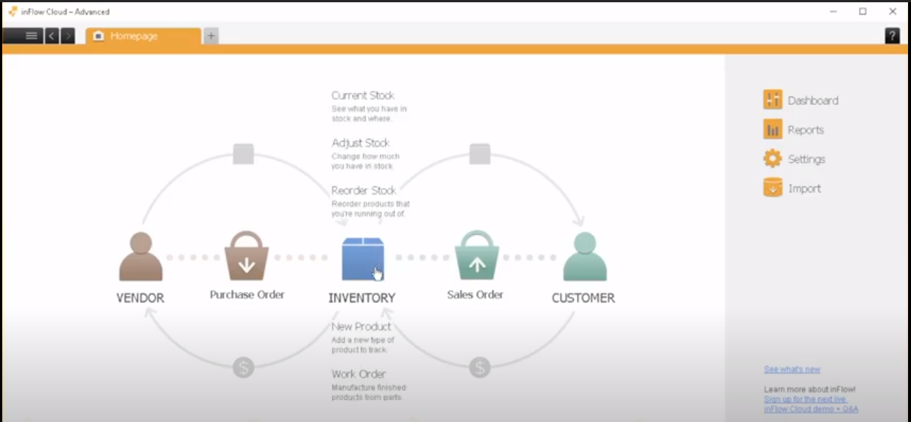*[12]*

*(Figure 1)*

This is the homepage where the users can navigate through the different sections.

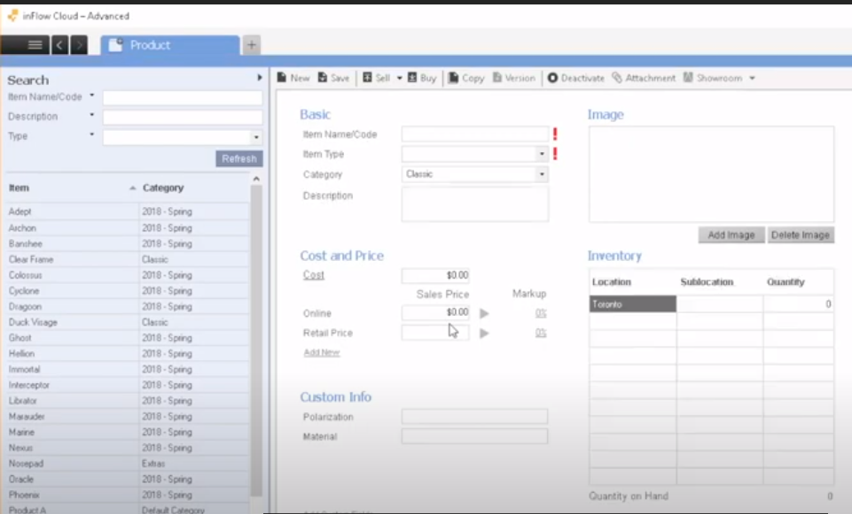*[ibid]*

*(Figure 2)*

This is the products page where users can perform the following tasks: click on the products to view their details shown in the figure 2.

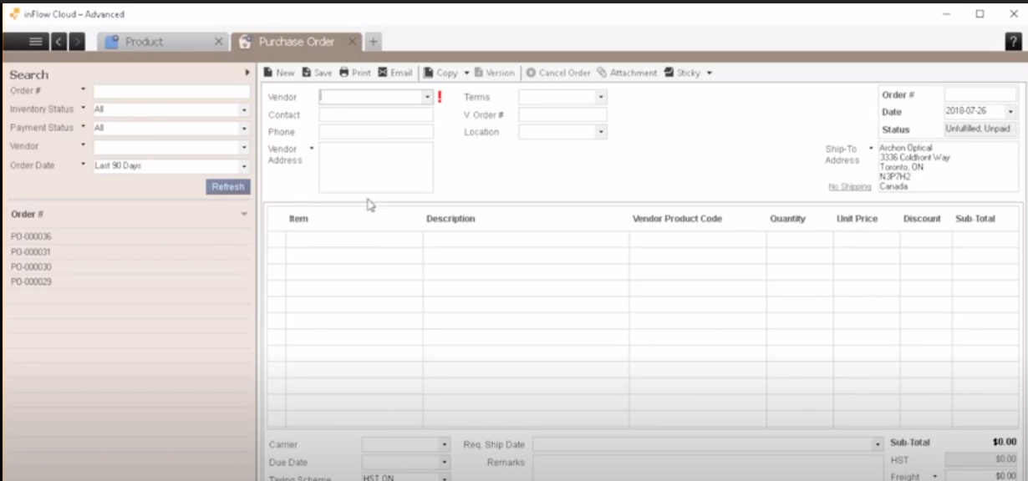*[ibid., 11]*

*(Figure 3)*

When the number of stocks becomes low for certain products then, this is the purchase order form where you would order more stock such as: entering the product details in the fields, you can also use auto fill e.g., just select the product name and all the details will be filled automatically, or by using a barcode scanner to scan as, a result the product will automatically be added to these input fields. Once, the details have been filled then, you can press the purchase button to purchase those items as it has a functionality to order items like ecommerce websites.

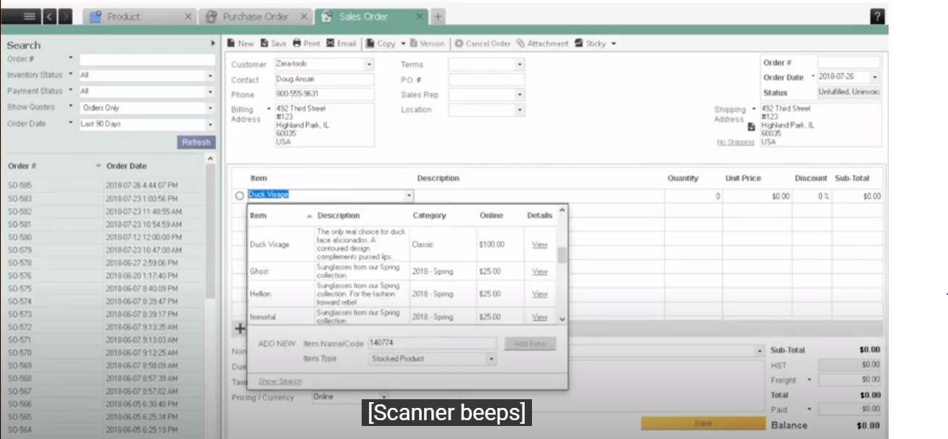*[ibid., 11]*

*(Figure 4)*

In Figure 4 you can see the sales order form which is used for selling orders to the customers. The way this works is that you can enter the customer name in the input field once then, it will auto-fill all the customer data in the remaining input fields e.g., customer address. There are 2 options the user can prompt, first: save the order, second: send the order, *“this way the invoice will be created which will be sync with a software called QuickBooks online” [ibid., 11]*. **(Refer to QuickBooks under its own section)**

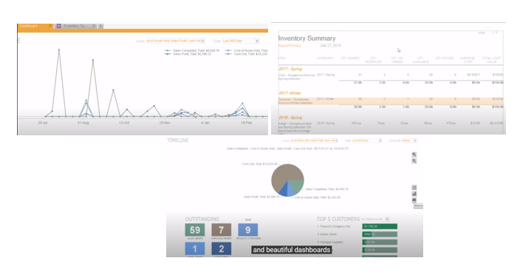

*(Figure 5)*

These are all the business reports shown in Figure 5. Using these reports, you can do the following: *“You can visualise top-selling products, gain insights on your most profitable customers” [ibid., 11]*, or view the full inventory report to see all the extended details e.g., which product was sold in which, month, date, time and how much stock was left after it was sold.

In the duration of my research on inFlow software I found some useful customer satisfaction reviews and in addition to that the number of customer satisfaction is 98.7%. Those reviews have come from the owners. Below you can witness some of those reviews:

*“We needed the ability to run a small number of inventory items outside of our current ERP. However, we quickly realized how much better and easy to work in inFlow was, so we’ve been migrating over for the past year. It’s a great powerful tool and I highly recommend it!*

*Rachel Wu | Griffin Distribution., President” [ibid., 11]*

*“inFlow has proven to be the most reliable, user-friendly, and cost-saving software tool to manage our inventory, sales and purchases all together.*

*Dominga Vitale | MedcOR Medical Systems., CEO” [ibid., 11]*

As, you can witness that businesses and their owners are very satisfied by using this software. It has a variety of benefits which includes the following: cross-platform which means it’s able to run on the following operating systems: **Web browsers, Windows, IOS (iPhone, MACs), and Android (Samsung Phones)**, all data is saved onto the cloud meaning there are less chances of data being lost, it uses intuitive and customizable tools: *“There are plenty of shortcuts, as is expected of a Windows-based system. You can access quickly Reports, Dashboard, and Settings from the main window.” [ibid., 10]*, reporting of the business current situations which includes the stocks, suppliers, customers, sales order, and using the current dataset to *“display them in various visual modes like a bar graph, line graph or pie chart.” [ibid., 9]*

After doing a further research and critical evaluative analysis I found a couple of drawbacks which were the following: *“The biggest con with both versions of this software is the inability to handle multiple warehouses properly” [13]*. *“If an item you have is in multiple locations, it treats those locations as different bins on the same shelf, so it will not tell you that you need to order more for warehouse "A" of there is enough in warehouse "B, C, D" to meet the min/max criteria. This requires you to use different part numbers for the same thing in each warehouse, which is doable but annoying when it comes to transferring between warehouses and labelling.” [ibid].* Another issue to be considered is that the reports are not showing the year e.g., 2020 in the full date of the sales and expenses therefore, it’s difficult for owners to review the reports when making important decisions the reason being, reports can be used to compare the performances of each year therefore, if there is no year listed then, it’s almost difficult to review your yearly performances. These drawbacks will open more ideas for me when I come to design and analyse my project as, I can use these to make improvements in my project design*.*

## **QuickBooks**

*“QuickBooks is an accounting software produced by Intuit. It is mainly meant for helping small and medium-sized businesses in their accounting and bookkeeping operations. Many owners of commercial ventures find it difficult to keep a proper track of their business transactions which makes it difficult to ensure the success of the business in the long run.” [14]*. QuickBooks can handle and monitor the businesses financial transactions this way it can support in the areas of *“managing and tracking cash procedures” [ibid]* and *“determining the output of the business” [ibid]*.

QuickBooks is a software which is used by many small businesses for managing their sales & income, generate reports: balance sheet, profit and loss report, statements of cash flow, run payroll, sales transactions, viewing expenses transactions.

The two main requirements of my software development project are to avoid businesses making poor business plans (finance is considered as a very important factor in a good and very decent business plan) and avoiding financial hurdles which includes: Lack of Cashflow, keeping to the budget, viewing unforeseen expenses, and most importantly marketing.

QuickBooks is a software which is used by many small businesses for their finance area which includes:

**Payroll** – payroll can sometimes seem quite difficult by business as it requires a lot of accuracy and care because, you are dealing with the payments which need to be made to their employees on the given date and time by their owners. This is where the owners must do the following tasks: paycheck processing, benefits of employees, insurances, and accountings tass e.g., taxes. This also includes other factors e.g., employees’ roles, overtime, days of work and leaves off work. QuickBooks is a software which will make it easier for the employees to manage their payroll process as *“multiple tasks can be performed easily. It helps in the easy accumulation of data. QuickBooks Payroll helps in keeping a proper record of the information related to insurance, retirement, and paid time off the employees. Any miscellaneous deductions like wage garnishment, union dues, charitable donations, etc. are also properly recorded.” [ibid]*. This way it will prepare the business payroll process and in addition to that, the payroll can be submitted via QuickBooks as, it also manages a list of bank accounts. This way the business can maintain their positive relationships with their employees, insurance companies and the tax agencies.

**Financial transactions** – this is where the business must properly manage their financial transactions which includes: payments of suppliers, purchases, sales, and receipts. These financial transactions are also known as ‘Bookkeeping’. This “*involves two categories i.e., single-entry bookkeeping system and the double-entry bookkeeping system. QuickBooks helps in completing the bookkeeping process in a prompt and accurate manner. This helps in making a correct assessment of the financial position of the business.” [ibid., 14]*. Therefore, the businesses can review their financial position and investigate if there are any problems with the finance for example, in many cases there might be delays and errors in payments by businesses as a result, the suppliers might come back to you saying, ‘We have not received your payment’ therefore, the business can view their position of their finance and recheck again. It helps maintain good records regarding the financial transactions.

**Invoices** – in businesses you deal with many clients and sometimes dealing with multiple clients which becomes difficult if you are manually going to create one invoices each time. Therefore, in QuickBooks you can just click a button once which will allow you to track your sales, product automatic receipts, and automatic invoices. These can be sent to the customers through email or automatically printed out and given to them on site-location.

**Bank accounts and Money Management** – in QuickBooks bank accounts are connected to the software therefore, you can make payments automatically or manually through the software using a debit or credit card. These bank accounts include accounts of the following: owners, employees, suppliers/vendors, customers (for delivery’s), location rent for shops, location rent for warehouses, lighting, heating, electricity etc. Therefore, you can witness how many bank accounts a business must deal with throughout each year.

QuickBooks allows you to connect several bank accounts which will except payments coming in and out of the business. Other advantages of this are that all the records regarding the bank statements can be accessed via the software if needed. It works the following way: the owners need to enter the date, time, and the amount payments as a result, on the date and time it will perform those transactions. *“QuickBooks software for accounts payable; errors can be minimized, processing costs can be reduced, late payments and fines can be avoided, reducing the need for paper documentation and improving a relationship with clients can be achieved.” [ibid., 14]*.

In addition to that, payments which come into the owners account can be viewed using QuickBooks. Those include customers payments or return items from suppliers/vendors. The money coming from accounts is an important factor for a business the reason being, it ensures *“the collection of money from customers and ensuring the fulfilment of operational expenses on time.” [14]*. *“By using QuickBooks accounts receivable, you can send invoices, retrieve payments, produce reports and send reminders to customers automatically. So, by using the software, managing the accounts receivable process will become easier.” [ibid., 14]*.

Another point to be added is that QuickBooks allows you to record all the banking transaction which have been made *“like deposits, ACH drafts, payroll drafts, debit card purchases, bank fees etc., can be recorded easily by using QuickBooks. This helps in saving time and energy along with proper maintenance of data.” [ibid., 14]*.

**Expenses** – the businesses expenses are mainly the stocks they purchase from their suppliers and some other objects which a typical small business will require e.g., shelfs, racks and counters/tills, Electricity & Bills. QuickBooks has an inventory section where all the stocks are documented as a table format when purchased from suppliers. Therefore, when the stocks are documented then, it gets the price of each stock and adds it to the expenses. The expenses are then shown in the reports using graphs. This way the business can analyse their expenses. It works the same way for the sales such as: when the stock is sold its removed from the inventory section which means is not part of the document as a result, it increases the sales in the reports.

**Financial Reports** – *“QuickBooks Pro can potentially generate a number of financial reports. These comprise of year-over-year income, expenditure, trends, and forecasting documents. Moreover, each report can be exported into a spreadsheet layout and delivered electronically by means of email.” [15]*.

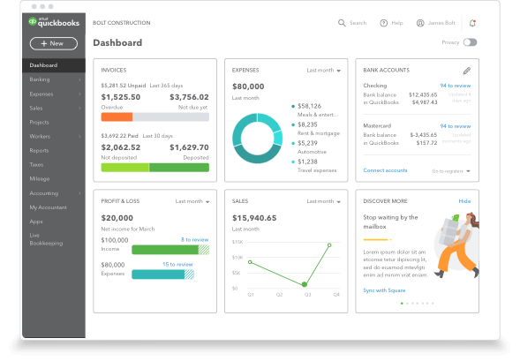*[16]*

*(Figure 6)*

This is the first view of the window you will view when the software opens. This is known as ‘Dashboard’. This is where you can view a brief information about the reports such as for the following: invoices, expenses, bank accounts, profit & loss, and the sales. On the left-hand side there is also a navbar which is used for viewing the financial area in detail.

In the duration of my research on QuickBooks I found some useful customer satisfaction reviews. Those reviews have come from the owners. Below you can witness some of those reviews:

*“Accounting is not my forte. QuickBooks helps me see my finances visually with graphs and things. Libby Hockenberry and Cary Smith, The Victorian”. [ibid]*. By witnessing this customer review, I can say that if the owners’ strong point is not accounting and finance then, by using QuickBooks they can still understand what happening around that area as, it makes it so easy, concise, and very precise which helps the owner to understand.

*“With QuickBooks, I feel like I always have my finger on the pulse of my business. Jennifer & Ben Johnson, West Egg” [ibid]*.

As, well as many great functions, features and reviews about QuickBooks there are drawbacks about as well which includes: you need to spend a lot of time to set-up your business information regarding e.g., finance which is time consuming resulting in time taken away from managing your business, there are also many other features in an inventory system such as product management as, a result there is a *“Lack of key reports outside of accounting” [17]* and finance, there are issues regarding the front-end system as *“Instability/system crashes” [ibid., 16]*, you can’t have too many users connected to it at once as there is a *“Limitations on the number of users” [ibid., 16]*, *“Built with a “small business mindset” [ibid., 16]* meaning you cannot really use it to grow your business, *“Lacks invoice design tools” [ibid., 16]*, *“Lack of industry and business-specific features such as lot tracking, eCommerce and barcode scanning” [ibid., 16]* meaning it could use features e.g., QR codes, and *“Lack of direct professional support” [ibid., 16]* therefore, QuickBooks is generally easy to understand the way its front-end has been developed but, in some unlikely situations there might be issues where users in an organisation might not understand there having some support will be useful which will then, possible avoid major mistakes because, think about it: if the user doesn’t know how to use the front-end then, they can possible make a mistake which can result in a major cause for the organisation, I do realise it’s very unlikely but, it can happen so this does needs to be considered for sure for example, having a support/help user guide will be useful which is built in the front-end itself.

In addition to that, there are two issues which I assume can be a major danger for the business organisation and those are the following:

*“How do we keep your data safe and secure?*

* *Whenever there are changes to your company file, your data is saved to two hard drives.*
* *We periodically copy all data to a third-party hard drive to protect your data in case something happens to the first two hard drives.*
* *Automatic backups are performed every night.*

***Note:****Because we update your records with every change, we cannot restore your file to a previous point in time.” [18]*.

According to my research I have found out that *“Data is not always backed-up so you risk losing information” [ibid., 16]* and this is a very important issue because, this can be counted as a major disaster for a business. This can lead organisations to a major loss or bankrupt in worst cases as, the data is considered as the most important factor. Therefore, I will recommend two suggestions which can be used to improve this, first: use cloud storage which reduces the risk of data being lost e.g., the hard-disk can be damaged due to a disaster therefore, the cloud will resolve this issue, and second: keep versions of your data e.g., when the record has been updated with a change then, backup with a different version number, this way you will have different versions of your files/data therefore, this will avoid the risk of losing information/data if something is needed to be restored. Currently, it does backup data regularly but, the problem is that it updates the same file each time.

Another major disadvantage is that *“Easy to find a fix errors/mistakes (which makes it easy for someone to manipulate your books)” [ibid., 16]*. Is this case there need to be a level of security for access rights. In my opinion there should be a user authentication system for different organisation management staff e.g., a login and a password to log onto QuickBooks for owners and users. In addition to that, you can have a user admin e.g., owner who is able to make edits/changes, and just users only e.g., employees who can only view the information. This way it will avoid this limitation.

There are also top 5 reasons why businesses do not prefer using QuickBooks. Below you can view those reasons why:

***“1. Limited reporting and transparency of your business health***

*Certain accounting reports in QuickBooks are very detailed and user-friendly, however, the nature of having a system that is not fully integrated means there may be data in other systems that are inaccessible. Certain warehouse or inventory data (not QuickBooks’ specialty) may be more difficult to combine in a meaningful way.” [19]*.

***“2. Double entry and keying errors***

*If you use a separate system in conjunction with QuickBooks (even Excel or paper) you probably already know the troubles of double-entry and keying errors. Taking information from one system and manually transferring it to another is like walking a tightrope with accidents just waiting to happen. Keying errors are particularly common when data does not move automatically throughout the system. Ultimately this can lead to incorrect business information and data loss – impacting customer satisfaction and hurting your bottom line.” [ibid]*.

***“3. Limitations with file size and data***

*Entry-level software is not built for substantial data requirements and may begin to slow as your business grows. To prevent this, it is common for a limit on data file size to be set, which forces you to purge your data on an ongoing basis.” [ibid]*.

***“4. Generic and impersonal support***

*QuickBooks is extremely popular, but as a result the support you receive may not be personalized and specific to your business. The benefit of moving upstream is that you will receive specialized support by those that understand your business (some businesses more than others).” [ibid]*.

***“5. Standalone applications lack integration.***

*One of the most compelling reasons to move off QuickBooks is to have a single system to manage your business. No more paper excels or inventory add-ons to worry about. Dealing with a single interface with interconnected data can do miraculous things for productivity.” [ibid]*.

Below, are two graphs in figure 7 and 8, which show a comparison of user satisfaction of QuickBooks in a variety of different areas which analyses the benefits and drawbacks of it and where it potentially needs improvements.

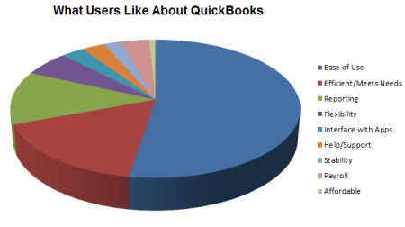 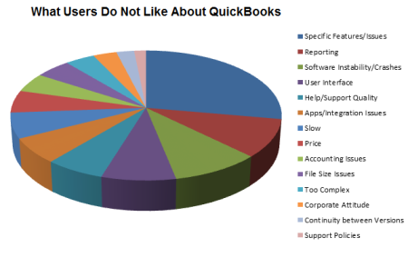

*(Figure - 7) [ibid., 16] (Figure - 8) [ibid., 16]*

Doing a research on QuickBooks, has opened more ideas for me to consider for my project for example, what else can I add to my design which I’ve learnt from this research e.g., implementing graphs analysis instead of large written reports, which makes it easier to analyse the current business situation. In addition to that, the improvements I have considered for QuickBooks can be considered for my project design.

## **Info Cloud vs QuickBooks**

There are comparisons which are made between the two software’s which shows their areas of strengths and weaknesses in different areas. Info Cloud is best for: *“inFlow is designed to run and manage any item based business. Suited for wholesalers, distributors, retailers, manufacturers, and online sellers. Customers are in over 90 countries.” [20]* whereas, QuickBooks is best for *“Editions dedicated to contractor, manufacturing and wholesale, non-profit, retail, and more.” [ibid]*. Both use the following features and functions: Forecasting, Manufacturing Inventory Management, Product Identification, Reporting/Analytics, supplier’s management, and warehouse management. Info Cloud tends to have a better inventory management system as, it uses more spaces in its inventory system and, as the system gets larger than it optimizes, whereas, in QuickBooks it gives you limited spaces and doesn’t allow you to optimize. Info cloud also has a better backup system as it uses the cloud to backup all its data whereas QuickBooks uses third-party hard drives. Info Cloud and QuickBooks both use report and analysis but, QuickBooks seems to use more detailed analysis by using a variety of graphs which makes it more concise therefore, it’s understood more easily than the reports produced in Info Cloud, which shows long written reports and only a couple of graphs. In general Info Cloud is better if you want to manage your inventories in the best way possible whereas, QuickBooks is better if the business wants to get rid of their financial hurdles the best way possible as, they are provided with the best tools to do that.

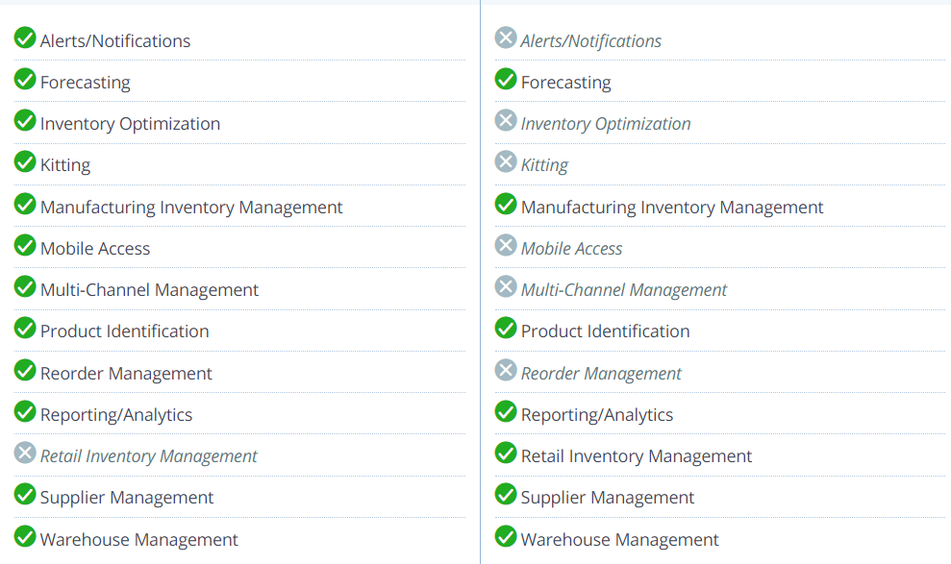*[ibid]*

*(figure - 9)*

In figure 9 you can see the debate between Info Cloud vs QuickBooks which shows which software has the most features and functions. The key point is that I completely understand the fact that, Info Cloud has more features and function then QuickBooks but, its main functions and features are just regarding the Inventory management system which are the following: Manufacturing Inventory system, product identification, supplier management, and warehouse management as, the rest of its other features apart from these are in less detail which can sometimes help but probably not if required in a great amount of detail. Whereas, I completely understand QuickBooks has less features compared to Info Cloud but, the main features of QuickBooks are reporting/analytics, and forecasting which are very detailed and concise to support organisations in their area of accounting and finance even if they have less knowledge in that area.

## **Other Existing Software**

In duration of my research, I read and explored about many different existing software’s regarding business inventory system and financial management. Since there were a variety of software’s which includes the following: NetSuite, Zoho IOS mobile application, TradeGeko, DEAR Systems, ABC Inventory, ORDORO, Upserve, CIN7, FishBowl manufacturing & warehouse, SAP business one professional, Cougar Mountain Denali Summit, AcountMate, Open Systems Traverse, Acumatica, **Info Cloud**, and **QuickBooks** etc. All these software’s which I’ve researched have similar and features regarding business inventory system, financial management, and project management. These software’s are rated one of the best one which are out there in the market. Therefore, I chose two review two software’s which are two of the best I can say out of all these which slightly have better features, functions, and customer satisfaction reviews then others. Due to the fact of features, functions, and customer satisfaction reviews I decided to choose those two. Those two were **Info Cloud** and **QuickBooks**.

I would need to make sure that my project is meeting all the criteria for the features, functionality, and usability. The way I am doing this is by researching on the tools and technologies. Below I will explain why I decided to use those tools and technologies.

It is extremely important to use the appropriate technologies for my project development the reason being, this would depend on how far my project will succeed. As, I mentioned before my idea is to build a desktop application for a ***‘A Modern Business Inventory and Management System for Small Businesses to manage and avoid potential disasters’*** therefore, I have decided to use these following tools and technologies which would be one of the greatest choice to develop my software system:

## **Java**

Java is an object-oriented and a class-based programming language *“developed by Sun Microsystems in the early 1990s. Although it is primarily****used for****Internet-based applications,****Java****is a simple, efficient, general-purpose****language****.****Java****was originally designed for embedded network applications running on multiple platforms.” [21]*. Using Java, a lot of other applications can be developed which includes: Mobile applications (on Android OS), Desktop applications, Web applications, Web servers and application servers, Games, Database connections, etc. These are the following advantages of using Java: Java works on different operating systems such as Windows, MAC, Android, Linux, Raspberry Pi, etc, it known as *“one of the most popular programming language in the world” [22]* which is *“easy to learn and simple to use” [ibid]*, its open-source and can be used free without cost, it’s a very secured, fast, and powerful language to use, *“Java is an object oriented language which gives a clear structure to programs and allows code to be reused, lowering development costs” [ibid]*, and Java is very close to the syntax of C language e.g., C++ or C meaning, that C language programmers can easily understand and pick up Java quickly. Many users including I have used Java from a beginner level to becoming almost an expert as, it uses some great features which helps users understand the concept of object-oriented programming, I understand that Java uses strict syntax but, that is what motivates most people as it makes programmers fix more errors and fixing more errors makes you a better programmer and that is the way I learnt programming myself.

Another big advantage of using Java is that apart from creating your own packages it comes with a variety of built-in packages which includes: *“lang, awt, javax, swing, net, io, util, sql etc.” [23]*. These packages are very useful which supports users developing more functionality and it also saves time and reduces the code length as, the class is already written for you therefore, the developer has to just use those classes to develop their required functionality. The built-in packages which will be useful for my project are the following: utility e.g., and sql (for database connections including JDBC) etc.

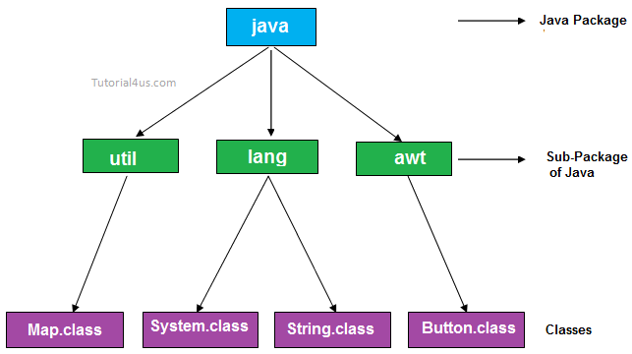*[24]*

*Figure 10*

As, you can see above in figure 10 which shows the sub-packages and classes are organised in Java. These sub-packages and classes are organised the same way of how a computer file system directories are sorted out. Therefore, in my main java program, if I wish to use a sub-package or a class for example, I want to use the utility package (util) then, I will have to import that in my main program e.g., java.util.Map (utility sub-packages hold a lot of data structure which I will talk about in the Java Utility Package section) I use java to access the whole package, then I add .util to import the sub-package and then, I just add the .Map to use the class. As, a result I can use the map data structure because, I can use the class after I have imported. From figure 10 diagram you can see how the package, sub-packages, and classes are connected together. In addition to that, another benefit is that you can use e.g., java.util.* to import all the classes in the utility sub-package as a result, you can use all classes for using a variety of data structures if it was the utility class.

In addition to that, using this structure shown in figure 10, I can also create my own sub-package and inside I can create my own classes which I can import in my main program to use those sub-packages and classes. For example, I can create a sub-package in the main java package called ‘users’ and then inside the ‘users’ package I can create my different classes called employees, customer, owners, and suppliers. After that, I can import those classes to hold the different types of user’s data.

## **Java Utility Package**

Java Utility is a built-in Java package which *“contains the collections framework, legacy collection classes, event model, date and time facilities, internationalization, and miscellaneous utility classes.” [25]*. The reason why I chose to use the java utility package is because it holds a lot of classes for a variety of data structures such as: Array List, Linked List, Stacks, Queues, HashMap, TreeMap, Graphs, Arrays, Abstract: Collections, lists, maps, queue, etc. Therefore, my plan is to use the array list data structure to hold all the stocks data and in addition to that, it also has a search algorithm which can be used to search a certain product by either a string(letters) or integers(numbers). The utility package also provides you with the current date and time therefore, I can use these classes to display the current date and time, and also use a timer countdown on the applications to send certain types of alerts e.g., ‘time is up, your about to automatically logout’.

## **Java Lang Package**

Java Lang is another built-in Java package which *“Provides classes that are fundamental to the design of the Java programming language. The most important classes are Object, which is the root of the class hierarchy, and Class, instances of which represent classes at run time.” [26]*. This is the package which holds all the different types of data types e.g., integer and strings and the two most important are known as, *“****Runtime****: Every Java application has a single instance of class Runtime that allows the application to interface with the environment in which the application is running” [ibid]*, *“****Void****: The Void class is an uninstantiable placeholder class to hold a reference to the Class object representing the Java keyword void.” [ibid., 21]*. Another major reason of this class regarding my project is threads which are imported though the Lang package. A thread is known for an execution of a particular code in your program, and thread groups works the same way but, the only difference is that a group represents a set of threads which are executed the same way. These threads will be used for my project development to execute code at a particular time e.g., my idea is to backup data after every hour, day, month, and year therefore, these groups of threads will execute at a certain time e.g., after one hour a thread will execute automatically to backup data remotely to the FTP-server.

## **Java JDBC & SQL Package**

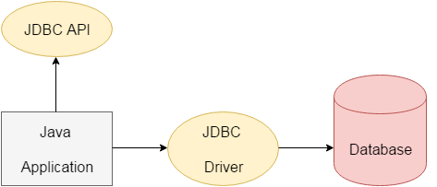*[27]*

*Figure 11 – Thin Driver*

### **What is API?**

*“API (Application programming interface) is a document that contains a description of all the features of a product or software. It represents classes and interfaces that software programs can follow to communicate with each other. An API can be created for applications, libraries, operating systems, etc.” [ibid]*

*“JDBC stands for Java Database Connectivity. JDBC is a Java API to connect and execute the query with the database. It is a part of JavaSE (Java Standard Edition). JDBC API uses JDBC drivers to connect with the database.” [ibid]*. The JDBC API comes with a jar file which needs to be added into the Java libraires after that, the JDBC API will enable *“The****java.sql****package contains classes and interfaces for JDBC API.” [ibid]*. Inside the java.sql package are the following classes which can be used e.g., access the database file from you file system, establish a connection between the database and the java application, to create a database with tables from scratch, using queries in your java application e.g., storing, deleting, editing, this can be done using statements and prepared statements, also display data on the java application using results set, results set meta data, etc:

Driver Manager – *“The DriverManager class acts as an interface between user and drivers. It keeps track of the drivers that are available and handles establishing a connection between a database and the appropriate driver. The DriverManager class maintains a list of Driver classes that have registered themselves by calling the method DriverManager.registerDriver().” [ibid]*

Connection Interface – *“A Connection is the session between java application and database. The Connection interface is a factory of Statement, PreparedStatement, and DatabaseMetaData i.e. object of Connection can be used to get the object of Statement and DatabaseMetaData. The Connection interface provide many methods for transaction management like commit(), rollback() etc.” [ibid]*

Statement Interface – *“The****Statement interface****provides methods to execute queries with the database. The statement interface is a factory of ResultSet i.e. it provides factory method to get the object of ResultSet.” [ibid., 22]*

Prepared Statement Interface – *“The PreparedStatement interface is a subinterface of Statement. It is used to execute parameterized query.” [ibid., 22]*. The reason why prepared statements are better than statements are because, it has a *“****Improves performance****: The performance of the application will be faster if you use PreparedStatement interface because query is compiled only once.” [ibid., 22]*.

Callable Statement Interface – is used to call the functions and procedures. *“We can have business logic on the database by the use of stored procedures and functions that will make the performance better because these are precompiled.” [ibid., 22]*.

Result Set Interface – The result set interface has methods and functions which displays the data in the database. Using this you can display all data rows, last row, or the first row. You can also use it as a cursor by using the method next() to display the next row in the data each time and you can also use it for following previous(), first(), last(), find the index, get by letters, get by numbers, find the row number etc. This all depends on your written algorithm within your java application.

ResultSetMetaData Interface – This uses functions and methods to return the following: *“table like total number of column, column name, column type etc. , ResultSetMetaData interface is useful because it provides methods to get metadata from the ResultSet object.” [ibid., 22]*.

DatabaseMetaData Interface – *“DatabaseMetaData interface provides methods to get meta data of a database such as database product name, database product version, driver name, name of total number of tables, name of total number of views etc.” [ibid., 22]*.

Row Set Interface – *“It is the wrapper of ResultSet. It holds tabular data like ResultSet but it is easy and flexible to use.” [ibid., 22]*.

There are many different types of advantages using JDBC which includes the following: no sophisticated installation is required, **provides existing enterprise data therefore *“Businesses can continue to use their installed databases and access information even if it is stored on different database management systems.” [28]*** which is considered as a benefit for small businesses. No configuration is required in terms of network, “*full access to meta data” [ibid]*, *“****Simplified Enterprise Development*** *– The combination of the Java API and the JDBC API makes application development easy and cost effective.” [ibid]*.

JDBC also uses four different types of drivers to interact with the database, they all work the same way in terms of the API and classes the only difference is the connection. Those are called the following: JDBC-ODBC bridge driver, Native-API driver (partially java driver), Network Protocol driver (fully java driver), and the Thin driver (fully java driver). The reason why I chose the thin driver is because it has the most less disadvantages compared to the other three. The thin drivers have these following advantages: it’s the best out of the other three in terms of its performance, and no software is required on the client/server side. The only limitation is that it only depends on the database but, nothing else.

## **Java IO Package**

The Java I/O package is another sub-package which is used for *“reading and writing data (input and output). Most applications need to process some input and produce some output based on that input. For instance, read data from a file or over network, and write to a file or write a response back over the network.” [29]*. This package contains many classes which you can see below in figure 12 with its architecture:

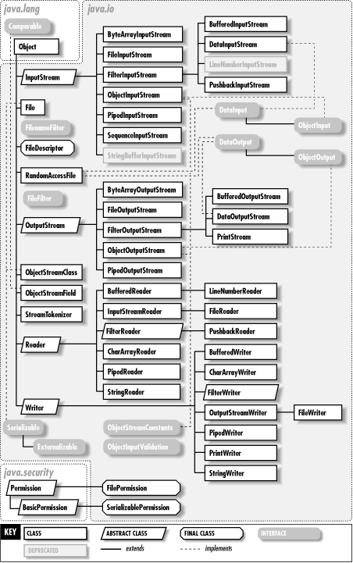*[30]*

*(Figure 12 – Java I/O Package Classes Architecture)*

In figure 12 you can witness the java.io package which all is classes and interfaces. According to my project requirements I’m interested in these following classes: file, file not found, and a print writer. The file class is used to find the path of the file and make it readable over the network, and file not found is an exception error which occurs if the file path is incorrect to alert users about this error. Once the file is recognised then, it’s also readable by your java program e.g., you can view the text which is in your text file in the java program. The print writer is a class which allows you to write to files from your program e.g., you write something in your java program and it will be readable inside your text file. Therefore, the data I receive from the database can be written direct into the file which is readable in the program by using the print writer and that’s my main purpose of using these three classes from this package.

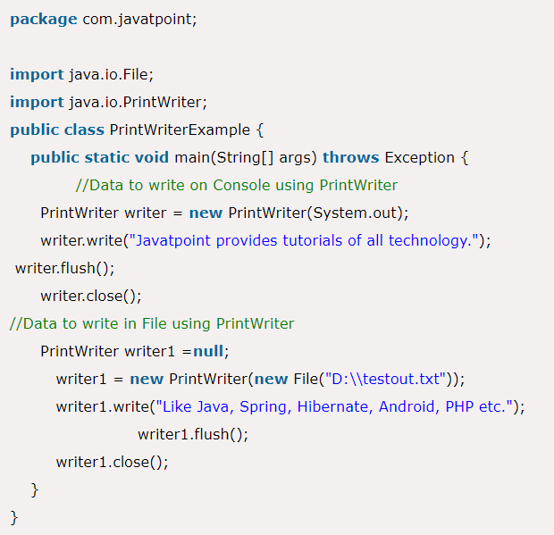*[31]*

6.) This method is used to close the file contents in just case if something is added accidently after what was required to be written.

2.) The location path for the file has been identified.

5.) This method has been used for flushing *“the output stream and forces any buffered output bytes to be written out. The general contract of flush is that calling it is an indication that, if any bytes previously written have been buffered by the implementation of the output stream, such bytes should immediately be written to their intended destination.” [32]*.

4.) Using the print writer to write to the file destination.

1.) The file and print writer classes have been imported.

3.) The print writer object has been created.

*(Figure 13 – Example code of File & Print Writer)*

As, you can see the example code in figure 13 of how the file and print writer’s work. There is one thing missing in this code and that is the file not found exception without that, if the file fails to be recognised then, the whole program will crash as a result, you will have to face further problems especially within small business this can also result in data loss which I have mentioned its consequences in the previous sections. Therefore, the file not found exception will just alert the user but, the program will; continues to run without crashing. Therefore, the file error can be fixed later by checking the latest file location and adding the new path in the program. You can see below in figure 14.

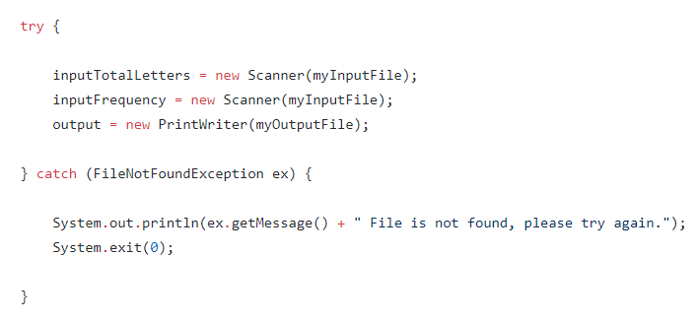*[33]*

*(Figure 14 – File not Found Exception Message)*

## **JavaFX**

JavaFX is a GUI software which is used for developing desktop applications and rich internet applications. JavaFX was released 11 years ago on 4th December 2008. JavaFX is a cross-platform software therefore, it has the ability to run on a variety of devices e.g., Windows, MAC, IOS, Linux, etc but, its main operating system is java runtime environment. JavaFX was developed using JavaFX script programming language. *“JavaFX Script was a scripting language designed by Sun Microsystems, forming part of the JavaFX family of technologies on the Java Platform.” [34]*.

Development of a desktop application can be eased by using JavaFX the reason being:

It has built-in controls –*“JavaFX provides users with all the necessary UI controls to develop a full-featured application. Moreover, components in a JavaFX application can be styled using Cascading Style Sheet (CSS)” [35]* just like in web development where you would use CSS to style your webpage to *“implement themes where user can change the entire appearance of the application with a single click” [35]* this is the same way for a desktop windows. You just need to attach CSS to your java program to enable it just like you use the link rel in HTML file, or you can do it wihtin the program e.g., undernath the code just like the style tags in the HTML file. You can choose different CSS files to style each different window. Java API – *“JavaFX is a library that is written in native Java. Therefore, it will be available for the languages that can be executed on JVM” [ibid]*.

*“JavaFX supports touch devices. Handling touch gestures such as scrolling, swiping, rotating, zooming, and even multitouching in JavaFX is as easy as handling any other type of event. Users just need to make an event listener for those touch events and write code to respond to them.” [ibid]*. These gestures will be considered such as in small businesses there are owners and employees who might have visual impairment thereofre, they can use the zoom in funcationaily. As, well as some windows might be long due to long text therefore, in this situation scrolling is the best option.

*“JavaFX supports Properties and data binding. Simply put, a property is a variable that is observable and can be attached with a listener, allowing users to write code that is triggered automatically whenever the property changes. In addition, with data binding, developers can bind properties to each other, which can be simply explained: if a property value changes, the value of the property that is bound to that property will automatically change, too” [ibid]* for exmaple, on the login window you cannot press the loign button until you have entered both the username and password value, once those have been inputted into their respected fields then, the login button will be enabled as, the login button property value will automaticlly change. Throughtout the application there are mnay reasons where this will be considred appropiate due to many reasons.

*“Rich set of APIs – Beside a rich set of API to develop GUI application, JavaFX also includes the capabilities of Java platform with features such as Generic, Annotation, Multithreading and Lambda Expression.” [ibid]*.

JavaFX also has the features of *“embedded web contents” [ibid]* and *“media playback” [ibid]*. This also supports *“Audio, video and HTML5” [ibid]*. Using JavaFX I can develop a whole media player with playing videos. This will include the following components: media player, media controls: play/pause, time slider, forward, backward, volume control, and full size/back to small size. You can witness the examples in figure 14 below:

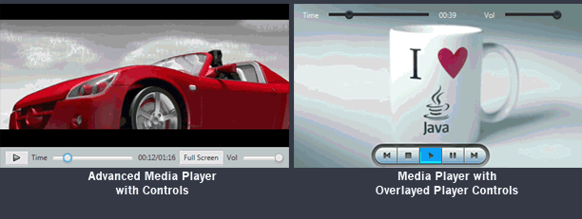*[36]*

*(Figure 14 – JavaFX Media Player Example)*

***“Creating a Media Player***

*The JavaFX media concept is based on the following entities.*

* ***Media****– A media resource, containing information about the media, such as its source, resolution, and metadata.*
* ***MediaPlayer****– The key component providing the controls for playing media.*
* ***MediaView****– A Node object to support animation, translucency, and effects.*

*Each element of the media functionality is available through the JavaFX API. Figure 1-2 shows the classes that reside in the**javafx.scene.media package. These classes are interdependent and are used in combination to create an embedded media player.*

***Figure 1-2 Classes in the javafx.scene.media Package” [ibid., 26]***

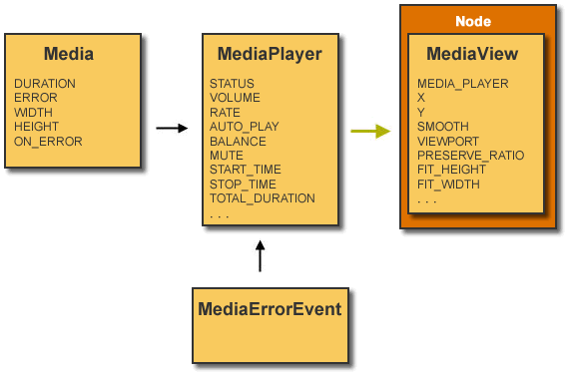

*(Figure 15 – The Class Diagram of the JavaFX Media Player)*

In figure 15 you can witness the class diagram yourself which can be used for the media player development. I’ve already explained a lot about the media player but, my main purpose of figure 15 is to show you how JavaFX classes actually work. For example, the javafx.scene.media package is a made up of sub-packages and classes just the same way as the other classes e.g., utility classes. You can import any GUI components e.g, buttons, media players, text, labels etc by importing their classes into your JavaFX applications. They call have different classes depending on their family tree e.g, which component they belong to e.g., Image, layout, control, text, paint, etc.

Below, you can witness the diagram in figure 16 which shows you the structure of JavaFX:

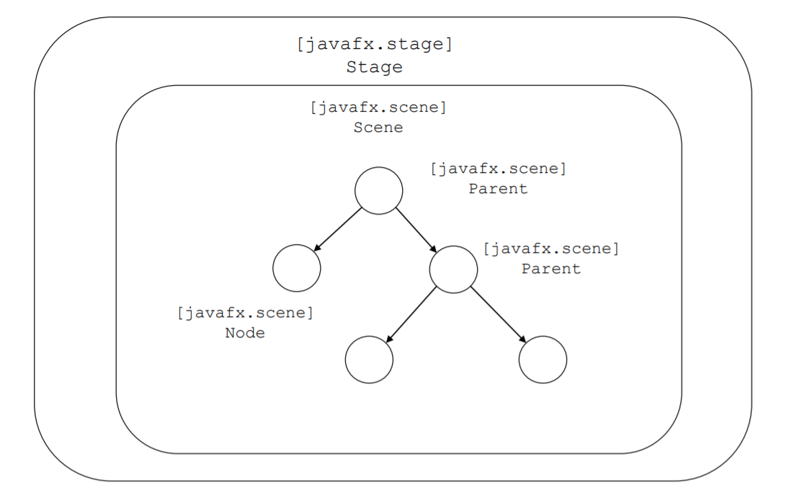

This is where there will be panes.

This is the parent node which will be connected to the GUI components e.g., Image Views, Canvas, Control, Chart etc.

This is where there will be primitives.

*(Figure 16 – The diagram for the structure of JavaFX with annoatations)*

In figure 16 you can see the structure tree of JavaFX program e.g., its application layout where is starts off with the application which is the *“main class for a JavaFX application extends the javafx.application.Application class. The start() method is the main entry point for all JavaFX applications” [37]*, and then the stage which is used for top-level container for JavaFX. After that, in figure 16 middle panel you can witness the scene class which contains all the GUI componets such as: buttons, media players, text, labels etc.

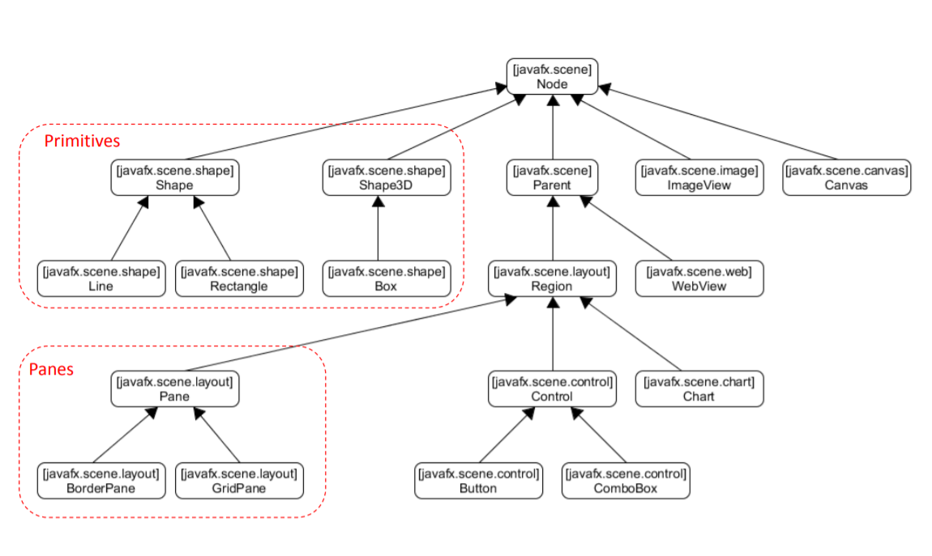

*(Figure 17 – The different types of nodes in the scenes)*

In figure 17 you can witness the diagram where you can see the JavaFX scenes contains a variety of different types of GUI components. The parent components are connected to the node, and there are some classes which are knows as primitives which do not include parent they are just connected to the node. This will give a more detailed idea of how this tree works, compared to figure 16 which just shows the outline. The primitives are just used for drawings or surrounds an area by a shape e.g., a square box shape can be used to make a border arounds to split sections e.g., finance section inside the different windows within your application. These are how the different types of GUI components are designed in JavaFX. Therefore, inside your java application you would need to import these classes in order to use the different types of GUI components in your JavaFX application. You can see below in figure 18 of how that is performed.

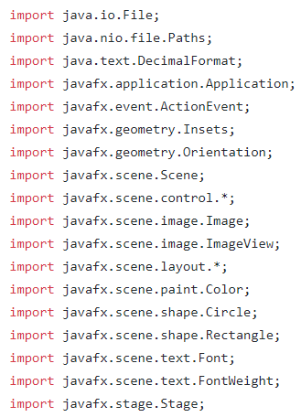

You can witness the rest of the GUI components which have been imported in this JavaFX application.

These two classes are mandatory as, I have mentioned before.

*(Figure 18 – Imports of JavaFX)*

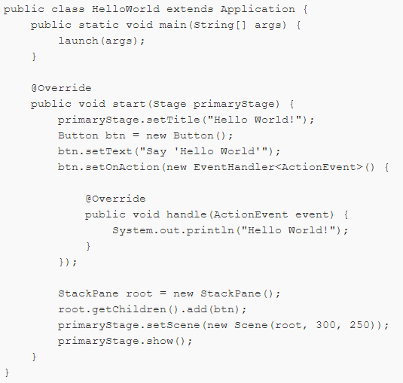

This is what launches the void start() method below to run the GUI.

The setScene() method is used for setting the window/form which has been first programmed with components and then, its set therefore, it adds that scene to the GUI therefore, it appears in the GUI when its running. Scenes in JavaFX are used for developing windows for example, if the software design shows 5 forms then, 5 scenes need to be created in JavaFX and all of those need to be called using the setScene() method. You can either set them all once which will show all of the windows/scenes together when the program runs or use event handlers to control the scenes e.g., click on this button to switch scene. I will discuss event handlers in the later section. In the scene you notice the numbers ‘300’ and ‘500’ those have been used to set the height and width of that particular scene/window. Finally the method show() is used to display the GUI when running I can use hide() as well but, then it won’t display the window/scene when the program is running. The, hide() method is useful when you are still developing a part of the application which has not been completed or for maintenance. For example, a business will not be affected as much because, only a part of software is under maintenance otherwise, the rest of other parts are working. Once, developed will use show() to display it again.

This is how JavaFX application stage method which is used to do all the programming for the GUI e.g., you add your components in this method if you want your GUI components to work. This can be done in several ways you can either code directly in the stage method or create a method and call it in the stage method or create a class and make the object from that created class inside the stage method.

This is how JavaFX application is started as, this makes it a JavaFX application without this the application would not be a JavaFX application.

*(Figure 19 – Example code of the JavaFX start-up)*

When the JavaFX GUI component class has been imported then, you create an object e.g., ‘Button = new Button’ which you will use to the object button to edit using the different methods and CSS styling and adding that to the scene therefore, it appears on the GUI. This would work with any GUI components but, you can see the button example in figure 19.

In figure 19 you can also witness methods e.g., setTitle() – used for setting the window title, set component text for example a button is a GUI component therefore setButtonText() is used for setting the text on the button and this works exactly the same with the other GUI components. There are other methods e.g., setting the height and width, colour, font, and etc. Obviously, the CSS styling can be used for styling those GUI components which makes it simpler then, using a lot of methods which also reduces the modularity of the programming code.

Apart from GUI components JavaFX also provides layout panes for managing your JavaFX application user interface e.g., how are the GUI components laid out, which GUI components go where etc. This is an excellent process to design your graphical user interface such as, UX/UI designers/people would give and develop different ideas for designing your best GUI therefore, you can achieve those by using the JavaFX layout panes. *“A JavaFX application can manually lay out the UI by setting the position and size properties for each UI element. However, an easier option is to make use of layout panes. The JavaFX SDK provides several layout panes for the easy setup and management of classic layouts such as rows, columns, stacks, tiles, and others. As a window is resized, the layout pane automatically repositions and resizes the nodes that it contains according to the properties for the nodes.” [38]* .Below, you can witness the examples of the layout panes as, JavaFX has a variety of them:

Border Pane – *“The Border Pane layout pane provides five regions in which to place nodes: top, bottom, left, right, and center. Figure 20-1 shows the type of layout that you can create with a border pane. The regions can be any size. If your application does not need one of the regions, you do not need to define it and no space is allocated for it.” [ibid]*.

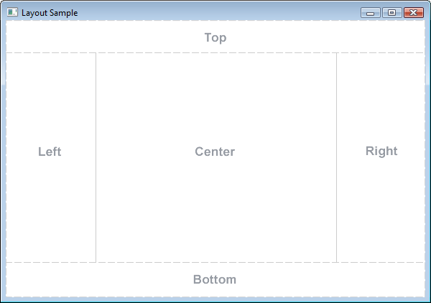

*(Figure 20.1 – Border Pane)*

*“A border pane is useful for the classic look of a tool bar at the top, a status bar at the bottom, a navigation panel on the left, additional information on the right, and a working area in the center.” [ibid]*. This can be considered, for developing a main menu for my own project software development system.

*HBox – “The HBox layout pane provides an easy way for arranging a series of nodes in a single row. Figure 20.2 shows an example of an HBox pane.” [ibid]*. The HBox is used for placing GUI components in a horizontal order.



*(Figure 20.2 – HBox)*

VBox – *“The VBox layout pane is similar to the HBox layout pane, except that the nodes are arranged in a single column. Figure 20.3 shows an example of a VBox pane.” [ibid]*. The VBox is used for placing GUI components in a vertical order.

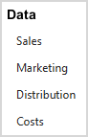

*(Figure 20.3 – VBox)*

*“The padding property can be set to manage the distance between the nodes and the edges of the VBox pane. Spacing can be set to manage the distance between the nodes. Margins can be set to add additional space around individual controls.” [ibid., 30]*. In addition to that, you can also use the methods setRight() and setLeft() to place the HBox or VBox in your chosen region.

StackPane – *“The StackPane layout pane places all of the nodes within a single stack with each new node added on top of the previous node. This layout model provides an easy way to overlay text on a shape or image or to overlap common shapes to create a complex shape. Figure 20.4 shows a help icon that is created by stacking a question mark on top of a rectangle with a gradient background.” [ibid., 30]*.



*(Figure 20.4 – Example of a StackPane)*

There are also methods for property alignment which can be used to set the children position within the StackPane which includes features such as: padding, margins, etc. This way it sets the position of the children within the StackPane.

GridPane – *“The GridPane layout pane enables you to create a flexible grid of rows and columns in which to lay out nodes. Nodes can be placed in any cell in the grid and can span cells as needed. A grid pane is useful for creating forms or any layout that is organized in rows and columns. Figure 20.5 shows a grid pane that contains an icon, title, subtitle, text, and a pie chart. In this figure, the gridLinesVisible property is set to display grid lines, which show the rows and columns and the gaps between the rows and columns. This property is useful for visually debugging your GridPane layouts.” [ibid., 30]*. When I’m developing my forms, I can organise the rows and columns to place my content in the correct location according to my GUI design.

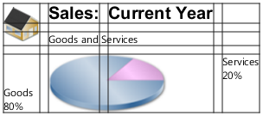

*(Figure 20.5 – Example of a GridPane)*

There are also a variety of different ways which can be used for managing spaces between the columns and rows. You can use padding for developing a good distance between the edge of the grid panes and also give a gap between the two contents. *“The vertical and horizontal alignment properties can be set to manage the alignment of individual controls in a cell.” [ibid., 30]*.

FlowPane – *“The nodes within a FlowPane layout pane are laid out consecutively and wrap at the boundary set for the pane. Nodes can flow vertically (in columns) or horizontally (in rows). A vertical flow pane wraps at the height boundary for the pane. A horizontal flow pane wraps at the width boundary for the pane. Figure 20.6 shows a sample horizontal flow pane using numbered icons. By contrast, in a vertical flow pane, column one would contain pages one through four and column two would contain pages five through eight.” [ibid., 30]*. There are also properties and methods which allows to give spaces from the edge and in-between the different contents.

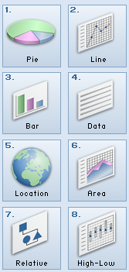

Spaces in-between each square box.

Spaces from the edge.

*(Figure 20.6 – Example of a FlowPane)*

TilePane – *“A tile pane is similar to a flow pane. The TilePane layout pane places all of the nodes in a grid in which each cell, or tile, is the same size. Nodes can be laid out horizontally (in rows) or vertically (in columns). Horizontal tiling wraps the tiles at the tile pane's width boundary and vertical tiling wraps them at the height boundary. Use the prefColumns and prefRows properties to establish the preferred size of the tile pane.” [ibid., 30]*. There are also properties and methods which allows to give spaces from the edge and in-between the different contents. The tile pane produces the same layout compared to figure 20.6 the example of a flow pane.

AnchorPane – *“The AnchorPane layout pane enables you to anchor nodes to the top, bottom, left side, right side, or center of the pane. As the window is resized, the nodes maintain their position relative to their anchor point. Nodes can be anchored to more than one position and more than one node can be anchored to the same position. Figure 20.7 shows an anchor pane with the grid pane from GridPane anchored to the top and an HBox pane with two buttons anchored to the bottom and the right side.” [ibid., 30]*.

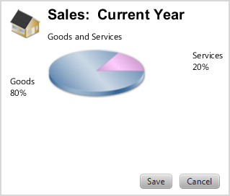

*(Figure 20.7 – Example of a AnchorPane)*

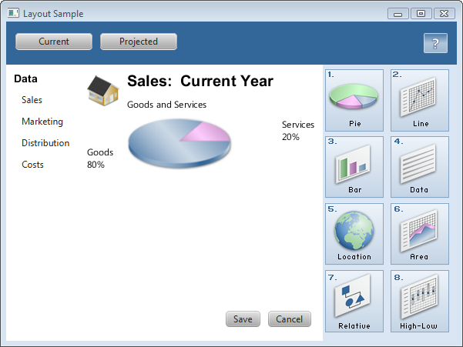

*(Figure 20.8 – Complete GUI with layout)*

After looking at all the different types of layout panes you can see in figure 20.8 that a complete GUI has been developed using those. In JavaFX users have the capability to make their own layout design which they can apply to their main JavaFX application. For example, a user can use the different types of layout panes together to make a design e.g., using their own classes and objects, or methods. After that, they can use those instances of objects or methods and call them in their main stage method to apply the design. You can view the example code below which will make my point of view even stronger:

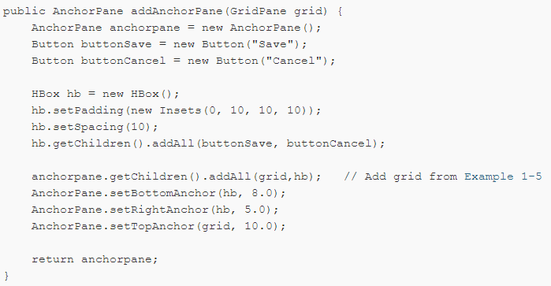

*(Figure 20.9 – Layout Panes used for developing an own design layout example code)*

In figure 20.9 you can see the add anchor pane method which has been developed using a combination of the different types of layout panes which includes the following: HBox, and AnchorPane. Then this method is called in the main JavaFX application to apply the layout design in the window which you can see in figure 20.7 – example of a AnchorPane. In those example only two layout panes types have been used to create a design layout but, you can create a method to which includes as many layout panes as you want for your GUI design. You can create different methods e.g., a method for just designing the navigation bar, main menu, etc. Apart from methods, you can create your own objects and classes to achieve this. This is one of the reasons why JavaFX is preferred as, it gives you a variety of options to achieve your design to the best of its ability.

JavaFX use event handling to achieve the required functionalities of the software e.g., what the GUI software is supposed to do. These are the following examples: clicking a button to perform an action such as change the window, exit, or building a navigation system within the application, drag the slider to change the brightness level of the window screen, using radio buttons, checkboxes, and sliders for selecting options on a list and, using the GUI components and adding an event handler to them for performing an action task. In addition to that, there are other types of event handlers for using your keyboards to perform actions such as: using the keys to move an object, or on a button instead of clicking you can also use the event handler for a keyboard key e.g., enter key and press that to enable the button to perform the task. There are also event handlers for touch screen e.g., click a button on the application by your own finger to perform an action e.g., but that depends on what device you are using. You can apply event handlers to any object in JavaFX and this also includes the layout panes or shapes which can be considered as another benefit of JavaFX because you can develop your own button by using shapes and just apply an action by using the event handlers. It is extremely important that you import the import javafx.event.ActionEvent class in your JavaFX application without that your actions will not work regardless. Below, in figure 21 you can see an example of how the event handlers will work.

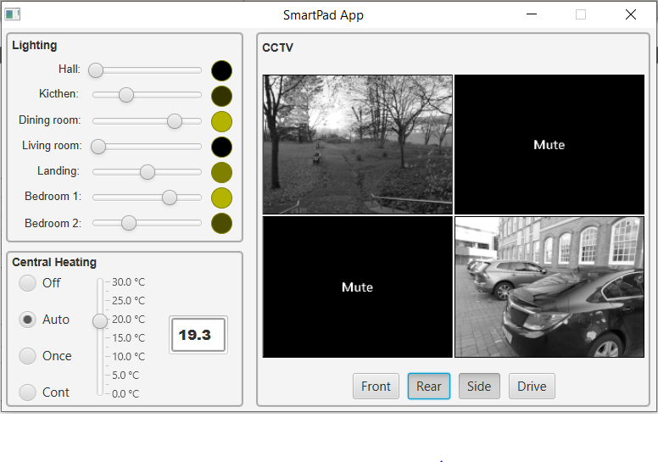

The mouse on drag method has been used in this event handler therefore, when you drag the slider the colour of the circle changes.

When you click on the button the image changes, and when you click on it again the images changes back. This is where the onclick method has been used to perform this action.

*(Figure 21 – Event Handlers Example)*

There are four different ways in JavaFX of how you can use the event handlers to perform your actions on the GUI components. Those four different ways are the following which you can witness below:

External classes – you can see an example of that in figure 21.1.

This is the main JavaFX program where the object has been created called ‘handler1’ using the external class. On the object created the setOnAction() has been applied when the button is clicked it performs the event. setOnAction() means on click.

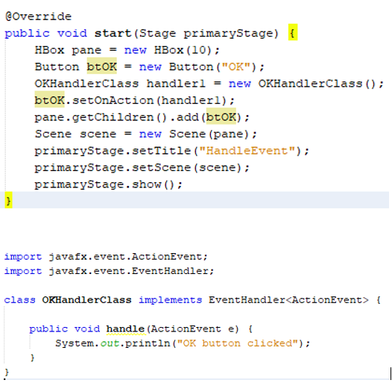

External Class where the event has been created. The event is printing a simple message to the console. But, inside the function handle is where you add your code to perform the event. For example, develop functionality to pay bills for a business.

*(Figure 21.1 – External Class Example)*

Inner classes - you can see an example of that in figure 21.2.

This works exactly the same way as; I have explained above for the external class. The procedure is exactly the same the only difference is that it uses an inner class this time instead of an external class.

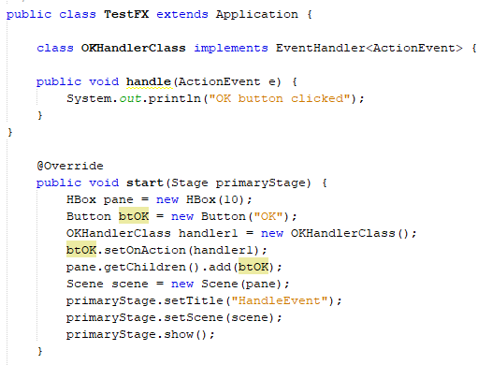

*(Figure 21.2 – Inner Class Example)*

Inner classes are nested within the main Java class. *“We use inner classes to logically group classes and interfaces in one place so that it can be more readable and maintainable.” [39]*, and *“it can access all the members of outer class including private data members and methods.”* *[ibid]*. The advantages of using them are the following requires less code which optimizes the code, *“Nested classes are used****to develop more readable and maintainable code****because it logically group classes and interfaces in one place only.” [ibid]* and, *“Nested classes represent a special type of relationship that is****it can access all the members (data members and methods) of outer class****including private.” [ibid]*. The inner classes can be used in Java and JavaFX they are not just part of JavaFX.

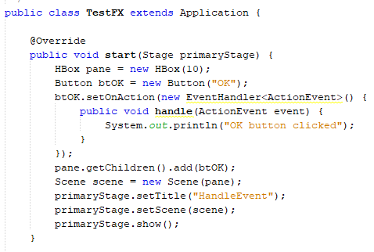

The event handler is added onto the button.

The event handler which includes setOnAction() and the method handle will be added directly into the stage method instead of the external or inner class. The event handler will work the same way as it will add the event on the button direct not via an object.

*(Figure 21.3 – Using it directly in the stage method example, also known as* anonymous class*)*

Note: for external, inner, and anonymous classes we have to import the class called import javafx.event.EventHandler to make the event handler work without that these 3 methods of event handling will not work in any case.

Lambda Expression – Whereas, for this last method I am going to explain is a lambda expression which does not require this javafx.event.EventHandler or javafx.event.ActionEvent in fact it doesn’t require an event handler or action event because, you can directly set the action on the GUI component.

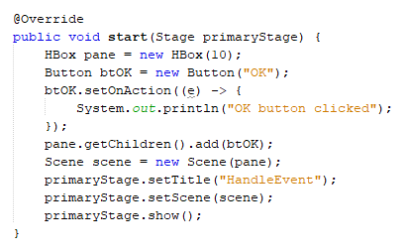

This is a lambda expression which is used for directly setting the action event on the button as you can see in figure 21.4. The code which goes in-between the lambda expression is what is going to be executed on the click of the button or in fact any other setting e.g., mouse drag. This is the best way out of the three the reason being, it uses less code which improves the modularity of the code. Therefore, it will be easier to understand in future for updating and maintenance development.

*(Figure 21.4 – Example of Lambda Expression)*

SetOnAction() is one type of an action which is performed on click but, there are a variety of other actions which can also be used to perform actions different. Those are the following: on touch, input and keypress, mouse dragged, slider drag, on rotate, and on swipe. These are all the other methods which can also be used on GUI components to perform actions differently. Obviously, you have to choose the appropriate ones e.g., for sliders you need mouse on dragged.



*(Figure 21.5 – Examples of Actions)*

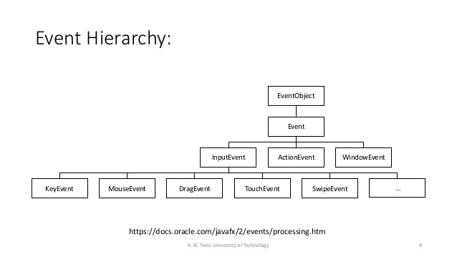*[40]*

*(Figure 21.6 – The different types of Events)*

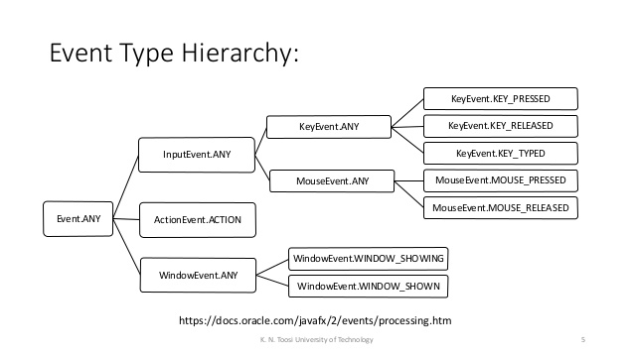*[ibid]*

*(Figure 21.7 – The different types of Events)*

In figure 21.6and 21.7 you can see view the event hierarchy for the different type of events which are used in JavaFX.

Java programming language is used in many well-known software’s especially because *“Java is highly prized for Android development partially because large parts of the Android OS itself were written in Java, and because its APIs are designed for Java” [41]* therefore, this shows that the Android OS is very close to Java. These are the following applications which use the Java programming language for their application development: Twitter – *“Twitter has used Java for all of its Android app development needs, primarily because the language works so smoothly across different devices and because it is one of Google’s two accepted languages for mobile apps” [ibid., 37]*, Spotify – *“That’s because Java is one of two official Android development languages and because Android’s APIs make Java development a much simpler and straightforward process.” [ibid., 37]*, Signal – *“The founders likely chose Java because of its dominance in the Android development community and full arsenal of out-the-box security tools, including class declarations, structured error handling, and code reusability” [ibid., 37]*, and CashApp – *“Cash App’s Android application uses Java for most of its code. That’s because of the language’s flexibility across device and out-the-box security features, which are especially important when dealing with bank accounts. These include its nonuse of pointers, Bytecode, and access control functionality” [ibid., 37]*.

*“Java has dominated the Android mobile app market since the OS was founded in October 2003. The language has been prized for its ease-of-use and flexibility, and because so many software developers are familiar with the language” [ibid., 37]*. Java is very popularly known for software engineering. Since 2003, Java has developed many projects as you can see below in figure 22 projects per language.  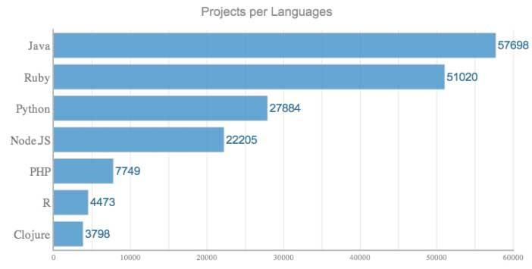*[ibid., 37]*

*(Figure 22 – Java Projects per Languages)*

There are also a variety of real-world software’s e.g., desktop applications which have been built using JavaFX. I will show a couple of examples below:

Quote Monitor – “*For monitoring the prices of commodities that we were holding and tracking our profit and loss in real time we created the “Quote Monitor” application which would be able to monitor prices in real-time and send out alerts if the profit/loss amounts hit predetermined levels. This application interfaced with Interactive Brokers Java API in order to retrieve commodity prices in real-time from the various commodity exchanges” [42]*.

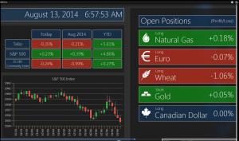*[ibid]*

*(Figure 23 – Quote Monitor JavaFX Desktop Application)*

MINT Trams – *“MINT TRMS is used by Airlines to schedule and administrate the training for its personnel. Training requirements are captured and allocated to the available resources. This is a very important topic in the aviation domain, as only qualified personnel are allowed to maintain or fly aircrafts. This client/server application had complex lazy loading requirements which could all be solved by using JavaFX” [ibid., 38]*.

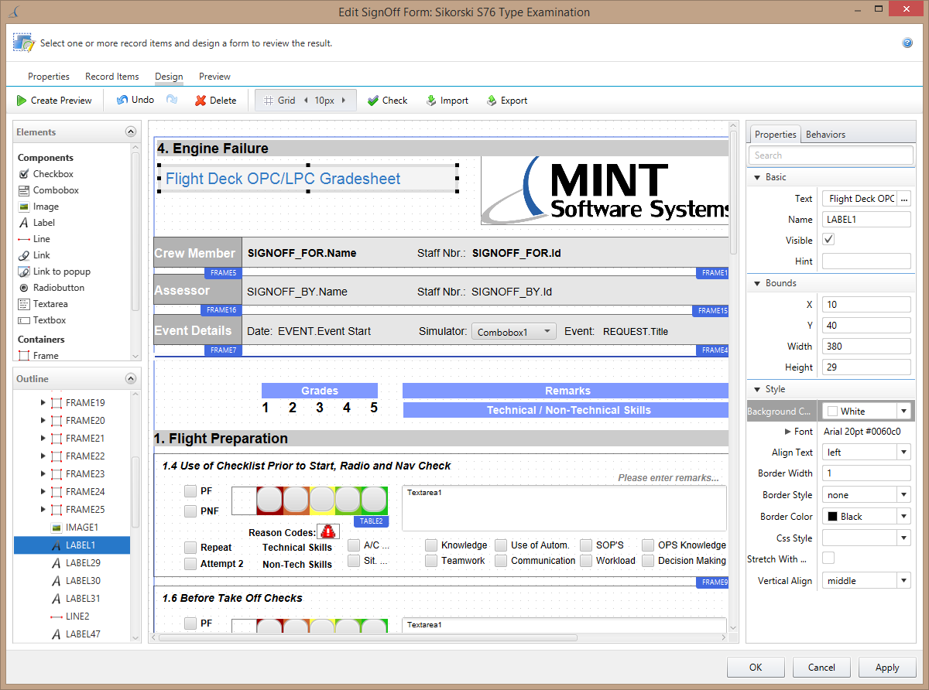*[ ibid., 38]*

*(Figure 24 – MINT Trams JavaFX Desktop Application)*

As, you can see in figure 23 that the GUI is developed using JavaFX. This Quote Monitor software has used JavaFX features such as: layout panes for its design to develop the GUI design and event handles to perform its actions. Figure 24 shows the example of MINT Trams software which is also developed using JavaFX using its features and function e.g., layout panes and also its sources mentions that the *“client/server application had complex lazy loading requirements which could all be solved by using JavaFX” [ibid., 37]* features e.g., JavaFX also provides loading features such as: loading bar. There are also other types of software’s which also use JavaFX for their desktop application development, loading, and event handling and, those are the following: Navigator Lynden, CuratorOR Caliop EIZO GmbH, Atlas Trader, Template Editor IAV, FORUM Carl Zeiss Meditec AG, AIDA German AIDS Foundation, MuseoID Museum Palaeontology of URCA, HRC-Matic AISO, and NEOS – New Eurovision Operations System EBU, etc.

## **MySQL**

MySQL is an open-source RDMS (Relational Database Management System) which *“started out with the intention of using the mSQL database system to connect to our tables using our own fast low-level (ISAM) routines. However, after some testing, we came to the conclusion that mSQL was not fast enough or flexible enough for our needs. This resulted in a new SQL interface to our database but with almost the same API interface as mSQL. This API was designed to enable third-party code that was written for use with mSQL to be ported easily for use with MySQL.*

*MySQL is named after co-founder Monty Widenius's daughter, My.*

*The name of the MySQL Dolphin (our logo) is “Sakila,” which was chosen from a huge list of names suggested by users in our “Name the Dolphin” contest. The winning name was submitted by Ambrose Twebaze, an Open Source software developer from Eswatini (formerly Swaziland), Africa. According to Ambrose, the feminine name Sakila has its roots in SiSwati, the local language of Eswatini. Sakila is also the name of a town in Arusha, Tanzania, near Ambrose's country of origin, Uganda.” [43]*.

MySQL is a database management system. MySQL can be used for simple things e.g., a simple list of data for shopping, or even something very complicated e.g., *“vast amounts of information in a corporate network” [ibid]*. A major benefit of MySQL is that its open-source which means that it can be downloaded from its website without paying anything this is good for small business because they are not known to be super-rich as, a result this would be useful for them as they don’t have to pay anything. *“To add, access, and process data stored in a computer database, you need a database management system such as MySQL Server. Since computers are very good at handling large amounts of data, database management systems play a central role in computing, as standalone utilities, or as parts of other applications.” [ibid]*.

MySQL databases are relational. *“A relational database stores data in separate tables rather than putting all the data in one big storeroom” [ibid]* this way the database structure is kept organised *“into physical files optimized for speed” [ibid]*. It has a good logical model which includes databases with tables, views, rows, and columns which makes it *“flexible for the programming environment” [ibid]*. In relational databases you set different relationship rules *“between different data fields” [ibid]* which includes one-to-one, one-to-many, many-to-many, many-to-one, recursive relationships, unique, required, and optional. There will be pointers used between the different tables in the database which you can see in figure 24 below:

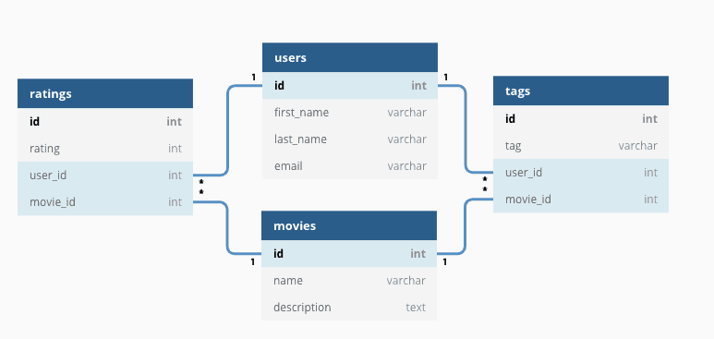

*(Figure 24 – relational database with relationships example)*

This way the database is well-designed, *“your application never sees inconsistent, duplicate, orphan, out-of-date, or missing data.” [ibid]*. This will be good for my project the reason being, it will keep the database will designed enforcing it with the set of rules I’ve mentioned above. The advantages of RDMS in terms of businesses are the following: increased flexibility, increased performance and scalability, reduced information redundancy, increased information integrity, and increased information security. In addition to that, it is much easy to understand and find data when required.

MySQL is known to be very fast, reliable, secure, and very easy to use. *“MySQL Server can run comfortably on a desktop or laptop, alongside your other applications, web servers, and so on, requiring little or no attention.” [ibid]* and this is known to be another good advantages for my project because my idea is to run two application a Business Inventory management system and a content management system to manage and view the data in detail therefore, both applications on the business owner desktop can work alright as, it has the ability to run alongside other applications. For MySQL, the business owner can also use a separate desktop as they would just have to *“adjust the settings to take advantage of all the memory, CPU power, and I/O capacity available. MySQL can also scale up to clusters of machines, networked together.” [ibid., 40]*. This way the business owners can manage data on a separate machine to keep it even easier for themselves that can be considered as one idea as well.

*“MySQL Server was originally developed to handle large databases much faster than existing solutions and has been successfully used in highly demanding production environments for several years.” [ibid., 40]*. After so many years, MySQL server till today provides a range of very useful tools and functions. MySQL server has a very good speed, security, and connectivity which makes it *“highly suited for accessing databases on the Internet.” [ibid., 40]*.

MySQL can also work in client/server or embedded systems, *“MySQL Database Software is a client/server system that consists of a multithreaded SQL server that supports different back ends, several different client programs and libraries, administrative tools, and a wide range of application programming interfaces (APIs).” [ibid., 40]*.

As, I’ve mentioned before MySQL is very easy to understand and use. When, you software goes under maintenance then, the MySQL language DML and DDL can be understood very easily because its uses a very easy syntax. The different types of queries in MySQL allows to meet my project requires such as: storing data for suppliers, stocks etc, searching data for stocks, suppliers, etc, viewing data with the query feature of ordering results by ascending and descending order, and also it uses aggregate functions which includes sum, min, max, count, and average and these can be used for doing some mathematics calculation e.g., in a business you can use aggregate functions to calculate some of you mathematical data such as profit and loss and update the query with the new data. You can see some examples below:

**SELECT * FROM Stocks** – this can be used to display all the data in the table. You can search for full data.

**SELECT Chairs, Glasses FROM WarehouseEssex** – this can be used to display some data from the table. This way you can search for some data.

**UPDATE Customers  
SET ContactName = 'Alfred Schmidt', City= London  
WHERE CustomerID = 1** – this can be used to update data such as the address of the customer has changed.

**DELETE FROM Customers WHERE CustomerName='Alfreds Futterkiste'** – Deleting the data from the database.

**SELECT MIN(Price) AS SmallestPrice  
FROM Products** – this is a query which is used for selecting the smallest price from the whole stock.

**SELECT position , AVG(salary) FROM Staff GROUP BY position** – this uses an aggregate function but, it’s very simple you could do a complexed query using these to perform a more complexed mathematical problem.

**INSERT INTO Warehouse VALUES ( ' East_London ' , ' 3 New Rd ' , ' London ' , ' XR5 6YU ' )** – this can be used to insert data into the table.

Above, I have shown all the different types of queries as, you can see the syntax is not that difficult it can easily be understood once, you know what you are doing. As, I’ve mentioned before that using the JDBC, MySQL database can be connected easily to the database using its driver. Therefore, in the java program these are the types of queries which will be executed with the java program. For example, for my project I have a add new stock section then, I will click on the text box to type and press the button to add, when I press the button add then, that add button will have an insert SQL query which will execute the query and add the data to the database.

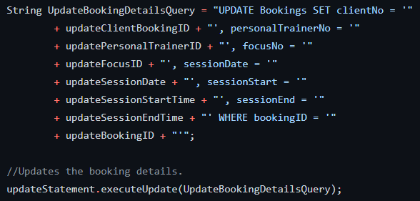

These in white text are the variables used in java to set the data, and these variables are used in the query therefore, its stored into the database.

In blue its all the SQL query text with the field names from the database.

*(Figure 25 – Example of an SQL query in Java-JDBC program)*

Figure 25 shows that how a query can be written in a Java program when it’s using JDBC. Therefore, the query in figure 25 is connected to an update button therefore, when the update button is pressed on the GUI software after that, it will add the data from the variables onto the database.

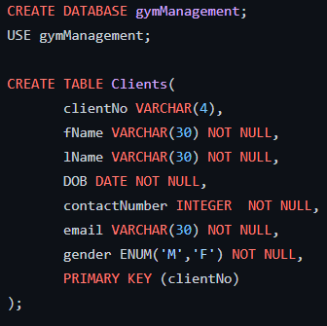

*(Figure 26 – SQL DDL Language to create a database)*

In figure 26 you can see the SQL data definition language which is used for creating tables for the database. DDL is a language where you would create your database model such as tables, data fields with the different types of datatypes, setting the primary key and foreign keys. The syntax is straightforward to understand as well.

MySQL uses a variety of datatypes, which is used for storing data in that particular datatype for example, if you want to store a number for the price then, you can easily use Integer which will recognise it as a number. The other datatypes are the following: Integers – Tiny Int, small int, medium int, big int, and big. As, you can see it gives you a variety of options to store your numbers depending on any size of your number you can choose your datatype. Text – varchar(30) which is commonly used for storing text and the number is used to set the length of the text, there are also others such as: char, long text, medium text, and small text for also storing data. There are also datatypes for storing in in the time format for example, if you want to store a date and time. The ENUM is used for giving you options to select one out of the two options just like a selection or voting system. It also provides with other types of data including the storge of binaries, geometric mathematics, and decimals. Therefore, an advantage is that it provides you with a range of datatypes therefore, you can store your data with the most appropriate datatype which will match.

Another benefit is that you don’t always have to write the SQL DDL code yourself as, you can use open-source administration tools to build your database e.g., tables and relationships. Those tools include the following: HeidiSQL, MySQL Server, and PostgreSQL etc. These software’s provide you with GUI interfaces which allow you to create your database manually without doing any programming. You can see the figures 27.1, 27.2, and 27.3 to see how they roughly work.

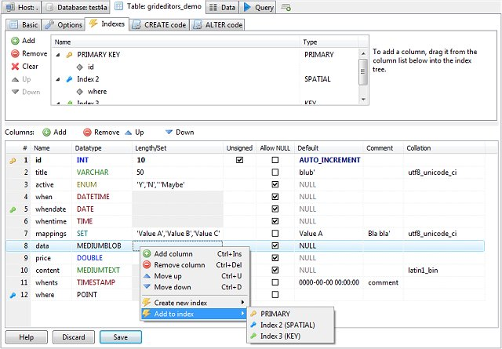

*(Figure 27.1 – HeidiSQL GUI Interface)*

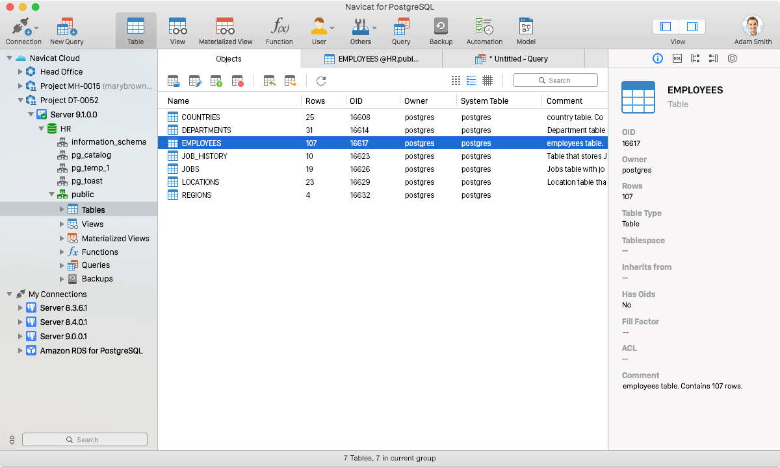

*(Figure 27.2 – PostgreSQL GUI Interface)*

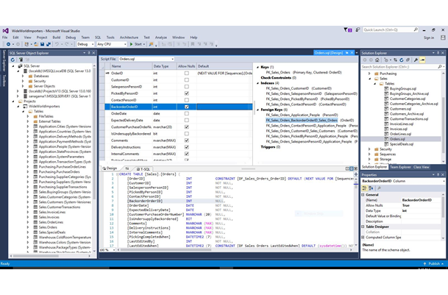

*(Figure 27.3 – Microsoft MySQL Server GUI Interface)*

*“Third-party proprietary and free graphical administration applications (or "front ends") are available that integrate with MySQL and enable users to work with database structure and data visually.” [44]*. The advantages of using these are that using those you can build the database very quickly. You just have the design e.g., ERD diagram therefore, you just use that to develop your database using the GUI software interface. These are the other types of GUI software’s: Adminer, Database Workbench, DBeaver, DBEdit, TablePlus, LibreOffice Base, Navicat, OpenOffice.org Base, phpMyAdmin, SQLBuddy, SQLyog, Toad for MySQL, and Webmin etc.

Backup and recovery of data is extremely important factor of my project. As, I have mentioned before that backing up of data is extremely important for business as, this is one of the reasons which can lead them to bankrupt. *“MySQL offers a variety of backup strategies from which you can choose the methods that best suit the requirements for your installation” [45]* and those include the following: *“Types of backups: Logical versus physical, full versus incremental, and so forth. Methods for creating backups. Recovery methods, including point-in-time recovery. Backup scheduling, compression, and encryption. Table maintenance, to enable recovery of corrupt tables.” [ibid]*. There is a tool called **mysqldump** which can be used to perform different versions of backups for your database. *“The****mysqldump****client utility performs logical backups, producing a set of SQL statements that can be executed to reproduce the original database object definitions and table data. It dumps one or more MySQL databases for backup or transfer to another SQL server. The****mysqldump****command can also generate output in CSV, other delimited text, or XML format.” [46]* and it also generates an .SQL file. Therefore, this is a great advantage as, you can perform those regularly and keep different versions therefore, your data is kept secured. The different versions of MySQL dumps file can be uploaded onto the cloud services e.g., Google Drive therefore, they are kept safe on the cloud and there is no risk of computer or hard disk fail/damage.

MySQL is used by many well-known industrial web-applications which includes the following: *“Drupal,****Joomla****, phpBB, and****WordPress****. MySQL is also used by many popular websites, including Facebook, Flickr, MediaWiki, Twitter, and YouTube.” [ibid]*. It’s also being used a lot around many multi-national industries as well and one example is *“BBC news” [47]* for their applications.

## **FTP-Server**

FTP (File Transfer Protocol) is known as a server which is used for transferring files across the internet. When you send files using the FTP-Server then, the files are uploaded onto the server, and they are also downloadable from the server. The business owners can use it to transfer their database data from their own personal device to the server. The server can be accessed from another computer because *“two computers to one another in the safest possible way to help transfer files between two or more points. To put it simply, it’s the means by which files are securely shared between parties.” [48]*.

FTP-servers can be considered as a solution to *“facilitate file transfers across the internet” [ibid]*. When you upload files, the files will be transferred from the computer to the server. When you want to download files, for this case the server can also be accessed from another computer, the files will be transferred from the server to your computer. *“TCP/IP (Transmission Control Protocol/Internet Protocol), or the language the internet uses to execute commands, is used to transfer files via FTP.” [ibid]*.

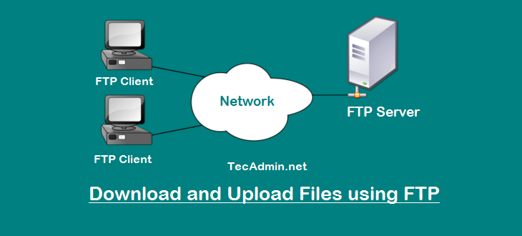

*(Figure 28 – Download & Upload Files using FTP)*

As, you can see there are 2 computers and one server which are connected. Therefore, you can upload one file to the sever from the first computer. After that, you can download the same file from the second computer. This works the same way no matter how many computers you use. You only need to have the network configuration done in the PC and the server can be accessed by the web link by the username and password, and in addition to that it makes your system and server more secured.

*“FTP servers can be considered the midpoint between the sender and the recipient of a file. For FTP servers to work, you need the server address.” [ibid]*. This is a following example of the server address <ftp://192.168.56.1> which is in a numeric form as its using the IP address. You can also do more advanced configuration in your setup to have a better web address such as: **‘ftp.businessmanagement.net’**. Therefore, once you do all the complicated settings then, it’s quite easy to access the server for example, business owners only need to hire people to set up the FTP-server for them after that, they can easily access it as it only requires a web address which people normally use in these modern days.

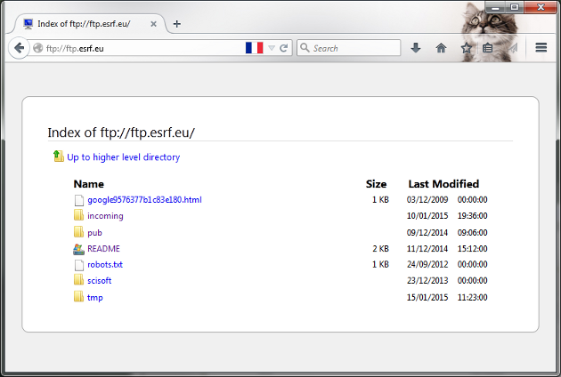

The user needs to click on the file to download the data onto the PC therefore, the user can view it. If the user clicks on the ‘tmp’ folder then it will download onto the machine. This works the same way for all the files on the server.

These are the files which have been uploaded to the server from the client previously. These files are currently here on the server.

This is the web address used to access the servers.

*(Figure 29 – Example of FTP on the web)*

These are the following advantages of why I decided to use the FTP-Server:

**Security** – this is the biggest advantage of using the FTP-Server because, it has the best level of security compared to other options and, according to one of my main project requirement is to keep the data secured and this will support me in doing that as they provide a range of options for security. The FTPS and SFTP which are both secured as they are encrypted and, the FTP-Server is adding *“another layer of security to traditional FTP transfers” [ibid., 45]*. The FTP-Servers are supporting the FTPS and SFTP for protecting their data even better when its being shared e.g., uploaded. Therefore, you have a guarantee that you files being transferred won’t get stolen, lost, or other third-parties won’t intercept during the transfer, it will also protect from malwares and viruses during the transfer as, when the FTP-Server is managed *“the expert vendor is responsible for providing the security necessary to keep data safe.” [ibid., 45]*.

**Control** – you have a great level of control over data. A variety of FTP-Server are offering access control rights which only allows your administrator to decide who is allowed to upload, edit, download, share files, or delete on the server and who is not and, in addition to that the administrator can set permissions for certain folders. Creating access right is a great feature the reason being, in a business only the owner can be the administrator of the FTP-Server where the owner himself has access to all the data regarding the business whereas, he can restrict other employees to just certain data only for example, the employee can only view the data for the stocks as he requires that to do his job but, he has nothing got to do with the suppliers that’s why its restricted for the employees because, that data is only relevant to the owner. Administrator controlling files and creating a control access level based on the user accounts can make your data files more secure.

**Large File Sizes for Data** – In business you need to transfer data many times such for doing stock counts you suddenly need to send the data to the employees therefore, doing that via an email would not be effective enough as, it restricts your to 32MB only but, having large data for stocks will have a very large file size as, a result *“you can use an FTP server that enables you to send gigabytes of data all at once.” [ibid., 45]* this way it won’t interrupt your sharing process as, a result this is a negative impact which will be avoided.

**Improved Workflow** – As, I have mentioned before that businesses spending time to find ways of how to send their data bit by bit will result in a negative impact for the business as, its taking time off business to concentrate on another area which is very unnecessary. Therefore, you need to find a way which will send and share all the data in one go instantly where the business can *“continue to work while large transfers are being made or schedule massive transfers for nights or weekends, so your workflow is not interrupted.” [ibid., 45]*. FTP-Server only has one location where you can store all your data files which is another advantage the reason being, it will reduce the time searching for the data file in different locations and in addition to that, storing everything in one location will reduce the chances of data files being lost as, one of my may gaol as I’ve motioned several times is to keep data secured and make sure that the data is not lost else it will cause serious consequences for businesses.

**Disaster Recovery** – This is the most important factor of my project and perhaps one of the main reason of why I decided to do research and develop this project about ***‘A Modern Business Inventory and Management System for Small Businesses to manage and avoid potential disasters.’*** As, you can see from the title that the project is about avoiding disasters in small businesses.

In this 21st century you never know what will happen at any time of the year for example, there may be a sudden issue or a disaster which can lead to data loss but, when you use the FTP-Server, then *“your vendor can ensure that your files are never lost, from your everyday data to your most important and sensitive files.” [ibid., 45]*.

When a disaster occurs such as: internet connection interrupted, power loss in the on-site building, or a natural disaster e.g., flood, earthquake, tsunami, heavy snow, or etc. When businesses are using an FTP-Server then, they don’t have to worry about their losing their data. The reason being the businesses data files are automatically backed up on the server which is a different location. In addition to that, FTP-Server provides you with a process to restore your data as well plus you can download the data from a different location for example, the owners office/shop machine might be destroyed but, the owner can still access their home machine to access the server to view and download their data and, their data will be the same as the disaster won’t affect the data. Therefore, the businesses will still have their data which is very important because, they can still keep the business continuity going from another location, you can see this architecture in the figure 28 which will support you in understanding how the servers can be access from different client machines. *“Storing your data in secure locations gives you the confidence that it will be safe from disaster or compromise.” [ibid., 45]*. Using FTP-Servers *“allows you to make the best decisions possible about your data.” [ibid., 45]*.

Java programming language allows creating an FTP-Client. This way you can use a Java program to send your files over to the FTP-Server. You can also develop your own file and write in it using the file reader and writer classes and then send it to the FTP-Server via the Java program.

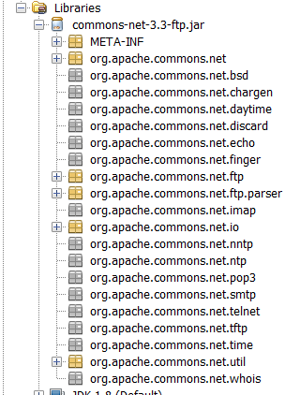

Figure 30 shows the JAR file added to the java program library which enables all the classes for using the FTP-Server components in your java application.

*(Figure 30.1 – API JAR file of FTP-Server)*

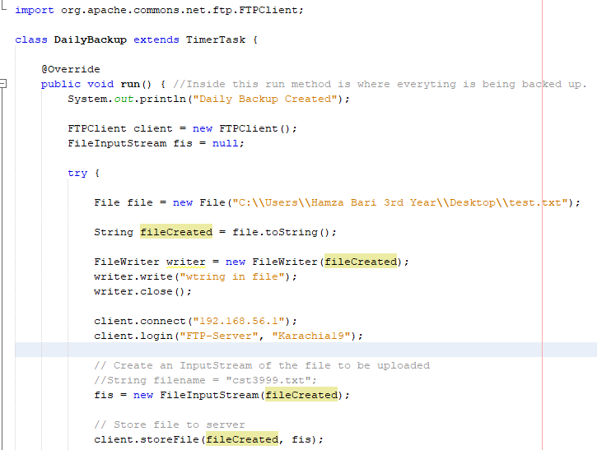

6. This is a method to logout of the server when the file has been sent to the FTP-Server.

5. Store your file to the FTP-Server this way your file will be in your FTP-Server you will be able to view it when you login from your web browser.

3. A file is accessed from the desktop.

4. You connect using your web address link which is the IP address for this case and login using your server FTP username and password. You don’t have to hardcode your password, I have done it just to show an example as there are ways and techniques that you can develop in java to keep this secured e.g., reading from a file, or using regular expressions and substrings.

2. This is where an FTP-Client object is created.

1. This is the class which is imported from the library to enable a connection for an FTP-Client.



*(Figure 30.2 – Example code of FTP-Client Connection)*

## **Java vs Python**

Both programming languages have some similarities such as both languages are free and open-source, cross platform-independent, and they both have a large support of libraries for different programming tasks. Both of them have differences as well such as java is a complied language whereas python is an intercepted language, the files for java are created once the runtime ends whereas in python it creates the file during the runtime. Java is statically typed which means you need to initiate the variables types each type as it will check those during the runtime whereas, python is dynamically typed meaning that the variables types don’t need to be initiated as it will do it automatically during the runtime. Python only has a runtime error whereas Java has runtime and compilation errors. Number of classes: Java – *“Only one public top-level class can exist in a single file in Java” [49]* and Python – *“Any number of classes can exist in a single file in Python” [ibid]*, Java involves writing more code compared to python. Java has a stricter syntax as, *“Every statement needs to end with a semicolon (****;****), and blocks of code are separated by curly braces (****{}****)” [ibid]* whereas, python *“Blocks of code are separated by indentation (the user can choose how many white spaces to use, but it should be consistent throughout the block)” [ibid]* therefore, you can understand that Java has a stricter syntax then, python and this is one of the reasons why python is considered the best for beginners but, I would prefer Java in this case the reason being, stricter syntax leading to more errors and the programming spending time fixing the errors and syntax makes them a better programmer and I am saying this because of my own personal experience whereas, in addition to that you understand the syntax better whereas, with python you may be able to build programs quicker with less error and easier syntax rules but, that doesn’t make you a better programmer for future. Multiple inheritance: Java – *“****Java****does not support multiple inheritance (inheriting from two or more base classes)” [ibid]* and python *“****Python****supports multiple inheritance although it is rarely implemented due to various issues like inheritance complexity, hierarchy, dependency issues, etc” [ibid]*. In terms of multi-threading python only allows single thread to run one at a time whereas Java supports *“two or more concurrent threads running at the same time” [ibid]* and for my project I require threads running at the same time because my back-up system of the database depends on multiple threads running at the same time to backup data to the FTP-Server as, with python I could not do that. At, last the execution speed of programs are much faster in Java compared to python as, python is slower at executing programs and usually its better if execution time is quicker because, functionally will be quicker in the application. Apart from that, both languages are good in their own way and both languages have been ranked the highest in terms of application programming *“such as accounting software, media players, and word processors. Java, Python, and C++ are among the common languages used to create apps.” [50]*.

## **MySQL vs SQLite**

*“SQLite is a library that gets embedded inside the application that makes use of it. It offers an amazing set of tools to handle all sorts of data. As a self-contained, file-based database, SQLite can be compared to hosted alternatives, like MySQL.” [51]*. Both MySQL and SQLite have certain similarities and differences for example SQLite only supports these data types which include *“Integer, text, null, and blob” [ibid]* whereas MySQL supports more data types then SQLite which include the following: *“NUMERIC, DATE, DATETIME, TIMESTAMP, NTINYTEXT, BLOB, TEXT, MEDIUMBLOB, MEDIUMTEXT,TIME, YEAR, CHAR, VARCHAR, TINYBLOB, TINYINT, SMALLINT, MEDIUMINT, INT or INTEGER, BIGINT, FLOAT, DOUBLE, DOUBLE DECIMAL, LONGBLOB, LONGTEXT, PRECISION, REAL, ENUM, and SET.” [ibid]*. Therefore, you have more regarding datatypes when you use MySQL compared to SQLite. In my project I require datatypes for data and time which MySQL can provide me not SQLite. SQLite is file-based meaning, the database will only contain a single file on the computer hard-disk *“which makes it extremely portable and reliable” [ibid]*. SQLite can be used for *“developing and testing and offers more than what is needed for development” [ibid., 49]*. MySQL is easier to work with for example, the installation is easier, it uses third-party tools which makes the database simple to get started with, it has more features and function such as for backups e.g., sqldump which I have mentioned in the MySQL section. MySQL *“supports a lot of SQL functionality that is expected from an RDBMS” [ibid., 49]*, its more secured, it has the ability to handle large data and *“can be used at-scale” [ibid., 49]*. MySQL has a better speed which makes it work *“efficiently and effectively” [ibid., 49]* compared to SQLite. SQLite is much secured compared to MySQL the reason being, it has *“****No user managemen****t: Advanced databases make user support a high priority. SQLite doesn’t support such features” [ibid., 49]*, not good for increased performance: The library is quite simple to use and you can’t really play around with its design therefore, *“you can't really tweak it further” [ibid., 49]*. In terms of the reliability for MySQL and its design, I have discovered that MySQL would not do everything for you as, it has just about had the feature and functionality which is useful and required by the development of an application. At, times MySQL can be a bit unreliable the reason being, during my research I found that some users have complaints about the development process. SQLite can be used for application which will require *“portability and don’t require expansion” [ibid., 49]* or if you want applications to read and write files directly to the hard-disk, and SQLite supports more programming languages compared to MySQL. MySQL can be used when you want very high security features for your data access and, high security of data is required for small businesses and once again this is my main goal of the project to keep the data secured for small businesses to keep their business continuity going. MySQL is also very scalable and easier to manage because, in projects there will be expected updates and team changes therefore, you require tools which can be managed easily. As, last, I will say both MySQL and SQLite are good in their own ways it’s just the fact that, MySQL will be better for my project in terms of the project analysis and design.

## **Hard disk vs Server Storage**

I understand the fact that when using hard disks you have more ease of use as its very commonly used and by using the external hard disks e.g., USBs the users can easily take it out of one machine and put it into another which makes it portable. I also understand that users will use hard disk for extra space on their computers as, the users have the flexibility to buy different external hard disks for different types of capacities which can be used to for storing large types of files e.g., videos and images as, some external hard disk come with 1TB data which can be useful for many different types of people for example, people who work on photo editing, and there are some types of external hard drives which can be bought cheap of cost. Therefore, it has great advantages but, uses need to realise the drawbacks and its negative impacts as well. Hard disks can be lost very easily, in many cases the data can be corrupted, less secure as it can be lost or stolen, and some else might get your data e.g, if this is a business then, your data can be seen by other companies this will result very negatively because, losing your data can result in a major loss for your own business whereas, it can benefit the other business as they might use your plans for their success such as high profits margin, and finally as, I have mentioned before disasters e.g., fire or any natural disaster like earthquake can occur anytime of the year which can also destroy your hard disk. All of these negative impact result in data loss. Whereas, if you use an FTP-Server which is a type of server-side storage then, these negative impacts won’t affect these issues in Hard-Disks the reason being, the data you transfer to the server would stay in the server location therefore, if your location is damaged due to a disaster e.g., fire then, you can recover your data through the server. FTP-Server also provides an extra layer of security and access rights therefore, no one can edit or access your data without your permission, and your data will be secured while being transferred as, I’ve mentioned in the FTP-Server section above, about the security. As, I have also shown that, how you can create FTP-Client using Java and then, using threads which run automatically to send the files to your FTP-Server over the network. You can access your files from different locations but, the only hassle is that you would need to configure the FTP-Server on each location you set-up and the configuration can be complicated as, a result if you hire someone then, that will cost the business money. Adding on the fact regarding support as, I mentioned my previous point about configuration but, you also need support therefore, it will even cost more if you keep calling the technicians or experts to deal with the FTP-Server and you have to understand the fact that small businesses will sometimes be in a loss therefore, every cost at times can to vital to them. In addition to that, internet connection is very important for FTP-Servers because *“If you are on a slow network you may have issues accessing your storage. In the event you find yourself somewhere without internet, you won't be able to access your files” [52]* this can be a major issue at times the reason being, businesses require their data at a certain time such as dealing with a customer or supplier therefore, the internet connection is important. Apart, from that I would still prefer the FTP-Server over the external and local hard-disks because, the internet can be recovered as, it’s a on and off situation and the business won’t face a major loss if they can’t access the data at a certain time then losing all the data they have and at last I want to add is that no technology perfect as, everything always has its drawbacks in some ways you just have to analyse and choose the best technologies and decide which factors will affect the project negatively and which factors won’t as much because, nothing is perfect.

# ***Requirements Analysis & Design***

## **Purpose of the project**

The purpose of this analysis and design section is to design my ***‘A Modern Business Inventory and Management System for Small Businesses to manage and avoid potential disasters’*** software. Then, using this software design to develop my project using the required technologies.

## **Target Audience**

This modern business inventory and management system is very useful for owners who are managing small businesses and in addition to that, it can also be useful for employees who are working within the small business.

## **Project Scope**

The purpose of this modern business inventory and management system software system is to manage and sort business inventories with more ease, search for the inventories with more ease by just using a code to search the product, manage their suppliers and suppliers orders with more ease, manage their employees with more ease e.g., their job role and wages, keep the business continuity going during disasters as this application will have all the data, backup business data frequently, keeping a track record of businesses profit and loss where businesses can see where they are making a profit or a loss which will help them analyse and make changes if required, and create regular disaster recovery and business plans, save and also edit them which is useful technique for a business. This develops a convenient system and easy to use desktop application for business owners managing their business and supporting during disasters.

The software system (Desktop Application) is based on the backend content management system application which is a relational database which communicates with the desktop application to store and retrieve data e.g., this includes different types of data for example business inventories.

The content management system communicates with the FTP-Server. There will be a variety of server which will be connected with the business FTP-Server account, with those server you can access all the data from the CMS. The desktop application will also be designed considering some of the UX and UI techniques which will give users a great experience when using this software system.

Below you can see the sketch of the software system.

## **Software Architectural Sketch**

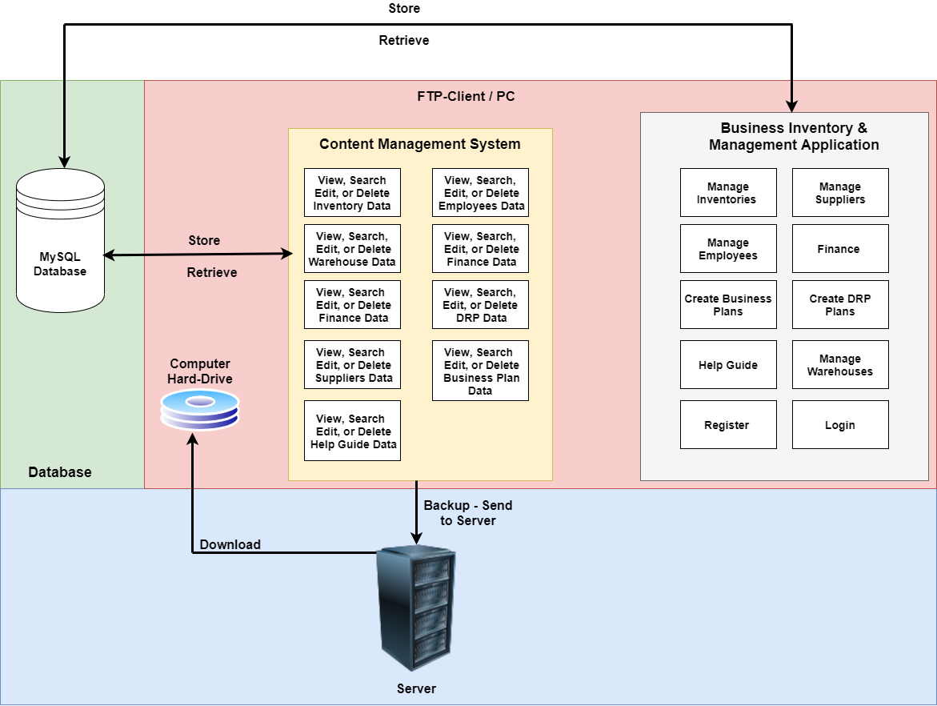

*(Figure 31 - Software Architectural Sketch with Communications showing the System Concept)*

Figure 31 shows the system concept, where you can view the architecture of our proposed software system. The software system is proposed to be used commercially by a variety of small businesses therefore, I have designed the architecture in the simplest way possible.

## **User Requirements**

These are the user requirements specifications which will specify what the user will expect the software to do. There are two types of users who will be using this software system and, those following users are: business owners and team of employees.

### **User Requirement List**

In the table below you can view the user requirement list:

|  |  |
| --- | --- |
| **User Requirement** | **How the Requirement will be met?** |
| 1. The system must have a Graphical User Interface. | I will use JavaFX to develop the graphical user interface, I will use the layout panes and CSS styling in JavaFX to develop and design my GUI according to the GUI wireframes. |
| 1. The navigation system must be intuitive. E.g., Each window will have a button to navigate back and forward, to the main menu and it will also have a logout button. | I will achieve this requirement by using the switch statement. As, I will assign each button to a case and, when that case is executed then, the window will change according to which window has been assigned to the case. For example, I will create a case named as, main menu, and inside that case I will add the code e.g., window.show(mainMenu) to the main menu case and then, assign that to the main menu button therefore, when the user clicks onto the main menu button then, the desktop application will navigate to the main menu from which ever window the user was on. This will be the same for all the other buttons including the exit/close application and the logout button. |
| 1. Registration System to register uses to use the application. | The registration requirement will be developed by using data validation if statements, which will check if the information added to the textbox forms are correct e.g., regular expressions and if statements will be used together for checking if the username validation or, is the password strong enough basically, checking the validity of all the input fields. If all of the data matches and are valid then, all the user information which he/she inputted in the input fields will be stored into the username. An, an if statement will also be used for checking if all the input fields have been entered and they, are not empty else it will return an error message on the screen. |
| 1. User authentication to access the application. | The username and password will be used to identify the user. A nested if statement will be used. The first if statement will be used to check if the username is registered to the database and if not then, it will return an error message on screen to alert about that. After that, if the username exists then, it will move to the next nested if statement which will check if the password for that account is correct therefore, if its correct then, it will access into the application otherwise, it will return an error message. |
| 1. Logout Functionality. | There will be a logout button. When the button is pressed it will automatically open the registration & login page and clear all the user details. Window. Open(Registration & Login) will be used to perform this requirement. |
| 1. Help Guide Documentation in the window. | All the text will be loaded from the database by using the select query. All the data will be added to the layout pane which would display it on the GUI window screen. |
| 1. Admin Rights for security and access for certain areas such as an employee user can only access some windows which is only require for his job whereas, owner user account can view everything and go on every form as, well as editing data. | This requirement will be achieved by developing two different types of navigation systems using the switch statements both, will be intuitive and work the same way which I have explain earlier in requirement 2. For example when an owner account logins then, the owner will have all the windows available to them and they can also perform edits but, when an employee logins into the application then, he will only be able to view certain windows and the employee would not be able to edit the data on the application. |
| 1. Supplier window with 4 sections. | There will be three section created in the supplier window which will be developed by the JavaFX layout panes to separate these three section into blocks which means one section, and underneath that another section. Those 3 sections are called: add/register a supplier, view supplier list, archive list of suppliers, and search suppliers. |
| 1. Add different Suppliers to the system with their details such as the type of suppliers. | This requirement will be achieved by the following: go to the suppliers window and then, input all the different suppliers details into the input text boxes which includes supplier id, supplier company name, supplier type (what sort of products they sell e.g. Coca-Cola drinks), quantity of products they have given. After that, once all the information is inputted into the text boxes then, press the add button which will store the supplier to that database. After that, the supplier registered would be placed under the section supplier list section. |
| 1. Delete suppliers by clicking a button. | This requirement will be achieved by the following: once the supplier has been placed into the supplier list section with its details then, next to the details will be 2 additional buttons which will be placed automatically and those 2 buttons are delete and archive/hide. The if statement will be used to perform this functionality. If the delete button is clicked then, it will perform the delete MySQL query e.g., **DELETE FROM `suppliers` WHERE `supplier_id` = ‘S001’;** Once, this query has been performed then, it will delete that supplier from the database and the window will be refreshed and, it won’t show that supplier. |
| 1. Archive suppliers by clicking a button. | The archive button will be used for hiding the supplier from the list. Another if statement will be used to perform this action. If the archive button is clicked then, it will perform 2 queries this time first would be to the insert into query which will add the supplier to the archive table and then, it will perform the delete query to remove it from the suppliers list. |
| 1. Restore the supplier. | In the archive supplier section you can view all the suppliers which you have archived. Therefore, similar as before, there will be a button assigned with the supplier detail and that, button called restore which, means you can click on the button to restore your supplier back into the supplier list. This will be done using an if statement therefore, when the user clicks the restore button it will perform the insert into query which will add the data into the suppliers table after that, it will perform the delete query to delete it from the archive list. |
| 1. Search for suppliers by their name or id. | In the suppliers list section there will be a button called search. If the button is clicked then, it will open a modal dialog window which will have a text box and a search button next to it. It will ask for the supplier name or a supplier id in the text box. You can input anyone of those, after that, you press the search button then it will perform the if statement therefore, if the supplier exits then it will place its information below the search bar otherwise, it will return an error message. It will search according to the select from query e.g., **SELECT Supplier_id, Supplier Name FROM Suppliers;** |
| 1. Order products from suppliers. Order System functionality required. | The order system will have its own window. A variety of GUI components will be used here which includes select dropdown list – to input product name and type, payments details with textboxes and date selectors, and the quantity, drop-down lists – to select product, supplier, radio buttons – to select payment type, date selector – select the data your prefer it to be delivered and the date for the card details, and buttons – to submit the order. The order will be saved to the database and at the delivery time it will add the products ordered into the products table by using the insert into query. |
| 1. Order history list. | All the order history will be listed using by using the **Select * From Order Details** query and a while loop to display all the results from the order details table and display them onto the GUI window. |
| 1. 4 warehouses windows and 1 on-site (shop) window required. | Each warehouse will have its own window and in addition to that, the onsite (shop) will also have its own window. These windows will be developed using JavaFX and their layout panes. |
| 1. Add stocks/products to the warehouses with their detail. | Each warehouses have their own Java classes. The products will be loaded onto an object constructor e.g., **Warehouse warehouse = new warehouse (Product Name – Glass ,Warehouse ID – W1, Warehouse location – Essex, shelf – C, number of the shelf – 3)**. These fields inside the object will also be loaded into the warehouse database table using the insert into query therefore, it also stores this to the database. |
| 1. Search stocks/products in the warehouses with their detail e.g., product name. | The achieve this search requirement the search query needs to be performed. In each of the warehouse window there is a search button which will open a modal dialog window. The dialogue window has a search bar and a button. In the search bar the user needs to input the product name and the click on the search button which will perform an if statement to check if the products exists or not, to check if it exists it will perform the search query. If it does exist then, it will display the product shelf location on the screen e.g., **Glasses, section C and shelf number 3** else it will return an error message. |
| 1. Archive stocks/products in the warehouses when products are unavailable. | If the product quantity gets to 0 then, you can press the archive button. When you press the archive button it will perform 2 queries first, the insert into query for adding the data to the archive table, and then use the delete query to delete the product from the warehouse. The archive table will display all its data in the archive list section of the software. |
| 1. Restore stocks/products in the warehouses when products are available. | If the product is available again then, you can click on the restore button to add your product back to the warehouse section from the archive list. The retore button in the archive list, which is executed by 2 queries. The first query is, insert into query to add the data back to the warehouse and then, delete query is performed to delete the product from the archive list so it’s not visible there anymore. Both, queries can be put into a method together and that method can be called when the button is pressed. |
| 1. Delete stocks/products in the warehouses by clicking the button delete. | The delete button will execute the delete query. For example, when the delete button is pressed then, it gets the product name field and inserts the field into the delete query and then the query gets executed which deletes the product from the warehouse by its name. |
| 1. Add stocks/products to the onsite location with their detail. | The onsite has its own Java class. The products will be loaded into an object constructor e.g., **Onsite onsite = new onsite (Product Name – Glass , Onsite ID – S1, Onsite location – Essex, section – A, Row – 4, number of the shelf – 5)**. These fields inside the object will also be loaded into the onsite database table using the insert into query therefore, it also stores this to the database. |
| 1. Search stocks/products in the onsite location with their detail e.g., product name. | The achieve this search requirement the search query needs to be performed. In the onsite window there is a search button which will open a modal dialog window. The dialogue window has a search bar and a button. In the search bar the user needs to input the product name and the click on the search button which will perform an if statement to check if the products exists or not, to check if it exists it will perform the search query. If it does exist then, it will display the product location on the screen e.g., **Shoes, Row 1, Shelf 3**, else it will return an error message. |
| 1. Delete stocks/products in the onsite location by clicking the button delete. | This requirement is needed when the products run out of stock in the onsite shop location therefore, you need to add more products from the shop to the warehouse. The delete button will execute the delete query. For example, when the delete button is pressed then, it gets the product name field and inserts the field into the delete query and then the query gets executed which deletes the product in the onsite by its name. |
| 1. Search employees details. | To search for employees there will be a search button which opens a search window which has a search bar and a search button. In the search bar you enter the employee name or id after that, when you press the button search it will perform a search query with the name that was inputted in the search bar. This is also where an if statement will be used to check if the employee exists or not therefore, if it does exist the query will be executed and it will display the employee details on the screen. If the employee doesn’t exist then, it will return an error message. |
| 1. Add a Job to the system. | There will be a java class for a job. A constructor will be used for storing the job details to the database. The details will be inputted by the user in the job window. The user would use the text fields to input their job id, data, and description and press the button save, by pressing the button save these details will be the data members of the object constructer. These data members will be added to the Job table of the database. |
| 1. Search & Delete Jobs. | To do this you use the search & delete window. The search bar will ask you for the job id. After adding the job id I would need to press the search button will perform a search query to the job id given. A data validation will be used to check if its correct or not and if not, it returns an error message. If its correct then, it displays the job name and the description. Below, there will be a delete button, if you press it then, that job will be deleted from the database. The delete query will be performed which will use the job id to perform the delete query to delete that job out of the software system. |
| 1. Assign employees to their job and set their salaries after they have registered. | This is a continuation from the previous requirement 23. When the user has searched for the employee then, with the details there are 2 extra GUI components which come along with the employees details and those are called assign job combo box and, a text-box to set the employee monthly wage. Therefore, the user would select a job id by using the combo box and set a monthly wage using the text box and then, click on the button save which will execute the insert into query as, that query will add the job id and monthly wage to fields to the employee database table. Therefore, the employee now has a job role and a monthly wage salary. |
| 1. Update employees details. | To update employees details there will be an update button which opens a window, which has an input fields to username and password. The employees will verify themselves if they want to update their details. Therefore, the if statement would be used for checking if the username exists as, well as the password is correct and if these are incorrect then, it will send an error message. If the details are valid then, all the employees input fields will be loaded inside the textboxes with their current details. The employees can then, edit their data fields and then, press the button update details. By, pressing the button save it will perform the update query to update all the details inside the database and by the if statement it will return a message to inform the employee that the details have successfully been saved. |
| 1. View & Delete employees from the system. | There will be a separate window to view all the details of the employees. The select query will be used to display all the employees in the list. Therefore, you can view all employees with their details. Next to each employee in the list will be a delete button. The delete button can be used to remove the employee from the list and the entire software system. When a delete button is pressed for a certain employee then, it persons the delete query by the employee name which removes them from the entire software system and the employee list as well. |
| 1. Business Budget section. | This requirement will be achieved by the following: the business will have its own account where it will have a budget amount. When the owner purchases more stocks from suppliers then, it will reduce that budget by using the mathematics subtraction function in java. The plus function will be used when the products are sold which will increase the budget. |
| 1. Finance section which shows a graph and statistics of businesses profit/loss, expenses, sales, balance sheet and cash/flow statement. | Expenses will be different types such as the rent, heating, lighting, and purchasing products from the suppliers. The sales would be the product sold from and the money the business has made. Therefore, I would use SQL select queries to get all the data for the expenses table with all their details and type and then, use mathematical functions to do the mathematics calculations. The same approach would be for the sales as all the data would be from the sales table and then, using the mathematical functions to do the mathematics calculations. Using these two tables expenses and sales I would use mathematical functions to work out the profit and loss which is expense minus the sales which give the profit/loss. Cash/flow is money coming in and out of the business. Therefore, I will show where money is going in terms of expenses and, where money is coming into the business in terms of the sales with the detail and sales loaded from the database. I will create all of these in a report format using string.format class to format them as, how they would look in a professional document. Using the mathematical figures which have been calculated with the mathematical function e.g., addition, subtraction, multiplication, and division. After that, I will use the JavaFX Graphs API to select a graph type for example, line graph, bar graph, etc. I will add these figures to the graph which will develop a graph which can be viewed in the section. |
| 1. Printing PDF Reports of statistics of businesses profit/loss, expenses, sales, balance sheet and cash/flow statement. | I will use the PDF reader API and its methods to export the reports into a PDF file format and send it to the FTP-Server. After that, I will use the print service API to connect to the printer and then, use a method to set that PDF to print. I will assign these methods to the print button in JavaFX. When the button is pressed the report will be printed out with its document format style. |
| 1. Disaster recovery and Business planning section. Allowing the user to input, edit, and delete data. | There will be different sections underneath each other which will contain large text box. Those sections are split up which creates a template for a business and disaster recovery plan. In each of those section text boxes the owners can wrote their plans and press the button save which will perform the insert into query and add the data to the database and in addition to that, the text boxes will freeze. The user (owner) can also press the button which will disable the freeze and enable the user to write again and this way they can update their plan. The text box can be freeze using textbox.disabled and enabled by textbox.enabled. |
| 1. Upload an image to the DRP e.g., for the floor plan. | The image file would be on the database. The select query will be used to display the image onto the GUI window. The way it will be on the window is by using the image pane and assigning the image page to the image therefore, when the image comes from the database it assigned already to the image pane which will display the image. The data validation will be used for checking for example, if the image does not come due to network issues then, it will display a message e.g, alt message, for example which are in websites. |
| 1. Video player for disaster recovery. | In a separate section, there is a media player which can be used to show videos which will support during disasters. The media player will be developed using the JavaFX media class as, it will use media player window, slider for volume, slider for the time frame, button to pause, play, and skip videos. All of these will be combined together to develop a video media player. |
| 1. Importing and playing videos for disaster recovery planning in its section. | The stack and queue data structure will be used from the java utility class. Inside the stack all the video file locations will be added and the video will play in the media player according to the stack. For example, video 1, video 2, and video 3 are in the stack. When the user clicks on the media player video 1 plays and the pops out and get added back at the end of the queue and, it continues this sequence. |
| 1. Content management system intuitive text-based user interface. | A text-based user interface will be created for this content management system. It will be used creating the nested switch statement which will give users different options to use which particular section. This is an example, input number 1 to view data, the user is in the view data section now, user input the number 3 according to the case option to view the employees data. There is also case number option to go back a section and exit. Using the same way you can navigate to another section such as edit and then, warehouses. This is how the navigation for the CMS is performed. With the options of back and exit it makes it intuitive. |
| 1. Content management system to insert, view, delete, and update the all the data. | This is where the following queries will be used to manipulate the data in the content management system. The select query will be executed to view the data is the option has been selected and same way the update query will be executed for editing and delete for deleting. These queries will execute according to the option the user selects in the text-based user interface. For example, if the user wants to insert data then, the user will need to navigate to that section and then the user interface will ask the user to input different which will then, perform a data validation to check of the information inputted is valid or not and, if not then it will return an error message. If its valid it will perform the query. |
| 1. Create and configure (connect) the FTP-Server to the Java Program. | The FTP Client class which be used to connect an FTP-User to the java program. After that you create an FTP client user by using the constructor. After that, you use its method connect to IP address and then, you use the login method where you enter your username and password to finally connect to the account. |
| 1. Backup data automatically every hour, daily basis, weekly basis, monthly basis, and yearly basis to the FTP-Server. | This requirement will be achieved by using java threads. The threads will have a timer which decides when the thread needs to be executed. There will be 5 threads and they will be executed hourly, daily, weekly, monthly, and yearly. According to these the timer will be set for each of the threads. When the thread runs then, it executes the code inside the thread, the code inside the thread is a store file method from the FTP client class which is used for storing the file to the FTP server therefore, the data file is inputted into the store file method. The code inside each thread is the same which is to send the file via the network onto the FTP-Server as, all the data will be backed up onto the FTP-Server. |
| 1. Use regular expression to secure the FTP-Server username and password within the application. | When connecting the FTP-Server to the Java program then, you must enter your FTP account username and password. Therefore, to enter that securely I can use strong regular expression patterns and then, input my username and password. This way it makes it very difficult for hacker or anyone to crack the username or the password. |

## **Wireframes/GUI Mock-Ups**

### **Registration & Login**

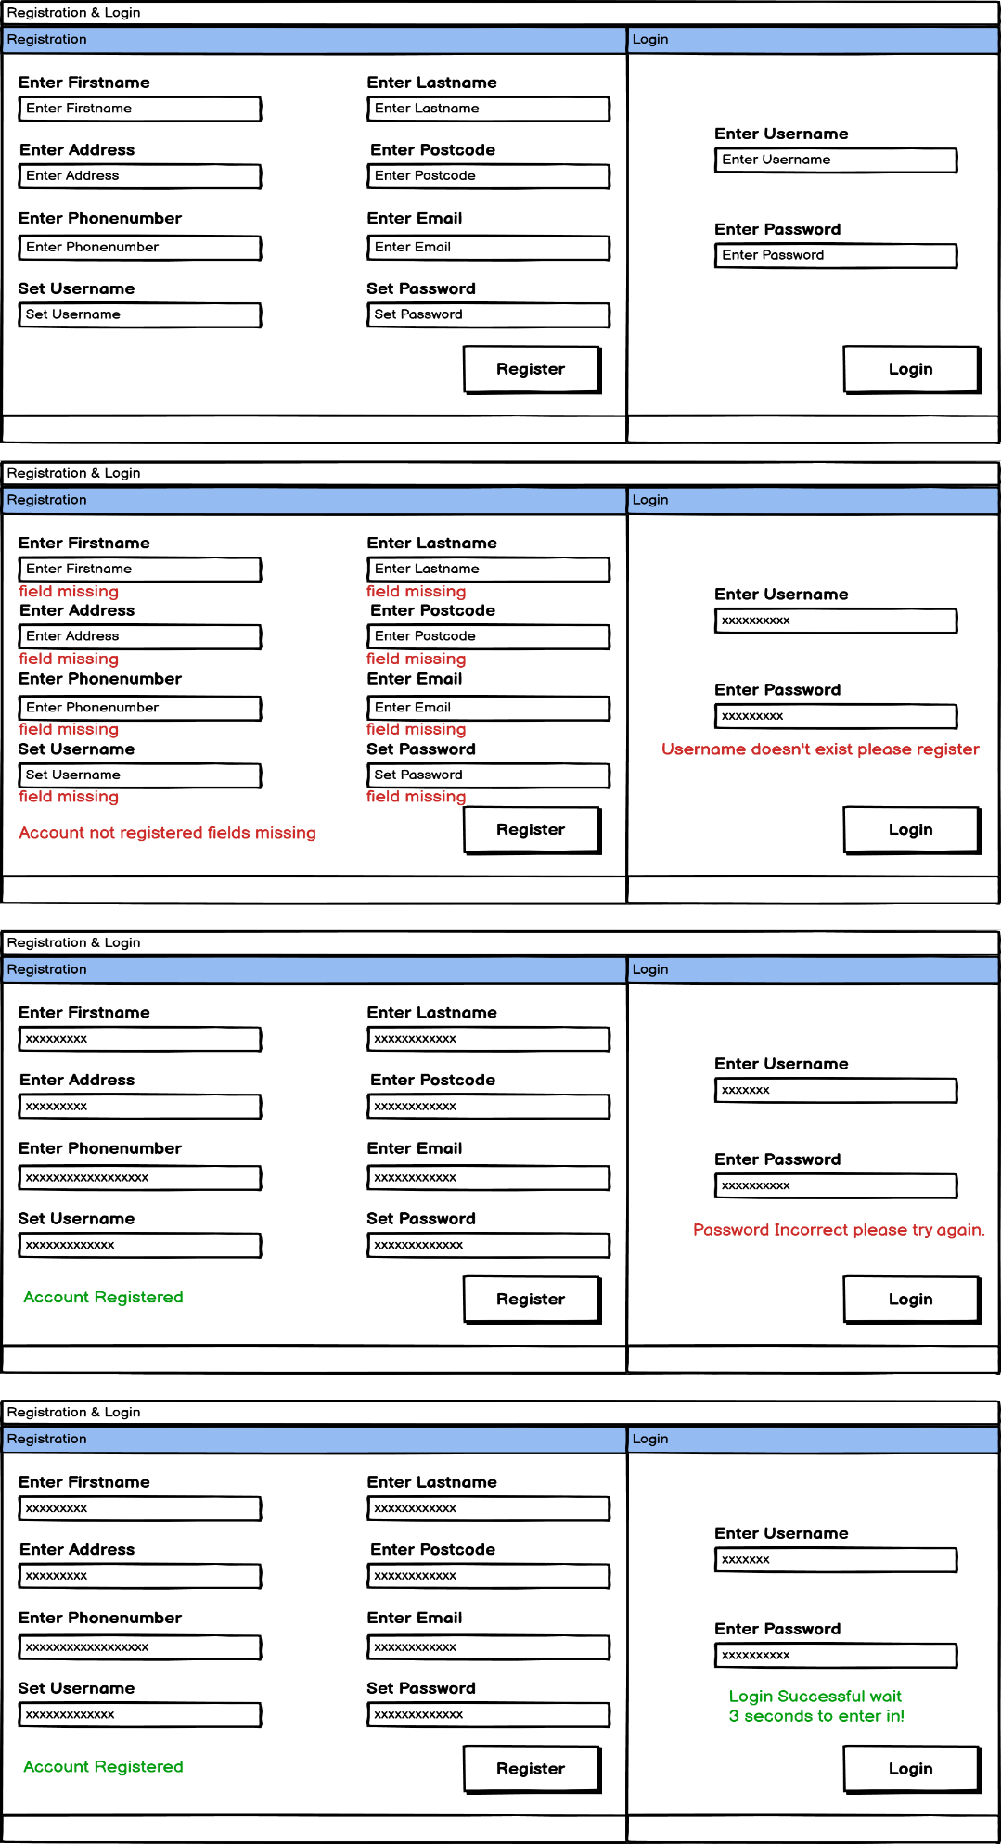

This is the Registration & Login GUI wireframe. As, you can see that each input fields including the Registration & Login section have a label on top of them and in addition to that, there a placeholder values to support users therefore, they know what type need to type inside the input fields which makes less chances of a mistake also, considering the fact that they can view it twice because of the label on top and the placeholder value in the input field. You can also witness that there are red label messages underneath the input fields which are used to indicate input error made by the users such as, they forgot to input a field, added the wrong information, username didn’t exist as they maybe forgot to register or, the password is incorrect. All the red messages are used for alerting a user that they have made mistake and by reading the red messages they can see explicitly what mistake they have made. You can also witness there are green messages which indicate the message of success for the users such as if they have inputted the correct fields then, it will return a message of success in a green colour to make them aware that their account is registered and, for the login it returns a message of success in green saying ‘access the application in 3 seconds’ meaning the user has successfully logged in and is waiting to access the application. The buttons ‘register’ and ‘login’ made a bit big and bold text in terms of design, the reason being, it allows the users to understand when they need to click, and also, once the button is clicked then, it returns either message of success or failure depending on the user input.

*(Figure 32.1 – Registration & Login Wireframe)*

### **Main Menu**

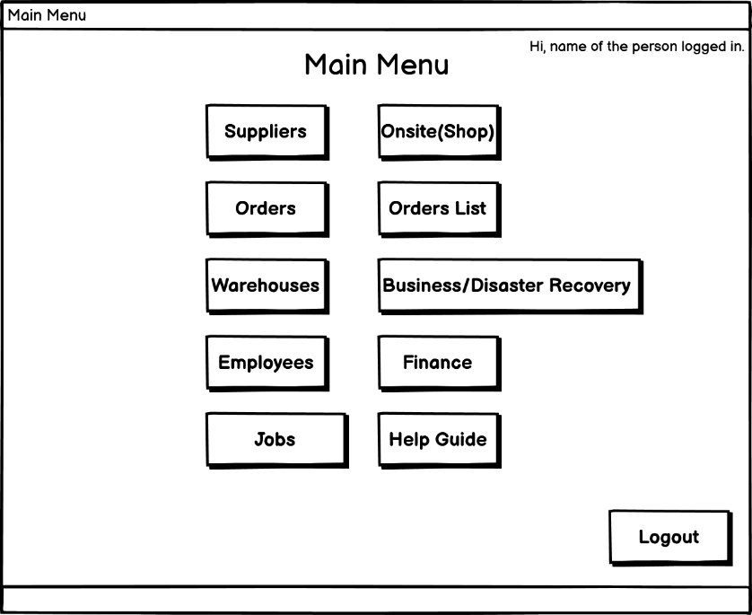

*(Figure 32.2 – Main Menu Wireframe)*

Figure 32.2 shows the main menu wireframe which was a requirement needed for the ease of navigation as, the users can use the main menu to access all the different parts of the software system such as: suppliers, onsite, orders, order list, warehouse, business/disaster recovery, employees, finance, jobs, and a help guide. This is the reason why we decided to make a homepage style main menu. The user can read the text on the button and easily access any area when required to do so. The user accesses the main menu after successfully going through the registration and login after 3 seconds. On the top-right corner of the window, a text label is used to alert the user with their name, this is used to alert the user that they are logged in successfully. On every other windows there is an option to go back to the previous page which makes the user interface intuitive as, you can witness from other wireframes that every window has a button to navigate back to the previous section. Finally, there is a logout button located on the bottom-right of the window which, indicates to the users that, if they wish to leave then, they can press the logout button as, by pressing the logout button the application will be redirected back to the registration and login from the main menu as, result the user will have to login again if they want to re-access the application as, by now you understand that the application can only be used if the user is logged in, without login there is no other chance to access the application.

### **Help Guide**

We understand the fact that not everybody is a technology or an IT expert this includes businesses owner himself or the employees from their management team therefore, we have designed a section for a simple help guide documentation. This help guide documentation contains small paragraphs which will inform users on how to use each section of the application for example, there is a paragraph for the suppliers which informs the uses on how to use the suppliers section. The users just need to read and understand as, this is a basic training for the new users who have recently joined. Once, they get the hang of it then, those user don’t really need to use it unless they forget due to some reasons.

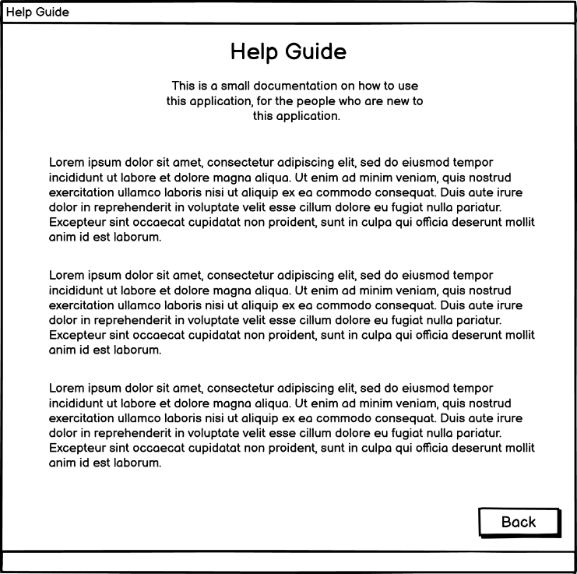

*(Figure 32.2 – Help Guide Wireframe)*

### **Suppliers**

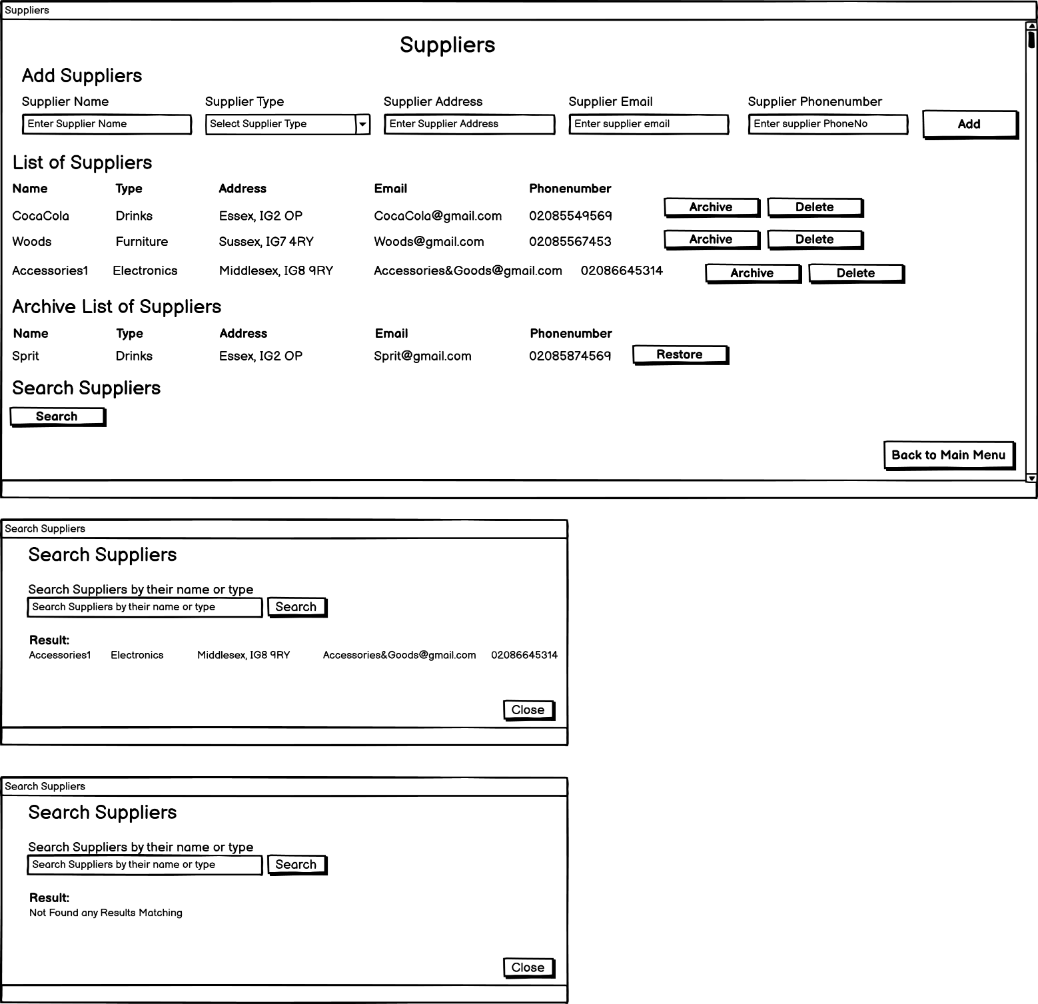

The suppliers section is split up into four sections which are the following: add suppliers: where there are input fields and placeholder values included with an ‘Add’ button, this is where the user can prompt to add new suppliers to their system, list of suppliers: under the list of suppliers section the users can view a list of suppliers with all their details, who are registered to this system, the list will be displayed using a while loop to display all members of the suppliers. In many cases, we understand the fact that that suppliers might be away for not available for some time therefore, in the list we have an archive button which is used to archive the supplier from the list and display them in the archive list of suppliers which is the sections below therefore, it alerts other users that this supplier is unavailable at the moment, and the archive list of suppliers will display a restore button to unarchive the supplier, when the supplier returns back, this way the supplier will go back into the list of suppliers which shows to the users that they are available again. There is also a delete button option in the list because, the supplier may no longer be available or perhaps the business may not use their services anymore therefore, by pressing the delete button the supplier would be deleted out of the system meaning, they would no longer exist in the list or the system. This will reduce memory off the system as well.

*(Figure 32.3 – Suppliers Wireframe)*

There is a search supplier button which is included in the last section of the suppliers window. The user clicks onto the search button which, opens up a separate search supplier modal dialog window with a search box to search for the supplier by name and a button to then, search that supplier, and after that, it will either return the details of the suppliers who was searched or, an error message if the user prompts an incorrect data in both cases, the return message will be displayed under the result label which alerts the user from beforehand that this is where you would expect to see your message after searching for the supplier. There is also an option to close this window if the user wishes to not use search supplier section anymore. The separate modal window for the search suppliers section was required as a design process as, there was too much data on the suppliers window which was making things confusing therefore, the solution of a separate modal window was decided. We have also included horizonal and vertical scroll bars in our design therefore, it’s easier for the users to view data on the GUI rather then, one large window will make in look confusing.

By using the sub-headings on top of each section the users will know which section is going to be used for what purpose therefore, they can easily differentiate between the different sections.

### **Orders**

In this order system wireframe design you can witness that this is a form which used to send an order invoice to the suppliers for ordering their products, for their own business. This order form has been designed using a variety of GUI components which include input fields, drop-down lists, buttons, radio buttons, and data selectors. This type of design for the order system has been considered after researching well-know sites which include amazon, eBay, etc.

The user needs to select a product type and the product name first from the drop-down list after that, some of the information will automatically be loaded up into the sections: product price, product description, product status, product quantity available, and the supplier name and type. If the user first selects the supplier name and type then, when the user comes to choose the product then they can only choose the products available from the supplier they selected. This way its better in terms of design because, it makes it easier for users as, they don’t have to remember information of by heart and in addition to that, there are more chances of a mistake if the users type in manually.

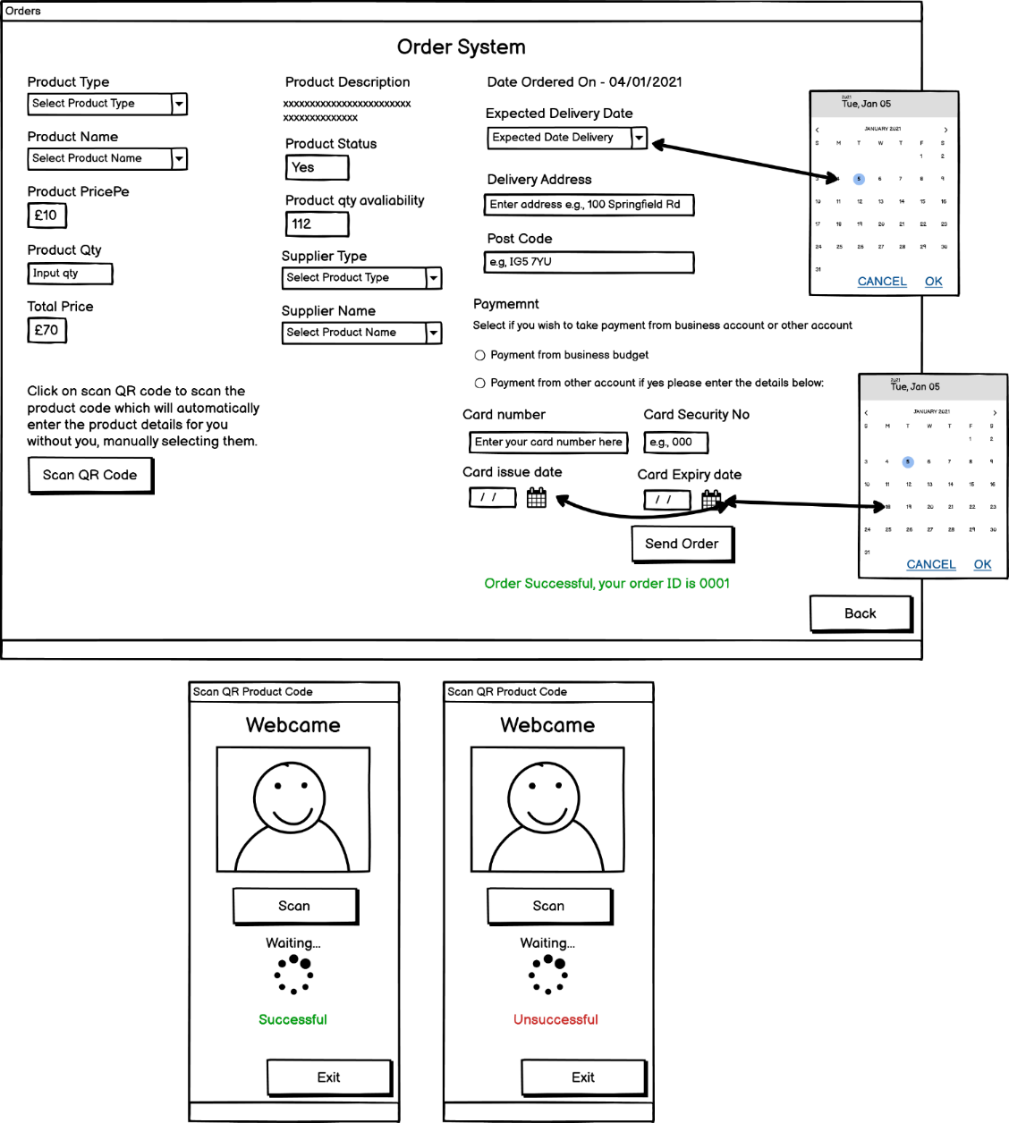

Loading bar is used for the waiting time as, the scan is still trying to search the QR code.

There is a button which allows you to scan the product QR code therefore, when the user clicks on the button then, it opens a modal dialog window. That windows allows you to scan a product code by your PC camera. If it is successful then, it will return a message of success and automatically fill in all the details, else it will return an error message if the code is incorrect. This allows you to process things quicker saving time that is why it was considered in this design process.

The users will have to input the product quantity themselves based on that the total price will ascend or descend. The date ordered on will automatically be generated according to the current date. The user would choose their expected delivery data by using the date picker, therefore the date is accurate because, if the user manually types in their date then, there are more chances of a mistake which will lead to confusions.

*(Figure 32.4 – Order System Wireframe)*

For selecting a payment type we decided to design that using the radio buttons because, by using radio buttons you can only select one options as, there are no multiple options and we only require one type of payment. After that, the user must fill in their card details: number, security number and, select a card issue and expiry data using the date picker to insert the accurate date with chances of less mistakes. After that, the user can send the order which will either return a message of success and generate an order id or, it will return an error message if something is missing or any information which is incorrect such as the card date might be outdated.

### **Orders List**

This is the order list section, where the users can view all their orders, they have made previously. The data will be displayed on the GUI using the while loop, which will display all the data. It has a vertical scroll bar because, there are too many orders so it won’t be appropriate to make a design which has a long window therefore, we came up with a decision to have a reasonable size for the window but, we will use a scroll bar therefore, the users can use this to view their history of orders. You can also search for order by pressing the search button.

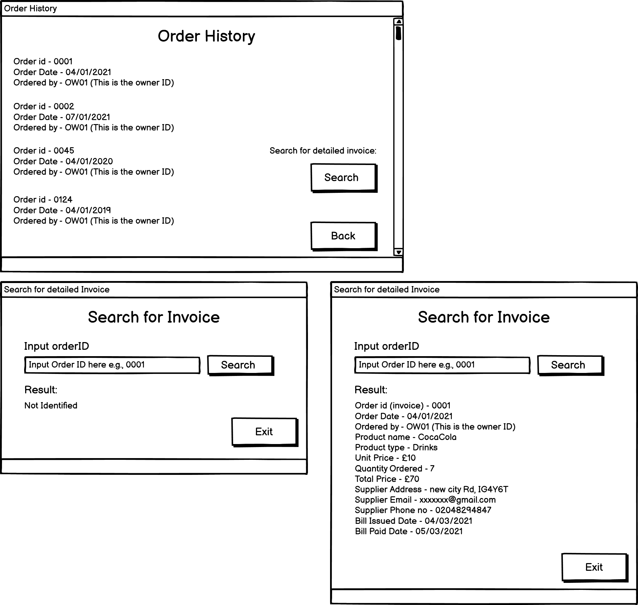

*(Figure 32.3 – Orders History Wireframe)*

As, it was mentioned before that if users want to individually search for their order/invoice then, they need to press the search button. After pressing the search button a modal window will open with a search box and a search button. The user has to input their order id, which was generated by their order and then, the result will be displayed showing all the invoice details for that particular order which you can view on the wireframe above and if, the user input an invalid order id then, it will return an error message saying, ‘not identified’. The reason why, we decided to have an extra window for searching the orders is because, on one window it makes it quite difficult to understand considering the fact that the list of orders was quite large as well therefore, we needed another window.

### **Onsite (Shop)**

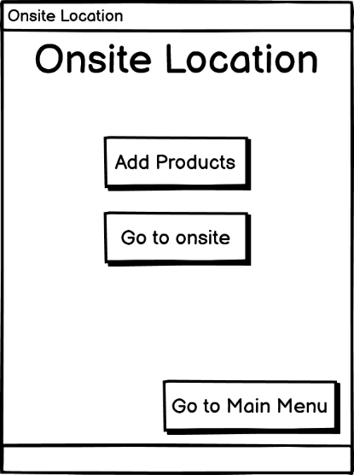

This is the onsite location section where it will direct the users to a main menu. The reason why we have a main menu for this section is because, its quite a large section therefore, its not possible to have everything on a single window and that will make it look more complicated. Therefore, by having a separate main menu for this section and splitting up the two sections, add products and, go to onsite will make the design clearer and easier to understand therefore, the users can easily navigate between the different sections.

*(Figure 32.4 – Onsite Location Wireframe)*

This is the add products section for adding the products to the onsite (shop) location. The user has to locate their products inside the onsite shop location. Typically, in a shop you have rows, and in each row, you have a shelf, and inside the shelf there are those products in quite a large numbers. Therefore, I have used that same pattern to locate the products via the application. When the user enters these add details input fields then, they are basically locating the product inside the shop. We have designed this from using subheadings, and inside the input fields we have used placeholders therefore, the users understand what they need to input.

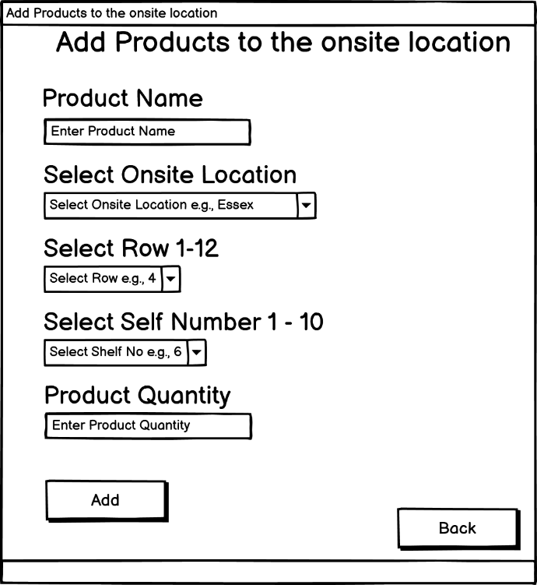

*(Figure 32.4 – Add Products to Onsite Location Wireframe)*

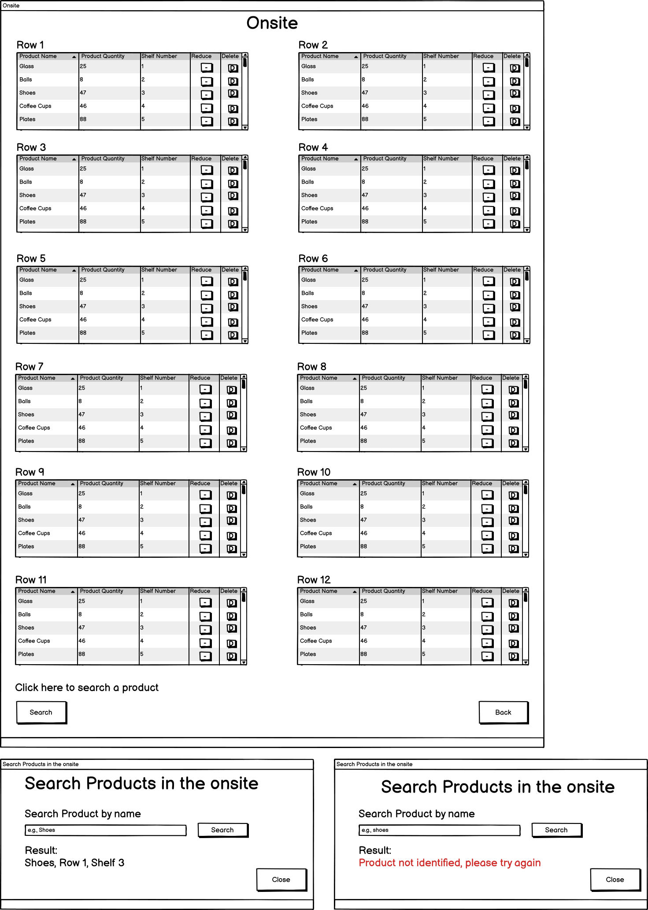

There are a variety of products which are located in each row therefore, we have attached a vertical scroll-bar therefore, the users can use this to view all the products which are inside the row.

At some point there will be a time where the product is out of stock in the onsite location therefore, you can delete the product from the onsite therefore, all the records are kept updated and there are no confusions.

There is also a button reduce the product quantity for example, if the product is sold then, you can use this recue button to reduce the product quantity.

Each row has a product name, the amount of product quantity, which shelf they are located in. When the users add the product then, this is how its displayed.

*(Figure 32.5 – Add Products to Onsite Location Wireframe)*

In the section ‘go to onsite’ is where you can view your products which currently available in store. In many cases, when customer come on store then, they are looking for a certain product and if they can’t find that product, they would come to an employee to ask them for guidance therefore, by using this design showed in figure 32.5 the employee user can instantly find out in which row and shelf is the product located or check if this product exists or not therefore, the employee can give an instant reply back to the customer rather than wasting time searching it for them themselves. Another quick feature which the employees can use is by searching the product by their name.



*(Figure 32.6 – Add Products to Onsite Location Wireframe)*

Figure 32.6 shows the search window. This allows the users to search quickly for one specific product to check if its located in store or not. The user has to input the product name in the search bar and then, press the button search. After that, an if statement is used for checking if the product exists in store or not and if it does then, it returns the product name, row number, and the shelf number else, it return a message in red to alert the user that the product is not identified, the possible reasons for that could be because the product is not in store yet or the name inputted is incorrect.

### **Warehouses**

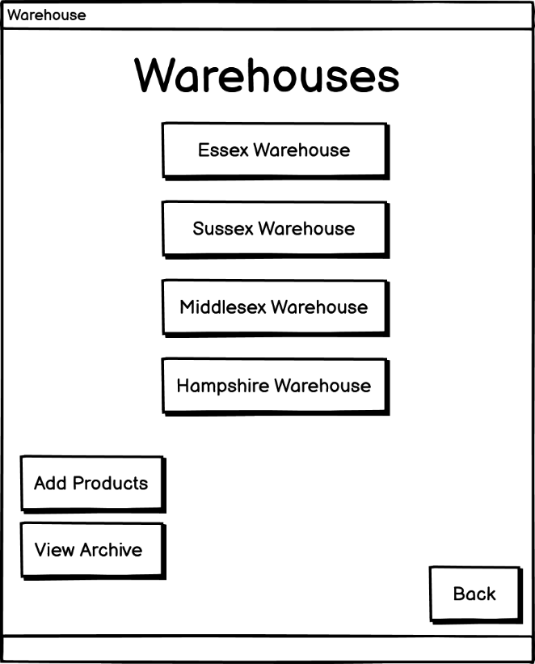

*(Figure 32.7 – Main Menu for Warehouse Locations Wireframe)*

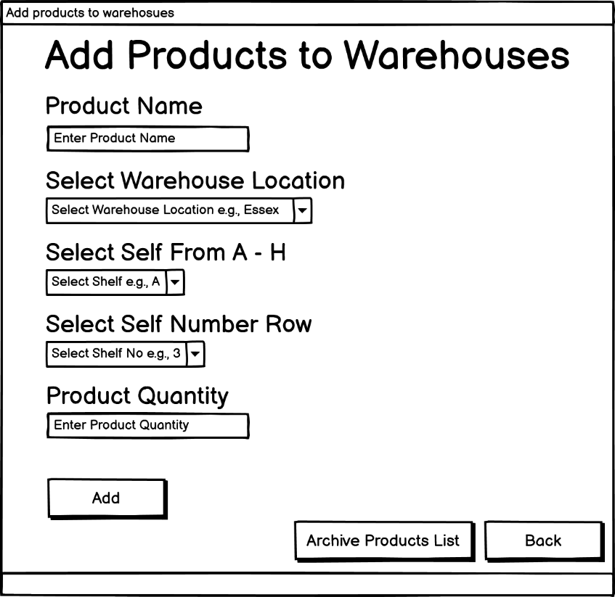

*(Figure 32.8 – Add Products to Warehouse Wireframe)*

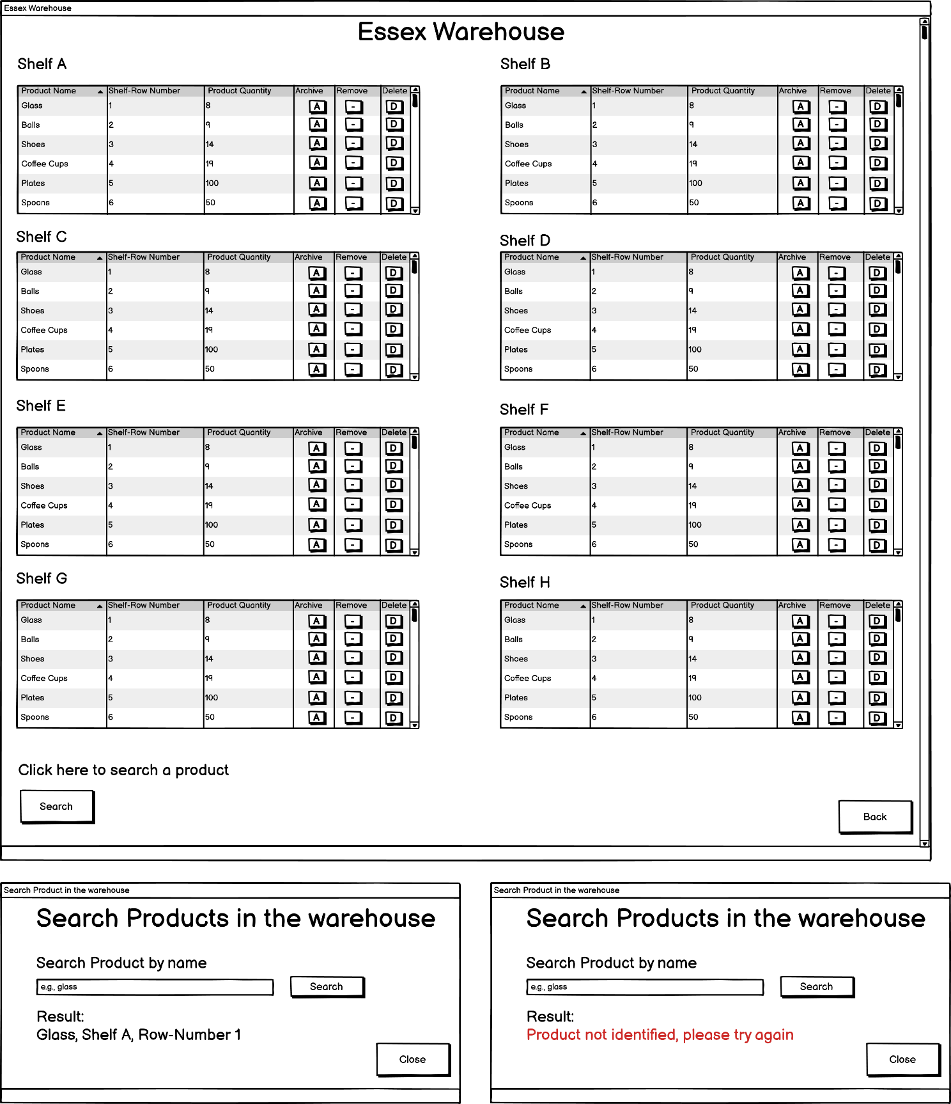

*(Figure 32.9 – Products inside the warehouse Wireframe)*



*(Figure 32.10 – Search Products in the warehouse Wireframe)*

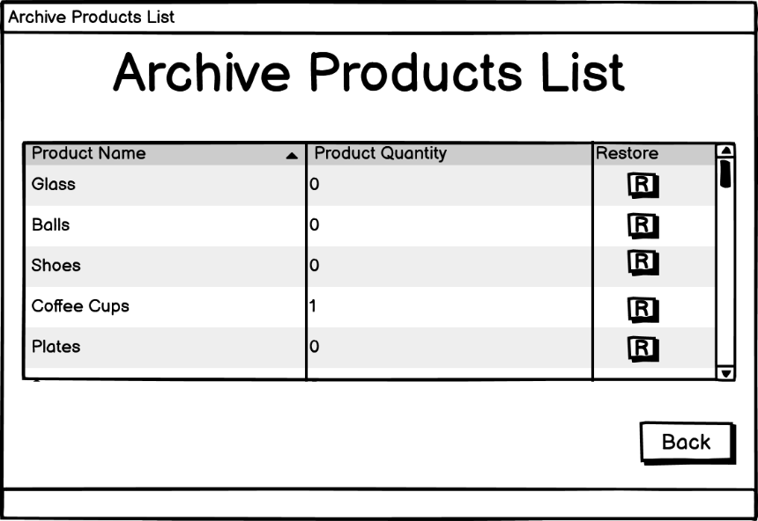

*(Figure 32.11 – Archive list of products for warehouses Wireframe)*

### **Employees**

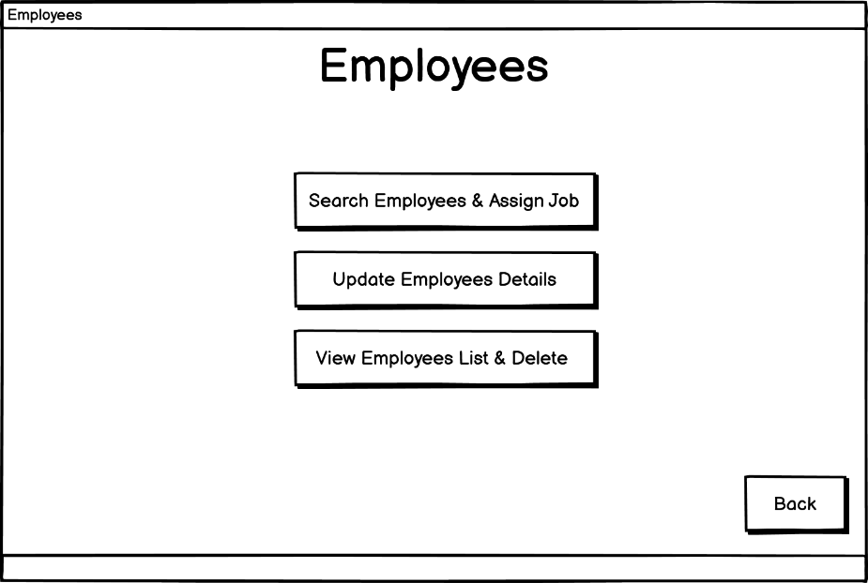

*(Figure 32.12 – Main Menu for Employees Wireframe)*

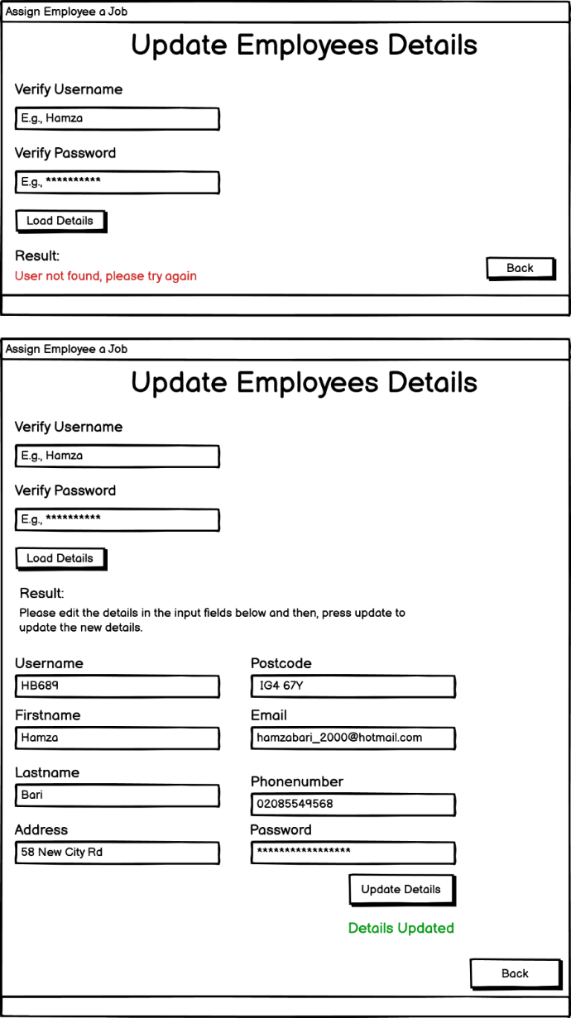

*(Figure 32.12 – Update Employees Details Wireframe)*

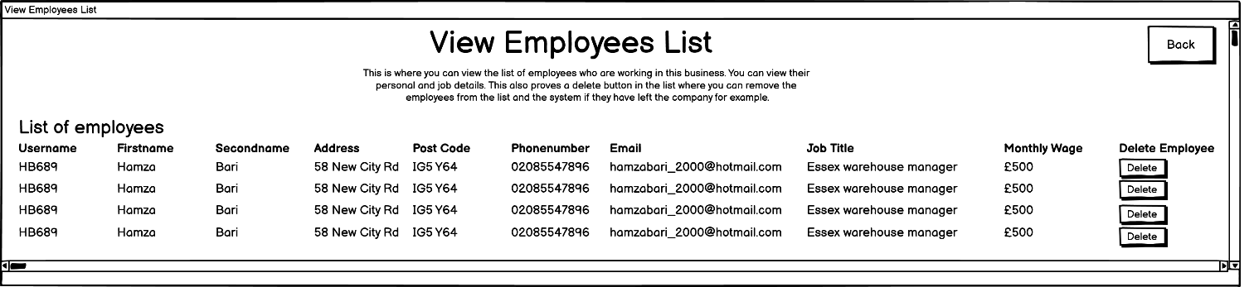

*(Figure 32.13 – View Employees List Wireframe)*

### **Business/Disaster Recovery**

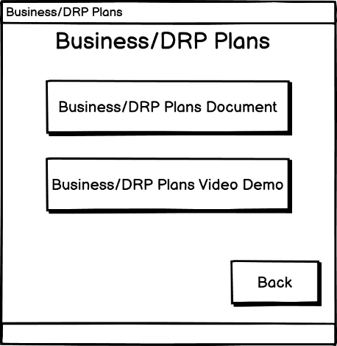

*(Figure 32.14 – Business/DRP Plans Wireframe)*

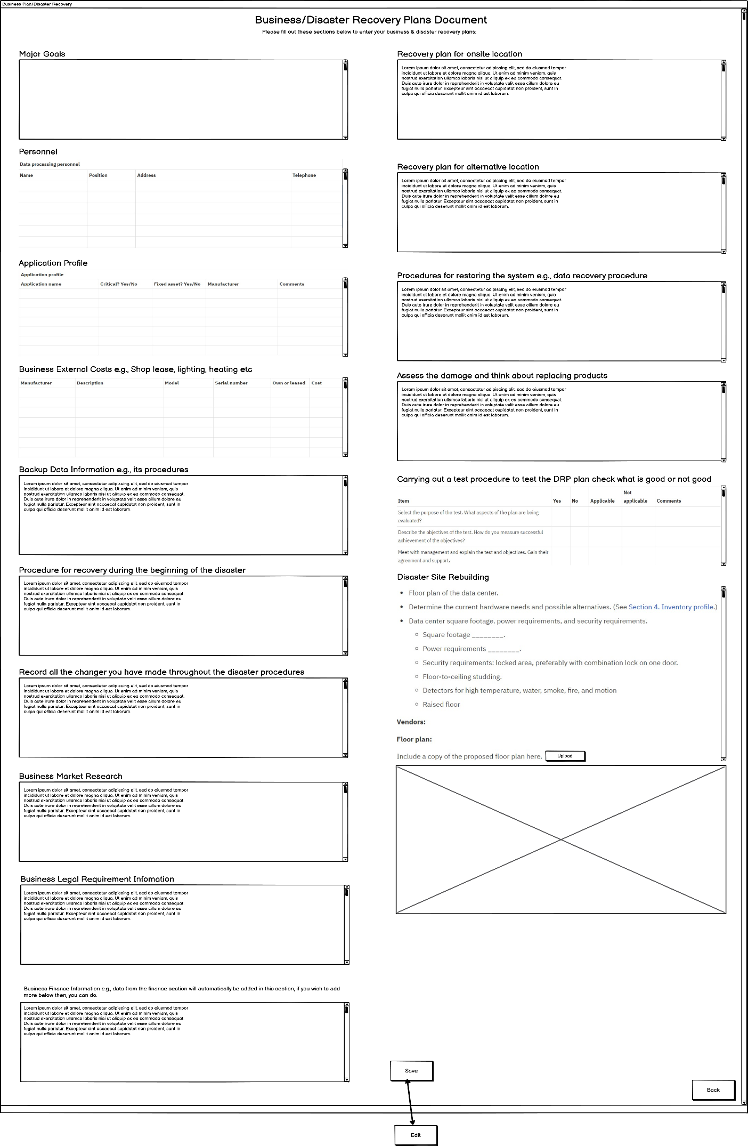

*(Figure 32.15 – Business Disaster Recovery Plan Document Wireframe)*

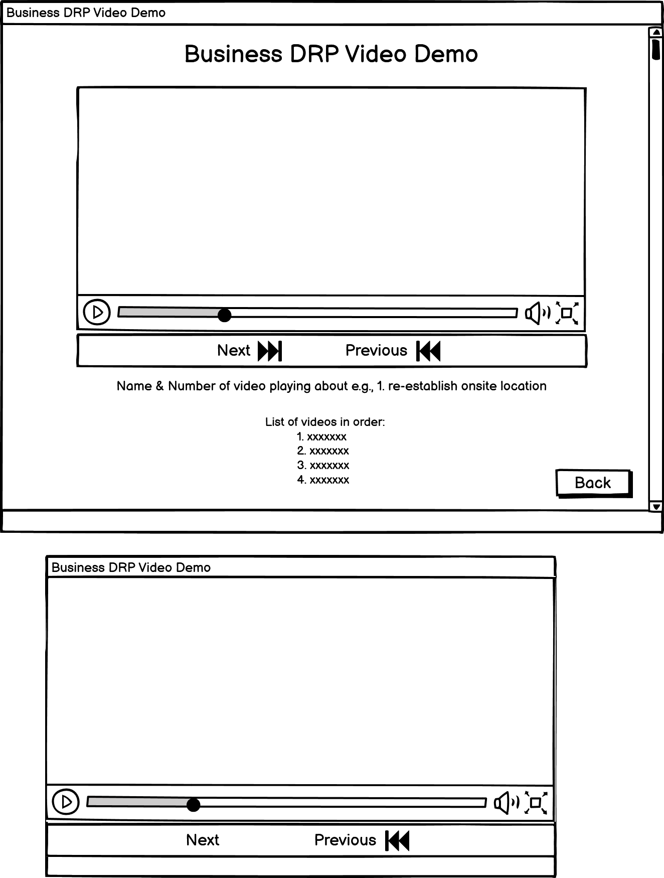

*(Figure 32.15 – Business Disaster Recovery Plan Video Wireframe)*

### **Finance**

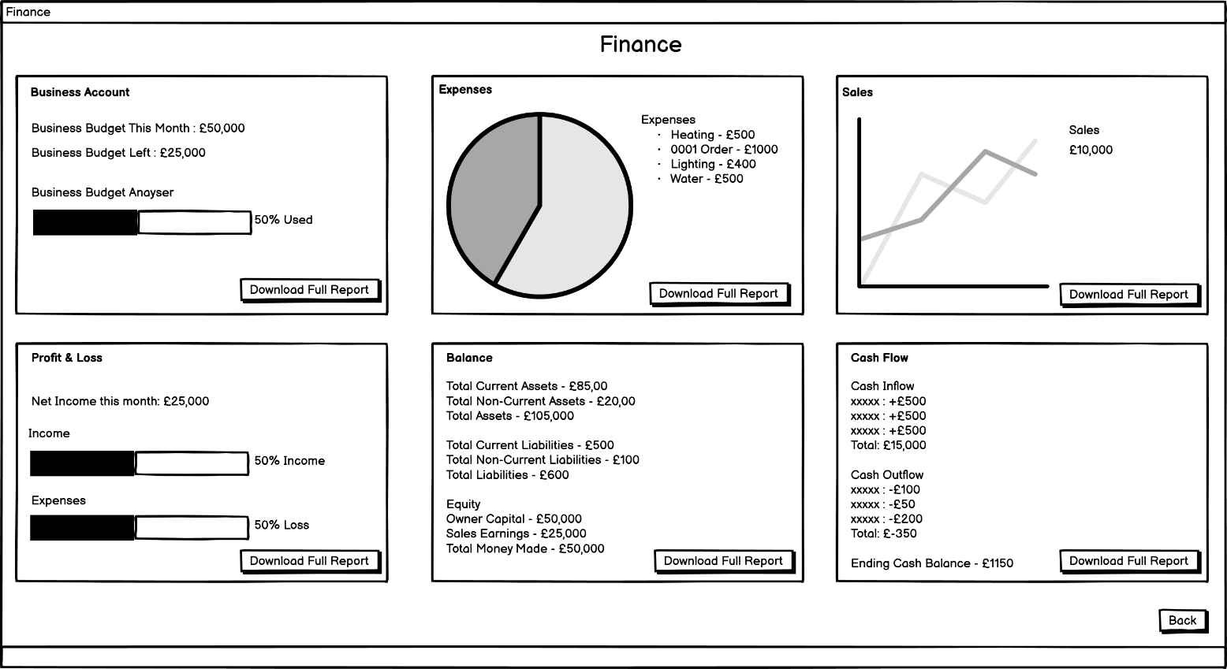

*(Figure 32.16 – Business Finance Wireframe)*

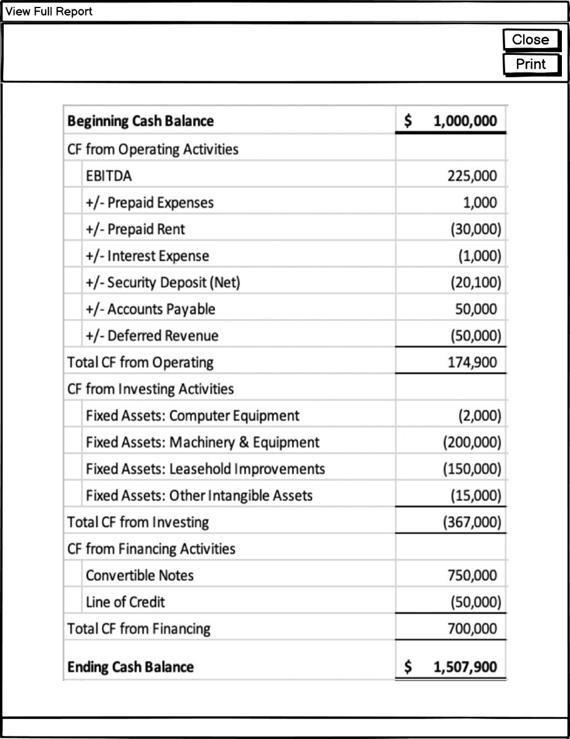

*(Figure 32.17 – Business Finance Reports Wireframe)*

### **Jobs**

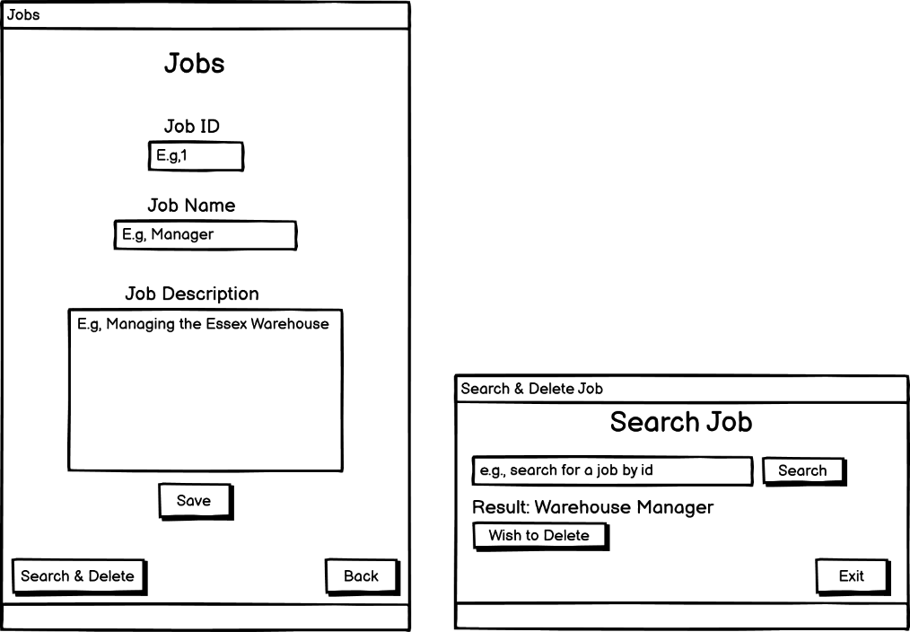

*(Figure 32.18 – Business Jobs Wireframe)*

## **Entity Relationship Diagram for the Database**

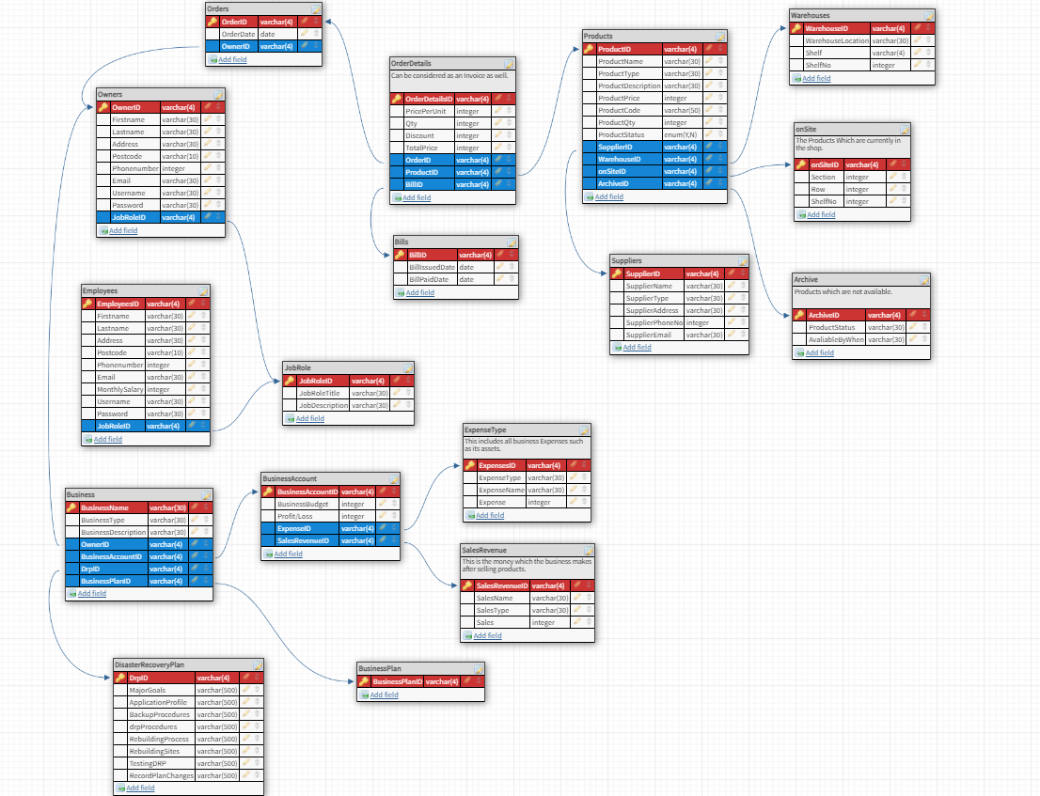

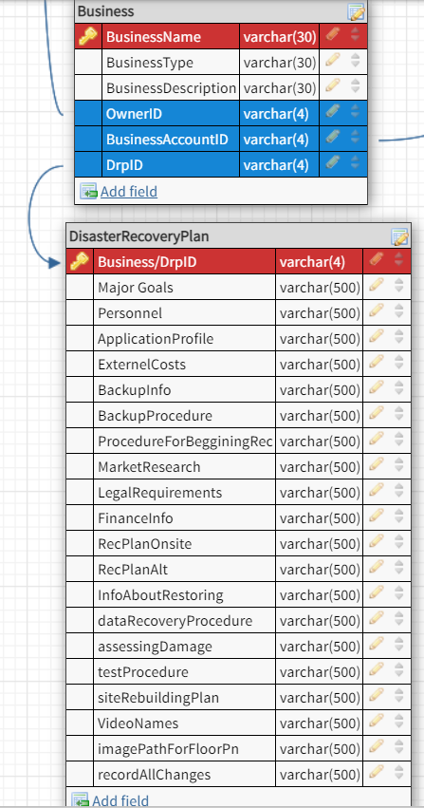

*(Figure 33 – Entity Relationship Diagram)*

## **UML Case Diagram**

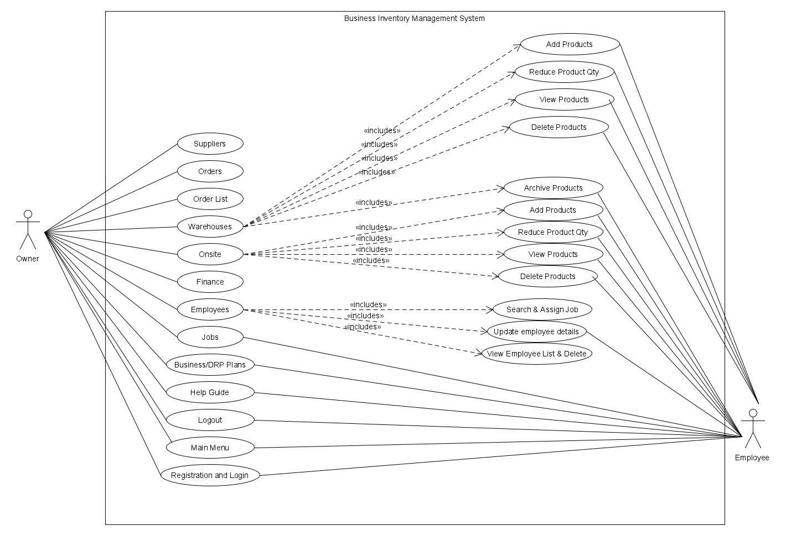

*(Figure 34 – UML Case Diagram for Application access rights)*

# ***References***

**[1]** Disaster Recovery Plan (DRP). Available online: <https://www.techopedia.com/definition/1074/disaster-recovery-plan-drp>. Accessed: 29 Nov 2020.

**[2]** How does a disaster recovery (DR) plan work? Available online: <https://www.ibm.com/services/business-continuity/disaster-recovery-plan>. Accessed: 30 Nov 2020.

**[3]** Bojana, B.D., (2018). 2020 Disaster Recovery Statistics That Will Shock Business Owners. Available online: <https://phoenixnap.com/blog/disaster-recovery-statistics>. Accessed: 27 Nov 2020.

**[4]** Risk & Costs of Not Having a Business Continuity Management Program. Available online: <https://www.rockdovesolutions.com/blog/risk-costs-of-not-having-a-business-continuity-management-program>. Accessed: 29 Nov 2020.

**[5]** Enterprise Resource Planning (ERP). Available online: <https://www.gartner.com/en/information-technology/glossary/enterprise-resource-planning-erp>. Accessed: 20 Nov 2020.

**[6]** Gough, O.G., (2017). UK independents still rely on pen and paper to manage their business. Available online: <https://smallbusiness.co.uk/independents-rely-paper-manage-business-2540481/>. Accessed: 15 Nov 2020.

**[7]** Thomas, T. UK independents still rely on pen and paper to manage their business. Available online: <https://www.inflowinventory.com/blog/still-keeping-spreadsheets-inventory-paper/>. Accessed: 15 Nov 2020.

**[8]** Moira, M.M., (2016). 11 Disadvantages of Using Excel To Manage Your Pricing. Available online: <https://blog.blackcurve.com/11-disadvantages-of-using-excel-to-manage-your-pricing> Accessed: 15 Nov 2020.

**[9]** Courtenay, C.S., (2020). The 14 Best Inventory Management Software for Small Businesses of 2020. Available online: <https://www.business.org/finance/inventory-management/best-inventory-management-software/>. Accessed: 16 Nov 2020.

**[10]** DISCOVER THE LEADING SAAS SOFTWARE COMPARISON SITE. Available online: <https://comparecamp.com/inflow-inventory-review-pricing-pros-cons-features/>. Accessed: 17 Nov 2020.

**[11]** inFlow is fully stocked with great features. Available online: <https://www.business.org/finance/inventory-management/best-inventory-management-software/>. Accessed: 17 Nov 2020.

**[12]** (2018). Inventory Management Software | inFlow Inventory. Available online: <https://www.youtube.com/watch?v=x70A2JV1j64>. Accessed: 17 Nov 2020.

**[13]** inFlow Inventory Reviews. Available online: <https://www.getapp.com/operations-management-software/a/inflow-cloud/reviews/>. Accessed: 20 Nov 2020.

**[14]** Harinder, P.S., (2019). QuickBooks Software – What Does It Do? Available online: <https://www.cogneesol.com/blog/quickbooks-software-what-does-it-do>. Accessed: 20 Nov 2020.

**[15]** Harinder, P.S., (2019). Advantages of Choosing QuickBooks Accounting Software. Available online: <https://www.cogneesol.com/blog/advantages-of-quickbooks-accounting-software>. Accessed: 20 Nov 2020.

**[16]** QuickBooks. Available online: <https://quickbooks.intuit.com/online/how-it-works/>. Accessed: 23 Nov 2020.

**[17]** Mark, M.K., Pros and Cons of QuickBooks | Limitations of QuickBooks. Available online: <https://www.bluelinkerp.com/blog/2013/08/05/pros-and-cons-of-quickbooks-quickbooks-limitations/>. Accessed: 25 Nov 2020.

**[18]** (2020). Do I need to back up my data with QuickBooks Online? Available online: [https://quickbooks.intuit.com/learn-support/en-uk/back-up-data/do-i-need-to-back-up-my-data-with-quickbooks-online/00/239889#](https://quickbooks.intuit.com/learn-support/en-uk/back-up-data/do-i-need-to-back-up-my-data-with-quickbooks-online/00/239889). Accessed: 26 Nov 2020.

**[19]** Mark, M.K., Top 5 Reasons to Replace QuickBooks. Available online: <https://www.bluelinkerp.com/blog/2012/06/18/top-5-reasons-to-replace-quickbooks/>. Accessed: 26 Nov 2020.

**[20]** inFlow Inventory vs QuickBooks Desktop Enterprise. Available online: <https://www.capterra.com/inventory-management-software/compare/174984-78431/QuickBooks-Enterprise-vs-inFlow-Inventory>. Accessed: 27 Nov 2020.

**[21]** Howard, H.A., (2003). Computer Programming Languages. Available online: <https://www.sciencedirect.com/topics/computer-science/java-programming-language>. Accessed: 3 Dec 2020.

**[22]** Java Introduction. Available online: <https://www.w3schools.com/java/java_intro.asp>. Accessed: 3 Dec 2020.

**[23]** Java Package. Available online: <https://www.javatpoint.com/package>. Accessed: 3 Dec 2020.

**[24]** Package in Java. Available online: <https://www.sitesbay.com/java/java-package>. Accessed: 3 Dec 2020.

**[25]** Java.util package tutorial. Available online: <https://www.tutorialspoint.com/java/util/index.htm>. Accessed: 3 Dec 2020.

**[26]** Java.lang package in Java. Available online: <https://www.geeksforgeeks.org/java-lang-package-java/>. Accessed: 14 Dec 2020.

**[27]** Java JDBC Tutorial. Available online: <https://www.javatpoint.com/java-jdbc>. Accessed: 14 Dec 2020.

**[28]** List the advantages of JDBC. Available online: <https://www.careerride.com/JDBC-Advantages.aspx>. Accessed: 16 Dec 2020.

**[29]** Jakob, J.J., (2020). Java IO Tutorial. Available online: <http://tutorials.jenkov.com/java-io/index.html>. Accessed: 18 Dec 2020.

**[30]** The java.io Package. Available online: <https://docstore.mik.ua/orelly/java-ent/jnut/ch11_01.htm>. Accessed: 19 Dec 2020.

**[31]** Java PrintWriter class. Available online: <https://www.javatpoint.com/java-printwriter-class>. Accessed: 23 Dec 2020.

**[32]** What is the purpose of flush() in Java streams? Available online: <https://stackoverflow.com/questions/2340106/what-is-the-purpose-of-flush-in-java-streams>. Accessed: 23 Dec 2020.

**[33]** Hamza, H.B., (2020). Available online: <https://github.com/HamzaBari2000/Java/blob/master/Assignment1/Task1/src/ApplicationRunner.java>. Accessed: 24 Dec 2020.

**[34]** JavaFX Script. Available online: <https://en.wikipedia.org/wiki/JavaFX_Script>. Accessed: 27 Dec 2020.

**[35]** Peter, (2017). JAVAFX 8 – A FANTASTIC TOOL TO CREATE BEAUTIFUL GUI FOR YOUR JAVA APPLICATION EASILY (PART 1). Available online: <https://etrenddot.wordpress.com/2017/03/19/javafx-8-a-fantastic-tool-to-create-beautiful-gui-for-your-java-application-easily-part-1/>. Accessed: 27 Dec 2020.

**[36]** JavaFX: Incorporating Media Assets into JavaFX Applications. Available online: <https://docs.oracle.com/javase/8/javafx/media-tutorial/overview.htm>. Accessed: 27 Dec 2020.

**[37]** Gail, G.C., (2013). Getting Started with JavaFX. Available online: <https://docs.oracle.com/javafx/2/get_started/hello_world.htm#CHDIFJHE>. Accessed: 28 Dec 2020.

**[38]** Joni, J.G., (2013). Using Built-in Layout Panes. Available online: <https://docs.oracle.com/javafx/2/layout/builtin_layouts.htm>. Accessed: 28 Dec 2020.

**[39]** Java Inner Classes. Available online: <https://www.javatpoint.com/java-inner-class>. Accessed: 28 Dec 2020.

**[40]** Mohammad, H.R., (2018). 004 - JavaFX Tutorial - Event Handling. Available online: <https://www.slideshare.net/MohammadHosseinRimaz/004-javafx-tutorial-event-handling>. Accessed: 28 Dec 2020.

**[41]** (2020). SOFTWARE The 5 Most Popular Mobile Apps Built with Java. Available online: <https://techbullion.com/the-5-most-popular-mobile-apps-built-with-java/>. Accessed: 28 Dec 2020.

**[42]** Alexander, A.C., (2016). 20 JavaFX real-world applications. Available online: <https://jaxenter.com/20-javafx-real-world-applications-123653.html>. Accessed: 29 Dec 2020.

**[43]** 1.2.1 What is MySQL? Available online: <https://dev.mysql.com/doc/refman/5.7/en/what-is-mysql.html>. Accessed: 29 Dec 2020.

**[44]** MySQL. Available online: <https://en.wikipedia.org/wiki/MySQL>. Accessed: 30 Dec 2020.

**[45]** Chapter 7 Backup and Recovery. Available online: <https://dev.mysql.com/doc/refman/5.7/en/backup-and-recovery.html>. Accessed: 30 Dec 2020.

**[46]** 4.5.4 mysqldump — A Database Backup Program. Available online: <https://dev.mysql.com/doc/refman/8.0/en/mysqldump.html>. Accessed: 30 Dec 2020.

**[47]** Featured Customers That Trust MySQL. Available online: <https://www.featuredcustomers.com/vendor/mysql/customers>. Accessed: 31 Dec 2020.

**[48]** Martin, M.H., (2019). How Does an FTP Server Work and What are Its Benefits? Available online: <https://www.ftptoday.com/blog/how-does-an-ftp-server-work-the-benefits>. Accessed: 31 Dec 2020.

**[49]** Archit, A.M., (2019). Java vs. Python: Which should you choose? Available online: <https://opensource.com/article/19/12/java-vs-python>. Accessed: 31 Dec 2020.

**[50]** Learn Key Programming Languages for Software Development. Available online: <https://online.maryville.edu/blog/programming-languages-for-software-developers/>. Accessed: 31 Dec 2020.

**[51]** Omar, K,N., (2016). SQLite vs. MySQL. Available online: <https://dzone.com/articles/sqlite-vs-mysql#:~:text=Both%20the%20SQLite%20and%20MYSQL,it%20extremely%20portable%20and%20reliable.&text=MySQL%20is%20secured%2C%20which%20makes,can%20be%20used%20at%2Dscale>. Accessed: 30 Dec 2020.

**[52]** Matthew, M.M., (2019). 10 Advantages and Disadvantages of Cloud Storage. Available online: <https://www.promax.com/blog/10-advantages-and-disadvantages-of-cloud-storage>. Accessed: 1 Jan 2021.